DIFFERENT Voltage Flicker Mitigation by FACTS Devices

*ABHIRAAM, **B. KIRAN
*PD Scholar, Department of Electrical & Electronics Engineering,, Velaga Nageswara Rao college of Engineering, Ponnur; Guntur (Dt); A.P, India.
**Assistant Professor, Department of Electrical & Electronics Engineering,, Velaga Nageswara Rao college of Engineering, Ponnur; Guntur (Dt); A.P, India.

ABSTRACT –
Voltage flicker is considered as one of the most severe power quality problems (especially in loads like electrical arc furnaces) and much attention has been paid to it lately. Due to the latest achievements in the semiconductors industry and consequently the emergence of the compensators based on voltage source converters, FACTS devices have been gradually noticed to be used for voltage flicker compensation. This paper covers the contrasting approaches; dealing with the voltage flicker mitigation in three stages and assessing the related results in details. Initially, the voltage flicker mitigation, using FCTCR (Fixed Capacitor Thyristor Controlled Reactor), was simulated. Secondly, the compensation for the Static Synchronous Compensator (STATCOM) has been performed. In this case, injection of harmonics into the system caused some problems which were later overcome by using SATCOM and RLC filters. The obtained results show that STATCOM is very efficient and effective for the flicker compensation. All the simulations have been performed on the MATLAB/Simulink Software.
Key Words - Power Quality, Voltage Flicker, Static Synchronous Compensator (STATCOM), RLC Filters

I. INTRODUCTION

The relationship between power quality and distribution system has been a subject of interest for several years. The concept of power quality describes the quality of the supplier voltage in relation to the transient breaks, falling voltage, harmonics and voltage flicker [1]. Voltage Flicker is the disturbance of lightning induced by voltage fluctuations. Very small variations are enough to induce lightning disturbance for human eye for a standard 230V, 60W coiled-coil filament lamp. The disturbance becomes perceptible for voltage variation frequency of 10 Hz and relative magnitude of 0.26% [1-2]. Huge non-linear industrial loads such as the electrical arc furnaces [3-4], pumps, welding machines, rolling mills and others are known as flicker generators. In this respect, the quality of supplied voltage is significantly reduced in an electrical power system and the oscillation of supplied voltage appears to be a major

problem. Electric arc furnace, the main generator of voltage flicker, behaves in the form of a constant reactance and a variable resistance. The transformer-reactance system is modelled as a lumped reactance, a furnace reactance (included connection cables and busses) and a variable resistance [5] which models the arc. Connecting this type of load to the network produces voltage variation at the common point of supply to other consumers. The relative voltage drop is expressed by equation
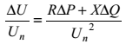 (1)
where ΔP and ΔQ are the variation in active and reactive power; Un is the nominal voltage and R and X are short circuit resistance and reactance. Since R is usually very small in comparison to X, ΔU is proportional to Q (reactive power).
Therefore, voltage flicker mitigation depends on reactive power control [5]. Two types of

structures can be used for the compensation of the reactive power fluctuations that cause the voltage drop:

A: shunt structure : in this type of compensation, the reactive power consumed by the compensator is kept constant at a sufficient value.

B: series structure : in this type, all the efforts are done to decrease the voltage drop mentioned above, and finally the reactive power is kept constant despite the load fluctuations by controlling the line reactance.
In addition to the aforesaid procedures for the compensators, the active filters are used for the voltage flickers mitigation as well. Furthermore, the mitigating devices based on Static VAR Compensator (SVC) such as Thyristor Switched Capacitor TSC, Thyristor Controlled Reactor (TCR) and FCTCR are the most frequently used devices for reduction in the voltage flicking. SVC devices achieved an acceptable level of mitigation, but because of their complicated control algorithms, they have problems such as injecting a large amount of current harmonics to the system and causing spikes in voltage waveforms. Advent of FACTS devices make them ideal for use in a power system and especially in the voltage flicker mitigation. In this respect, the FACTS devices based on voltage-source converters have been able to improve the problems related to SVC [5].A new technique based on a novel control algorithm, which extracts the voltage disturbance to suppress the voltage flicker, is presented in this paper. The technique is to use STATCOM for voltage flicker compensation to overcome the aforementioned problems related to other techniques. The concept of instantaneous reactive power components is used in the controlling system.

A two-bus system is exploited to fulfill the investigation of the presented procedure. All the simulations are done according to the usage of MATLAB software. The related compensation was performed first by FCTCR. Afterwards, a 6-pulse voltage-source converter STATCOM was used to compensate for the voltage flicker. With respect to the harmonic problem in this stage, a 12-pulse voltage-source converter STATCOM was designed to isolate load harmonics and mitigate the propagation of voltage flicker to the system in the next stage. The obtained results clearly confirmed the efficiency of the 12-pulse STATCOM to complete the voltage flicker mitigation.

II. INTRODUCTION TO POWER QUALITY

If there is any deviation of voltage, current and frequency at the load side then it is said to be power quality problem. Due to these power quality problems the performance of various sensitive loads is very poor. If we said that the power quality is good the voltage should be within permissible limits. The shape of the wave form should be pure sinusoidal. In all the three phases voltage should be same. Power supply should be consistent i.e. unremitting availability without break. Contemporary industrial machines and business-related computer networks are lying face down to many diverse failure modes. When the congregation line stops, or the computer network crashes for no obvious reason, very frequently the electric power quality is suspected. Power quality problems may be very difficult to troubleshoot, and often the electric power may not have any relation to the actual problem.
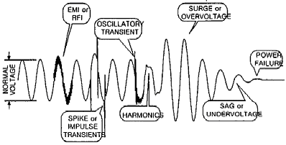

Fig 1: Power Quality and Reliability
The modern trunk crane industry, similar to many other industry segments, is frequently enamored by the bells and whistles, colorful diagnostic displays, high speed performance, and levels of automation that can be achieved. Although these features and their indirectly related computer based enhancements are key issues to an efficient terminal operation, we must not forget the foundation upon which we are building. Power quality problem is the mortar which bonds the base blocks. Power quality can also affects the operating economics, environment, crane consistency and primary asset in distribution systems to maintain new crane installations.
A. Power Quality Problems
Power Quality can be defined as the deviation of voltage, current and frequency at the distribution side. The problems due to the poor power quality include:
• High harmonic in distribution system
• Lower Power Factor
• Voltage Transients
• Low Voltage than nominal voltage in system
• High Voltage than nominal voltage
The AC and DC adjustable speed drives utilized on board trunk cranes are important contributors to total harmonic voltage distortion and current distortion. Whereas silicon controlled rectifier phase control creates the desired average power factor, DC silicon controlled rectifier drives operate at less than this. In accumulation, line notching occurs when silicon controlled rectifiers commutate, creating transient peak revival voltages that is 3 – 4 times the nominal line voltage. That depends up on the dimension of drives and system impedance. Due to power quality problem the systems disturb.
The power quality problem severity and the frequency of the system vary with the speed of the drive. If the drives are operating at low speeds, high amount of harmonic current is injected by the DC and AC drives and also the power factor will be low when drives are operating initial acceleration and deceleration periods.

Low power factor require a greater kVA demand load on the utility. Due to the lower power factor the life span of the sensitive load will decrease and also it affect the voltage stability. DC drive SCR line notching creates voltage transients, high harmonic signals and AC drive voltage chopping are the sources of noise in the sensitive loads. Power quality can be improved through:
• By correcting Power factor,
• By connecting special line notch filtering,
• By connecting harmonic filter,
• By suppression of Transient voltage surge,
• By providing proper earthing systems.
B. Power Quality Benefits
Power Quality problem plays a very important role in the distribution side. If Power quality is good in the electrical power system the following benefits are achieved.
• Equipment Reliability
• Power System Adequacy
• Environment
• Economic Impact.
III. INTRODUCTION TO FACTS
Flexible AC Transmission Systems, called FACTS, which are power electronics devices. These devices have high controllability in power system. There are several FACTS devices which are used to control the power system. For the most part of the applications the controllability is used to avoid cost intensive. FACTS-devices provide a better edition to changing functioning conditions and improve the usage of active installations. The basic applications of FACTS devices are:
• Voltage flicker compensation
• To control Power flow,
• Increase of transmission capability,
• To Voltage control,
• To compensate the Reactive power,
• To improve the Stability,
• For improvement of Power quality,
• For Power conditioning,
•Interconnection of renewable and distributed generation and storages.
According to IEEE FACTS can be defined as AC Transmission Systems incorporating power electronic devices other controllers (static controllers) to improve the Active Power Transfer Capability and controllability. Due to the increase in industries day by day there is a chance to increase in power demand. This leads to increase power system stabilizers. Due to rapid growth of power system stabilizers there are some disadvantages. Power outages and power interruptions are some of the problems which affect the customer as well as economy of any country.
The above constraints affect the power quality. These problems can be overcome by improving the power system control. FACTS devices are one of the power system controllers to compensate the power quality problems. Figure 4.2 shows a number of basic devices separated into the conventional ones and the FACTS-devices.
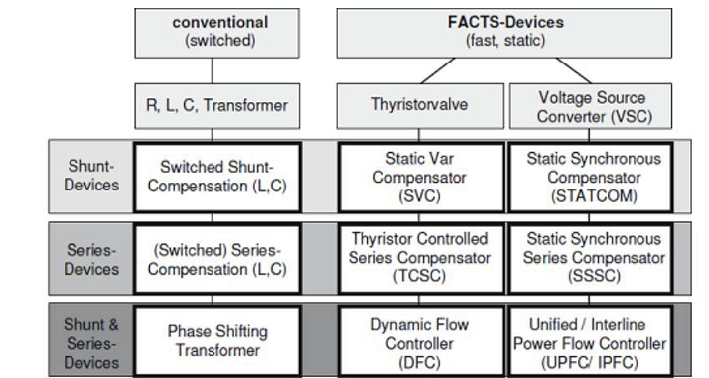

Fig..2. Overview of FACTS devices

IV. VOLTAGE FLICKER

Flicker is a very complicated problem to measure and to resolve. The combination of the following factors is necessary for flicker to be a problem: 1) some divergence in voltage supplying lighting circuits and 2) a person being present to view the probable change in light intensity due to the voltage difference. The human factor significantly complicates the issue and for this reason flicker has historically been deemed "a problem of perception." The voltage deviations involved are often much less than the thresholds of susceptibility for electrical equipment, so major operating problems are only experienced in rare cases. To office personnel, on the other hand, voltage deviations on the order of a few tenths of one percent could produce extremely annoying fluctuations in the output of lights, especially if the frequency of repetitive deviations is 5-15 Hz. Due to the clear relationship between voltage divergence and light response, the term "flicker" often means different things to different people with the interpretation primarily governed by the concerns of a particular discussion.
A. Controlling System
The concept of instantaneous reactive power is used for the controlling system. Following this, the 3-phase voltage upon the use of the park presented by Akagi [20] has been transformed to the synchronous reference frame (Park or dq₀ transformation). This transformation leads to the appearances of three instantaneous space vectors: V_{d} on the d-axis (real or direct axis), V_{q} on the q-axis (imaginary or quadrature axis) and V₀, from the 3-phase voltage of V_{a}, V_{b} and V_{c}. The related equations of this transformation, expressed in the MATLAB software, are as follows:
${ V}_{d}=\frac{2}{3}\left[V_{a}\sin\left(ωt\right)+V_{b}\sin\left(ωt-\frac{2π}{3}\right)+V_{c}\sin\left(ωt+\frac{2π}{3}\right)\right]$ (2)
${ V}_{q}=\frac{2}{3}\left[V_{a}\cos\left(ωt\right)+V_{b}\cos\left(ωt-\frac{2π}{3}\right)+V_{c}\cos\left(ωt+\frac{2π}{3}\right)\right]$ (3)
${ V}_{0}=\frac{1}{3}\left[V_{a}+V_{b}+V_{c}\right]$ (4)
A dynamic computation shows that the voltage oscillations in the connecting node of the flicker generating load to the network are created by 3 vectors: real current (ip), imaginary current (iq) and the derivative of the real current with respect to time dip/dt. In general, for the complete voltage flicker compensation, the compensating current (ic) regarding the currents converted to the dq0 axis is given as [3]:

$i_{c}=j\left(i_{q}+i_{p}\frac{R}{X}f+\frac{1}{ω}\frac{di_{p}}{dω}f+k\right)$(5)
Where R and X are the synchronous resistance and reactance of the line and f is the correcting coefficient. The constant k is also used to eliminate the average reactive power of the network [3]. If the compensation current of the above equation is injected to the network, the whole voltage flicker existing in the network will be eliminated. Regarding the equation, related to the dq-transformation of the 3-phase-voltages to the instantaneous vectors, it is obvious that under the conditions of accessing an average voltage flicker, Vd and V0, the obtained values are close to zero and Vq is a proper value adapting to the voltage oscillation of the network.
V. SIMULATION AND ANALYSIS OF THE RESULTS

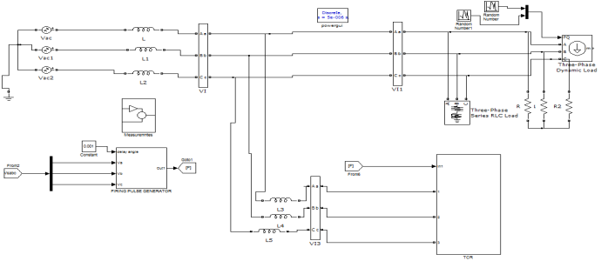

Fig.3. Simulink circuit for FC-TCR
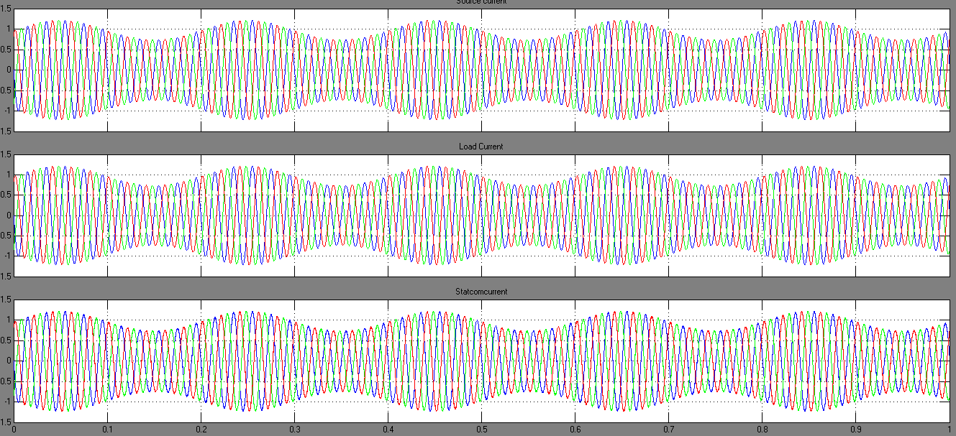

Fig.4. simulation results for (a) source current (b) load current (c) FCTCR current

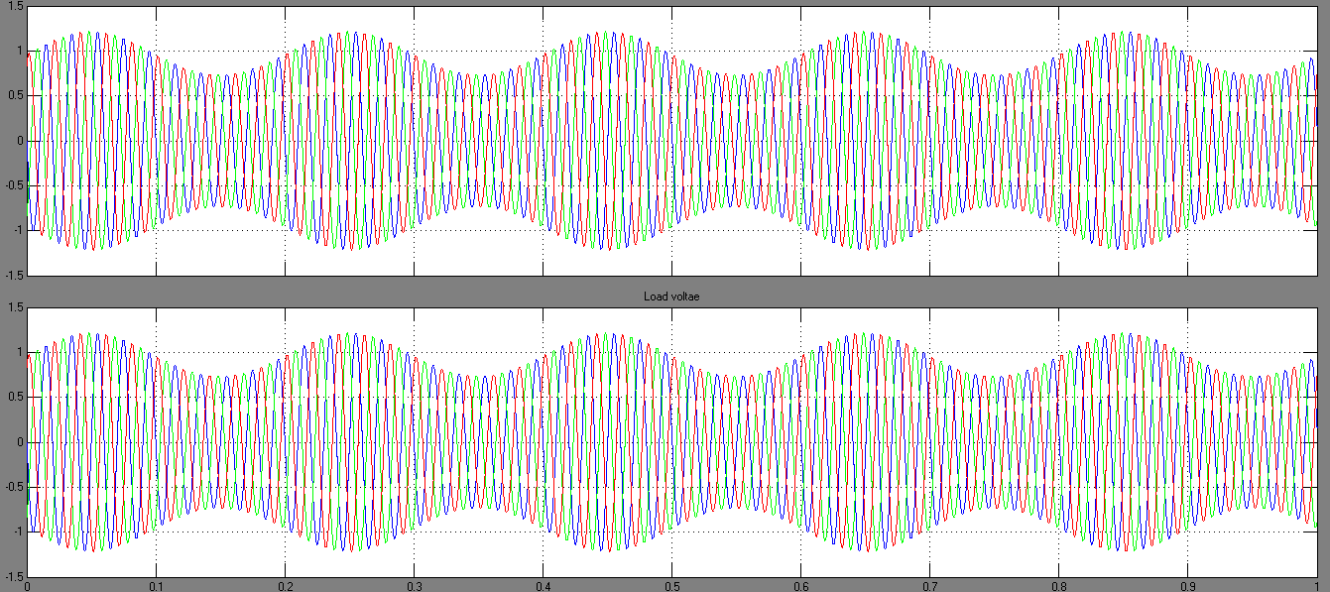

Fig.5. simulation results for (a) source voltage and (b) load voltage by using FCTCR

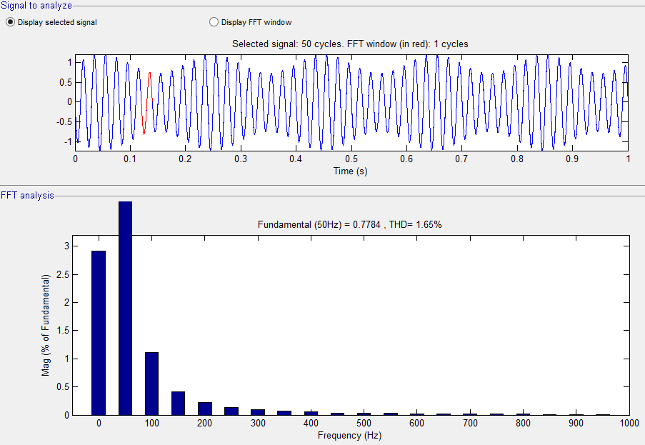
Fig.6. FFT analysis for FCTCR voltage

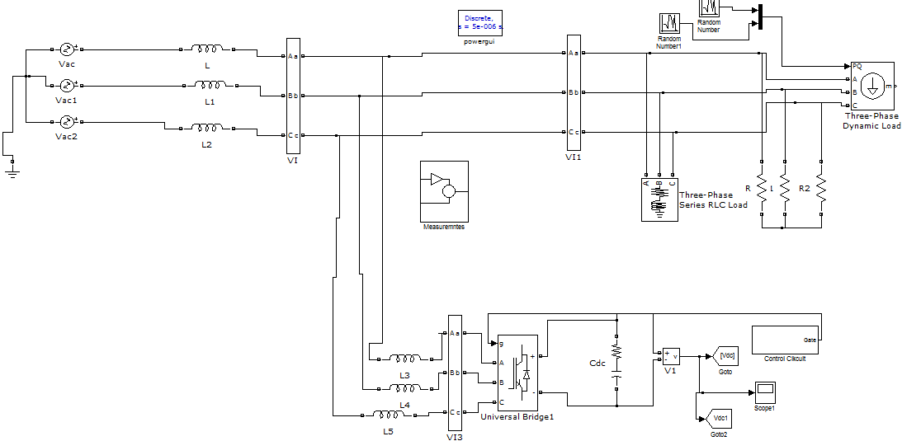

Fig.7. Simulink circuit for STATCOM

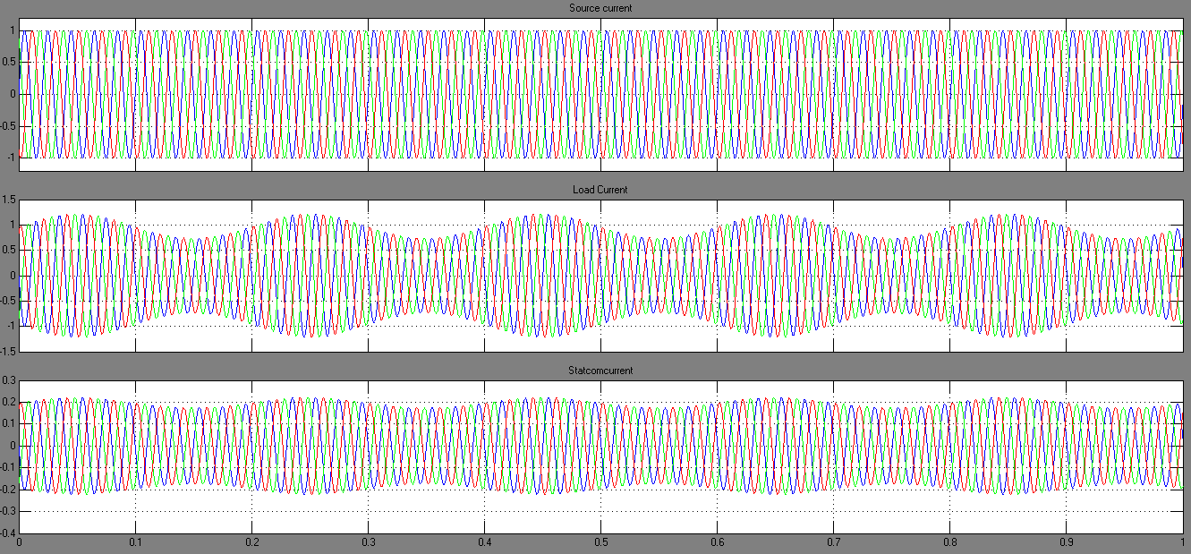

Fig.8. simulation results for (a) source current (b) load current (c) STATCOM current

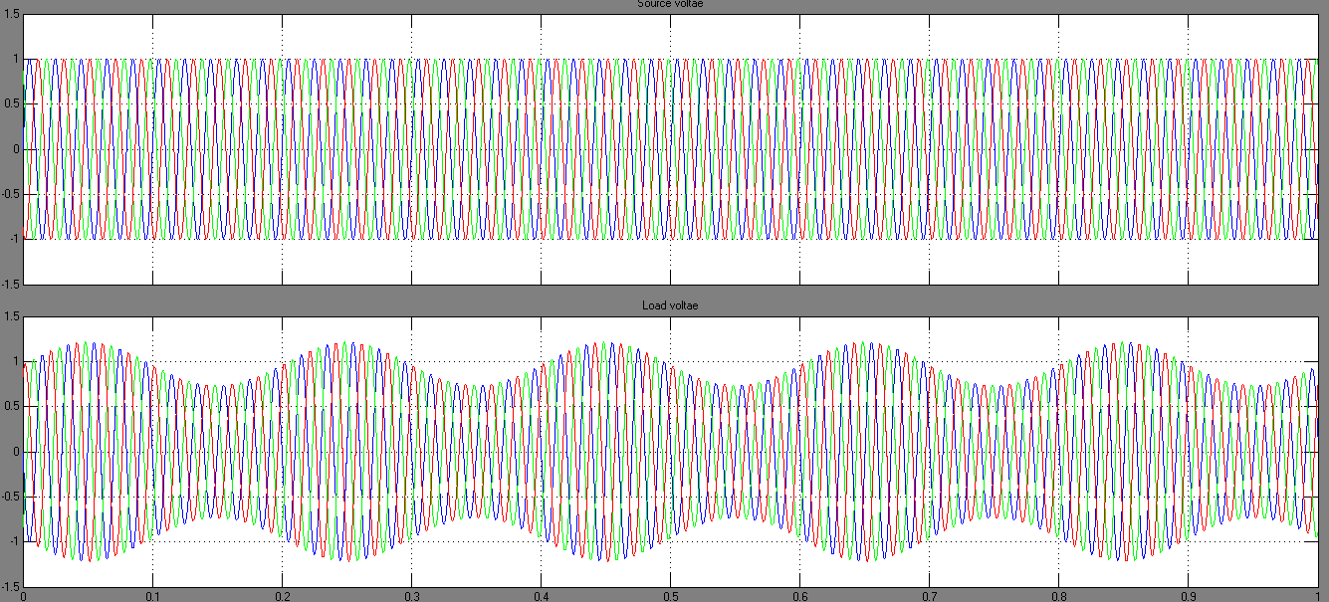

Fig.9.Simulation results for source voltage and current

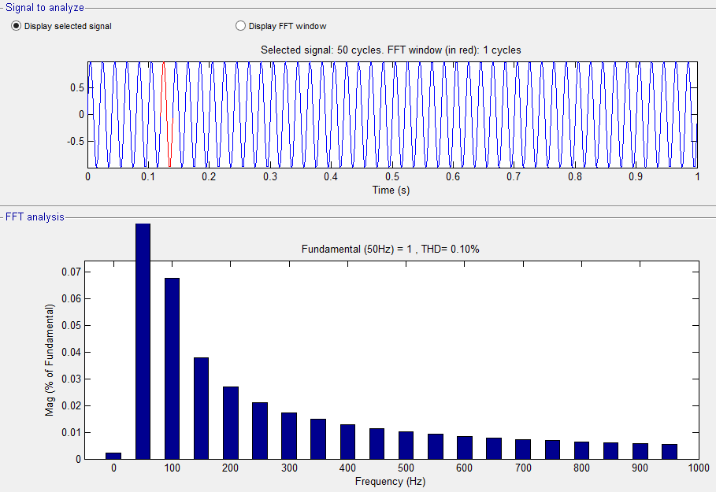

Fig.10. FFT analysis for STATCOM voltage

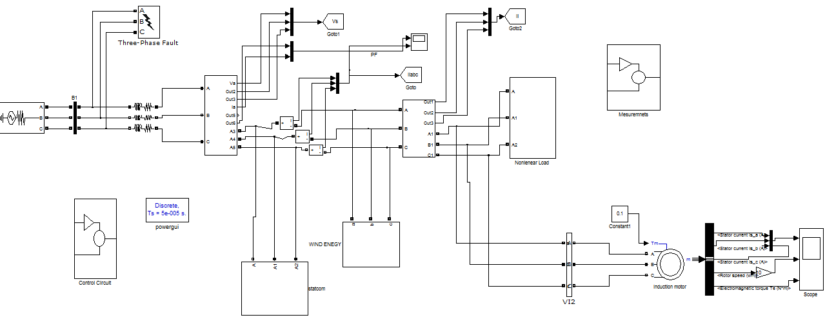

Fig.11. Simulink circuit for STATCOM based induction motor drive and faults

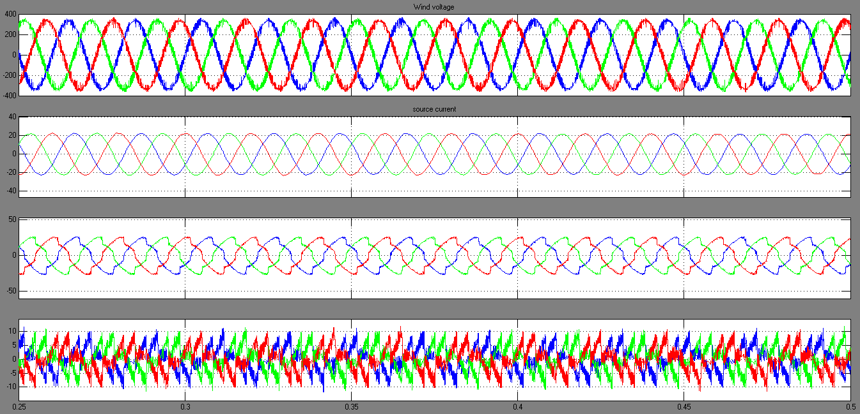

Fig.12. Simulation result source voltage, current, load current and compensated currents

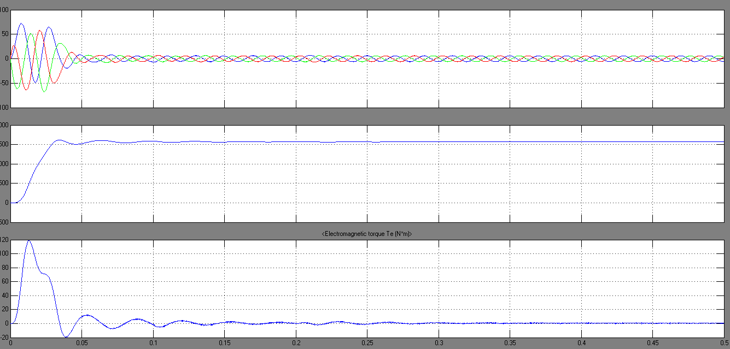

Fig.13. Simulation results for stator currents, speed and torque of induction motor
VI. CONCLUSION
The design and application of STATCOM technology based on voltage-source converters for voltage flicker mitigation is discussed in this paper. Mitigation is done in two stages and the results are compared and contrasted. First, FCTCR is used to compensate for the voltage flicker, then a 6- pulse voltage-source converter STATCOM and finally 8- pulse STATCOM based on voltage-source converter equipped with an RLC filter are designed for complete voltage flicker compensation without harmonics. All the simulated results which have been performed in MATLAB show that a 6-pulse STATCOM is efficiently effective in decreasing the voltage flicker of the generating loads. However, there is injection of the harmonic from STATCOM into the system which can be improved with the increase of the voltage source converters of STATCOM.

REFERENCES

[1] J.Sune, D.Czarkowski, Z.Zabarr, “Voltage Flicker Mitigation UsingPWM-Based Distribution STATCOM”, IEEE Power Engineering Society Summer Meeting, Volume.1, (21-25 July 2002), page no. 616- 621.
[2] Mahmhood Joorabien, Davar Mirabbasi Alireza Sina “Voltage Flicker Compensation usingSTATCOM” ICIEA-2009 page no 2274 – 2279

[3] J.Mckim, "The UIE Flicker-meter Demystified", Hewlett Packard's Power Products Division, 1997.
[4] R.Collantas Bellide, T.Gomz, "Identification &Modeling of a Three Phase Arc Furnace for Voltage Distribution Simulation", IEEE Trans. On PowerDelivery; Volume .12, No.4,1997, pageno. 1812-1817.
[5] L. Tang, S. Kolluri, M.F. Mc Granaghan, "Voltage Flicker Prediction for Two Simultaneously Operated AC Arc Furnaces" IEEE Trans. on Power Delivery; Vol.12, No.2, (1997), pp. 985-991.
[6] M. Zouitii, S. Saadatee, X. Lombard, C. Poumarede, C. Levillain, “Electronic Based Equipment for FlickerMitigation”, Proceedings of International Conference on Harmonics &Quality of Power, Volume.2, (1998), page. 1182-1187.
[7] G.Montanari, M.Loggini, L.Pitti, E.Tironi, D.Zaninelli, “The effects of series inductors for flicker reduction electric power systems supplying arc furnaces”, IEEE Industry Applications Society Annual Meeting, Volume.2, (2-8 Oct. 1993), page no;.1496-1503.
[8] M.Marshall, “singSeries Capacitors to Mitigate Voltage Flicker Problems” IEEE Rural Electric Power Conference, (20-22 April 1997)
[9] Larsson, Poumared, “STATCOM, an efficient means forflicker mitigation” IEEE Power EngineeringSociety Winter Meeting, Volume.2, (Jan-4Feb 1999), pp. 1208-1213.
[10] C.Chen, J. Chuang, T. Hsu, M. Tscng, “Stochastic Voltage Flicker Analysis&Its Mitigation for Steel Industrial PowerSystems”, IEEE Power Tech Proceedings, Volume .1, (10-13 Sept. 2001).
[11] Z. Zhang, N.Fahmi, W.Norris, “Flicker Analysis and Methods for Electric Arc Furnace FlickerMitigation”, IEEE Power Tech Proceedings, Volume .1, (10-13 Sept. 2001).
[12] J.Clouston, J.Gurney, “Field Demonstration of a Distribution Static Compensator Used to Mitigate Voltage Flicker”, IEEE Power Engineering Society

Winter Meeting, Volume.2, (31 Jan-4 Feb 1999), pp. 1138- 1141.
[13] AElnady, W.khattam, A. Salama, “Mitigation of AC Furnace Voltage Flicker Using the UPQC”, IEEE Power Engineering Society Winter Meeting, Vol.2, (27-31 Jan. 2002), pp. 735-739.

