ANALYSIS AND CONTROL OF RENEWABLE POWER SOURCES INTEGRATION BY USING DC MICROGRID
*P.APARNA, ** K.RAJENDER
*PG Scholar, Krishna chaitanya institute of technology & sciences, Markapur, Prakasam, Andhra Pradesh.
**Assistant professor , Krishna chaitanya institute of technology & sciences, Markapur, Prakasam, Andhra Pradesh

ABSTRACT
This venture proposes an incorporated breeze and wave control age framework nourished to an air conditioner control network or associated with a secluded load utilizing a dc microgrid. A bidirectional dc/dc converter is proposed to accomplish the mix of both breeze and wave control age frameworks with vulnerability and discontinuous attributes. The breeze control age framework mimicked by a changeless magnet synchronous generator (PMSG) driven by a breeze turbine (WT) is associated with the dc microgrid through a VSC of PMSG. The wave control age framework mimicked by a LPMG driven by a straight perpetual magnet engine (LPMM) is likewise associated with the dc microgrid through a VSC of LPMG. Established breeze vitality transformation frameworks are typically inactive generators. The created control does not rely upon the framework prerequisite but rather altogether on the fluctuant wind condition. Include coupled breeze/hydrogen/supercapacitor mixture control framework is considered in this venture. The motivation behind the control framework is to arrange these diverse sources, especially their energy trade, keeping in mind the end goal to make controllable the produced control. Therefore, a dynamic breeze generator can be worked to give somewhere in the range of a helper administrations to the matrix. The control framework ought to be adjusted to coordinate the power administration methodologies. Two power administration methodologies are exhibited and thought about tentatively.

1.INTRODUCTION
In recent years, renewable energy and distributed generationsystems (DGSs) have attracted increasing attention and havebeen extensively researched and developed. They graduallyalter the concepts and operations of conventional power generationsystems. The rise in several countries makes it possiblethat this kind of DGS can be practically applied to a grid-tiedsystem or an isolated system with wind power, solar energy, hydropower,etc. The output of DGS usually includes two kinds:dc and variable ac. Moreover, the generating capacity of DGScomparing with conventional large synchronous generators is much smaller, and hence, the dc microgrid can be practicallyapplied to convert the generated time-varying quantities ofnatural renewable energy and DGS into smooth dc electricitythat can then be converted back into ac quantities deliveredto other power systems.How can we increase the amount of photovoltaic (PV) generation? From this viewpoint, we are overviewing electric facilities from power plants to electric appliances in demand sites. PV modules generate DC electric power. The power should be converted to AC that is synchronized with commercial grids to be transmitted and distributed to demand sites. To reduce energy dissipation through the transmission, the power is sent near the demand site after being raised the electric voltage to 66 kV or higher. The power is transformed to 100 V and provided to residential outlets after multi-processed reduction in voltage at substations and pole-mounted transformers. Therefore, we should consider how we can establish efficient transmission and distribution systems for PV generation in addition to cost, efficiency and lifetime for generation facilities, if we utilize the power source as infrastructure. Transmission facilities for PV generation often stay idle as well as generation facilities themselves, because they do not yield electricity during night and poor weather. If contribution from solar power were much smaller than transfer capability, existing facilities could take care of it. To understand this problem easily, we assume a huge PV farm comparable to a nuclear power plant with a giga wattage class output. PV generation, which has poor yield for its footprint, needs vast ground to generate such a big power. Consequently, the generation facilities must be set up in sites far from consuming regions.Transmission facilities must have enough largebe applied across the cell, therefore they present two double-layers, one at each electrode/electrolyte interface. An ion-permeable separator is placed between the electrodes in order to prevent electrical contact, but still allows ions from the electrolyte to pass through. capacity for maximum current which can be generated under the best weather condition. They do not work during off-generating time such as at night and under poor sunshine. If PV plants supplied constant huge power as dam type hydraulic or nuclear plants, we would make choice of a far-reaching transmission system that connects distant sources and a consuming center.Electric power storage devices, such as batteries, can absorb fluctuation of PV generation and equalize power transmission. However, this scheme reduces capacity of transmission facilities and requires rather huge additional cost for the huge accumulators. Therefore, until drastically reduced cost is available for storage devices, we cannot adopt this method. Then, put gas turbines together, with which we are able to adjust

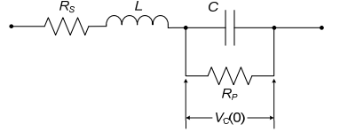
Fig 1.1First order cicuit super –capacitor model
In order to simulate a hybrid ac/dc microgridsystem,photovoltaic and wind power generator models, a doubly fedinduction generator model, and an inverter model were establishedto simulate the dynamic responses of the studied system. Even though three phase ac power systems have existed for over 100 years due to their efficient transformation of ac power at different voltage levels, keeping in mind the environmental issues such as global warming, pollution, depletion of fossil fuels time had come to concentrate on renewable to concentrate on renewable sources of energy. More and more dc loads such as light-emitting diode (LED) lights and electric vehicles (EVs) are connected to ac power systems to save energy and reduce CO2 emission. When power can be fully supplied by local renewable power sources, long distance high voltage transmission is no longer necessary.
A hybrid AC/DC micro grid has been proposed to facilitate the connection of renewable power sources to conventional ac systems. However, dc power from the renewable photovoltaic (PV) panels or fuel cells has to be converted into ac using dc/dc boosters and dc/ac inverters in order to connect to an ac grid. In an ac grid, embedded ac/dc and dc/dc converters are required for various home and office facilities to supply different dc voltages. AC/DC/AC converters are commonly used as drives in order to control the speed of ac motors in industrial plants.

A practical low-voltage bipolar-type dc microgridwasconstructed using a gas engine as the power source, while abidirectional dc/dc converter shunting a super-capacitor was utilizedas an energy storage device to balance the power demandof the studied system. Most microgrids adopt ac distribution as well as conventional power systems. In this case, dc output type sources, such as photovoltaic (PV) system, fuel cell, and energy storages (e.g., Li-ion secondary battery and super capacitor) need inverters. In addition, some gas engine cogenerations (GECs) and wind turbines also need inverters because the output voltages and the frequencies are different from those of the utility grids. Therefore, dc distribution-type microgrids (dc microgrids) were also proposed and researched in order to reduce conversion losses from the sources to loads.
2.DC MICROGRID
2.1. PURPOSE AND ARCHITECTURE OF THE DC MICRO GRID SYSTEM
Following three terms are briefly summarized purposes of the DC micro grid system.
(1) Increase the introduction of distributedPV units.
(2) Reduce energy dissipation and facility costs resulting from AC/DC conversion by integrating the junction between a commercial grid and DC bus which connects PV units and accumulators.
(3) Supply power to loads via regular distribution lines (not exclusive lines for emergency) even during the blackout of commercial grids.
Figure 2.1 shows a schematic view of the DC micro grid system. This system utilizes a DC bus as its backbone and distributes power to a community that consists of several dozens or a hundred of households in a residential area. A 350 V DC bus is installed instead of 200 V / 100 V lines in conventional AC distribution
systems and connected with a high voltage commercial grid through the intermediary of a bidirectional AC/DC converter.Allthe PV units in the community are linked with the DC bus through DC/DC converters.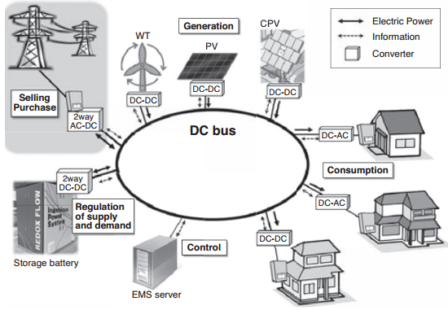
Fig.2.1: Schematic diagram of a DC micro grid system
These converters always track the maximum power point of the DC power sources which fluctuates depending on the intensity of solar radiation. Conventional appliances can be used as they are if an inverter is installed in each house to change the DC power into 200 V / 100 V AC power, but DC power feeding will spread widely because of its high efficiency, once safe and compact gears, such as breakers and outlets, are standardized in the future. Storage batteries of the community are also linked to the DC bus. The DC-based distribution system reduces facility costs and energy dissipation associated with AC/DC conversion because the PV units and battery are DC connected and most of the current energy-saving appliances operate on DC due to the progress of inverter technology. This is why we should push ahead with the DC system.The system doesn’t require long transmission lines to convey solar power from remote areas because the PV units have been distributed in the demand area. Power sources and loads are closely located to each other in a community. The excess and deficiency of power are variable factors which should be compensated for a good balance between supply and demand. The compensation

system, which consists of storage batteries and a bidirectional power converter, keeps a good power balance in the community by absorbing short term power fluctuations. Since long term fluctuations, such as those between day and night, are also smoothed by the battery system, the micro grid system seems to be a small source or load for the outer wide-area grid. Consequently,this scheme reduces the cost for the stabilization of commercial grids.
The state of charge (SOC) of the storage battery always indicates the time integral of difference between supply and demand in the DC micro grid system. The SOC becomes full with excess power, whereas it reaches the lower limit in deficiency. The amount and direction of the power flow from a commercial grid is controlled according to the SOC, and power supply is maintained in the micro grid. However, power supply to the micro grid might be regulated to stabilize the power flow of the commercial grid. Therefore, information about the situation of the commercial grid is essential for the operation of the micro grid system.
3.SYSTEM CONFIGURATION
Fig3.1 shows the configuration of the studied integrated windand wave power generation system connected to an acgridthrough a dcmicrogrid. The wind power generation system simulatedby a permanent-magnet synchronous generator (PMSG)driven by a wind turbine (WT) is connected to the dc microgridthrough a VSC of VSC_PMSG. The wave power generation system simulated by an LPMG driven by a linear permanentmagnetmotor (LPMM) is also connected to the dc microgridthrough a VSC of VSC_LPMG. A resistive dc load R_{Load}isconnected to the dc microgrid through a load dc/dc converter.
To achieve stable power flow (or power balance condition)and load demand control of the dc microgrid under differentoperating
conditions, a battery is connected to the dc microgridthrough a bidirectional dc/dc converter, while an ac grid isconnected to the dc microgrid through a bidirectional grid-tiedinverter and a transmission line. When available wind powerand/or wave power can be injected into the dc microgrid with afully charged battery, the surplus power of the dc microgridcanbe delivered to the ac grid through the bidirectional grid-tiedinverter. When no wind power or no wave power is deliveredto the dc microgrid with a low-energy battery, the insufficientpower of the dc microgrid can be captured from the ac gridthrough the bidirectional grid-tied inverter. The power of theresistive dc load R_{Load} can be obtained from the dc microgridthrough the load dc/dc converter only when the dc microgridhas enough power. The load dc/dc converter with the resistivedc load R_{Load} can also slightly adjust the power balancecondition of the dc microgrid. The control functions of the bidirectionaldc/dc converter, the bidirectional grid-tied inverter,and the load dc/dc converter must be adequately coordinatedwith each other to obtain stable operation of the dc microgrid.
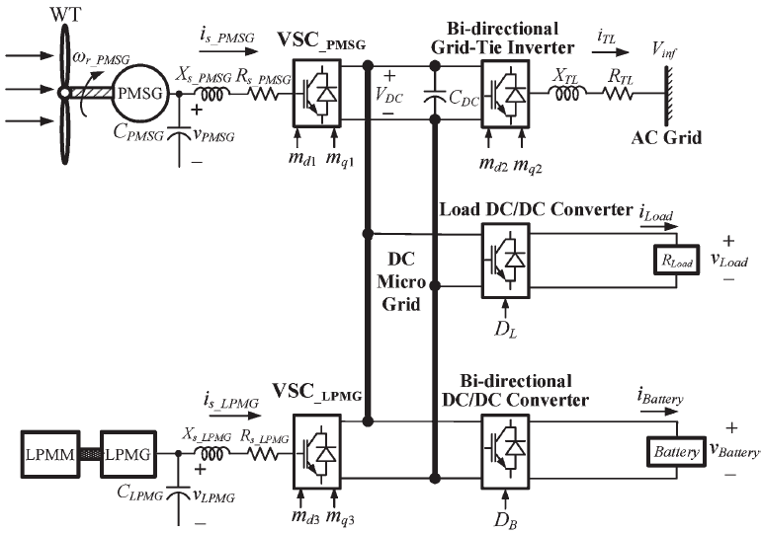
Fig3.1: Configuration of the studied integrated wind and wave power generation system connected to a power grid through the proposed dc microgrid.

3.1 PMSG BASED WIND ENERGY GENERATION SYSTEM
3.1.1INTRODUCTION
Over the last years, with technological advancement, wind power has grown rapidly and becomes themost competitive form of renewable energy. Furthermore, Variable Speed Wind Energy ConversionSystems (VS-WECS) are the dominant technologies in the present wind power industry for the reasonthat they possess several advantages, over the fixed velocity systems, as the ability to obtain MaximumPower Point Tracking (MPPT) control methodology in order to extract maximum power at different wind,higheroverall efficiency, power quality and it can be controlled to reduce aerodynamic noise andmechanical stress on VS-WECS by absorbing the wind-power fluctuations.
3.2 SYSTEM MODELING
3.2.1WIND TURBINE CHARACTERISTICS
A Wind Turbine (WT) cannot fully capture wind energy. Then, the output power of the wind-turbineis described as:
$$P_{turbine}= \frac{1}{2}{ρπR}^{2}C_{p}(λ,β)v^{3}$$
where, ρ is the air density ( kg/m3 ), R is the blade radius (m), CP is the performance coefficient of theturbine which is a function of the pitch angle of rotor blades β ( in degrees ) and v is the wind speed (inm/s). The tip-speed ratio λ is given by:
$$λ=\frac{w_{m}R}{v}$$
where R and $w_{m}$ are the blade length (in m) and the wind turbine rotor speed (in rad/sec), respectively.The wind turbine mechanical torque output Tm given as:

$$T_{m}=\frac{1}{2}ρAC_{p}\left(λ,β\right)v^{3}\left(\frac{1}{w_{m}}\right)$$
A generic equation is used to model the coefficient of power conversion $C_{p}$(λ, β) based on the modelling turbine characteristics described as:
$$C_{p}=\frac{1}{2}\left(\frac{116}{λ_{i}}-0.4β-5\right)e^{-\left(\frac{21}{λ_{i}}\right)}$$
$$\frac{1}{λ_{i}}=\frac{1}{λ+0.08β}- \frac{0.035}{β^{3}+1}$$
The coefficient of power conversion and the power are maximums at a certain value of tip speed ratiocalled optimum tip speed ratioλopt. Therefore, the maximum value of${ C}_{p}$(λ,β), that ismax$C_{p}$ = 0.41, isachieved for λopt = 8.1 and for β =$0^{0}$. Besides, any change in the wind velocity or the generator speedinduces change in the tip speed ratio leading to power coefficient variation. Consequently, the extractedpower is affected. This power is maximized at the particular rotational speed for various winds and it isobligatory to keep the PMSG speed at an optimum value of the tip speed ratio, λopt. Accordingly, thesystem can operate at the peak of the P($w_{m}$)curve when the wind speed changes and the maximumpower is extracted continuously from the wind (MPPT control). That is shown in Fig.3.2
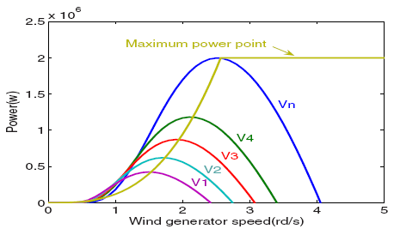
Fig.3.2. Wind generator power curves at various wind speed
4.PROPOSED CONTROLLER
4.1 PI Notch Filter
In order to inject into the controller grid, the same amount of energy that is being extracted from the wind, a power balance is performed in the system through the dc-link voltage. The dc-link voltage, vdc, is set to a fixed reference value, vdc, that can only be kept constant by injecting the appropriate amount of current to the grid, ig. The dc-link voltage is controlled with a PI controlleraugmented with a notch filter shown below equation.

wherekpis the proportional gain, and kiis the integral gain, ξzand ξpare the damping coefficients of the notch filter zeros and poles, respectively, and ωnis the central frequency of the filter. It is noted that the controller gains are different to the PI controllers already described.
The notch filter is used to prevent the controller from rejecting the necessary dc voltage oscillation required to absorb the instantaneous power difference between a three-phase system, the PMSG, and a single-phase grid connection. Otherwise this oscillation would be translated to the controller output which is the RMS grid current command, i∗RMS . The controller has been tuned to achieve a closed-loop bandwidth of 40 Hz with the notch filter providing −20 dB of attenuation at 100 Hz (i.e., single-phase instantaneous power pulsation).
4.2.RESONANTCONTROLLER
In order to achieve unity power factor, the RMS grid current command, iRMS , is synchronized with the grid voltage using a synchronous phase-locked loop (PLL) algorithm [31], The instantaneous grid current command, ig, is injected into the grid by means of the H-bridge inverter, controlled by a proportional-resonant (PR) controller.

wherekpand krare the proportional and resonant gains, respectively, and ωris the resonant frequency. The proportional gain has a different value than the controllers previously described. This type of controller ensures zero tracking error at the resonant frequency which is set to the grid frequency. The controller has been tuned to achieve a closed-loop bandwidth of 500 Hz, a worst-case disturbance rejection frequency response of −30 dB, and a resonant frequency of 50 Hz.

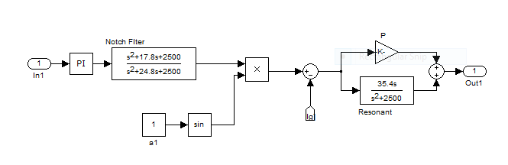
5.SIMULATION RESULTS

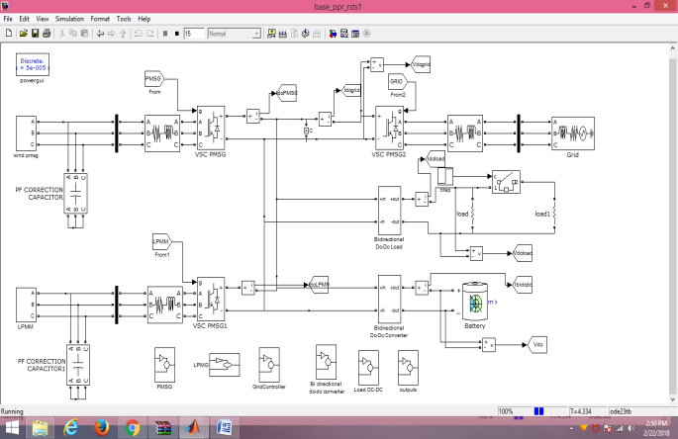
Fig.5.1 SIMULATION DIAGRAM
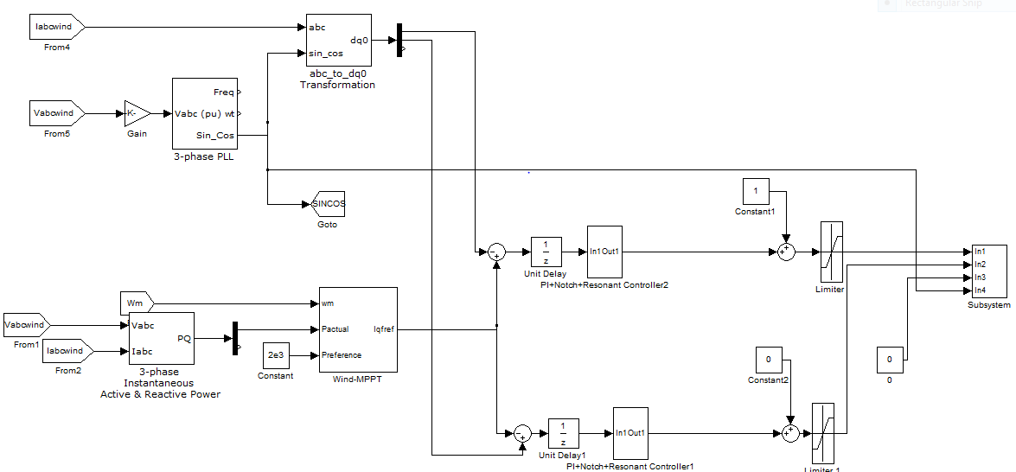
Fig.5.2 SIMULATION PROPOSED CONTROL DIAGRAM FOR PMSG
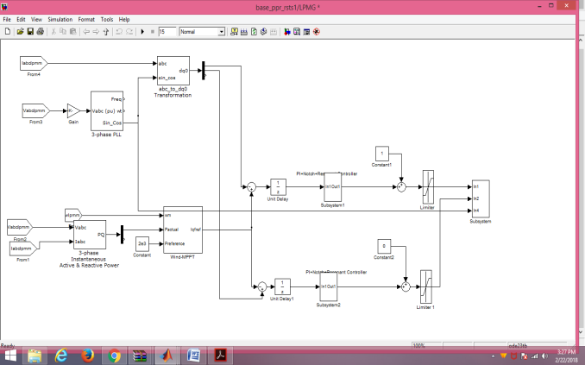
Fig.5.3 SIMULATION PROPOSED CONTROL DIAGRAM FOR LPMG
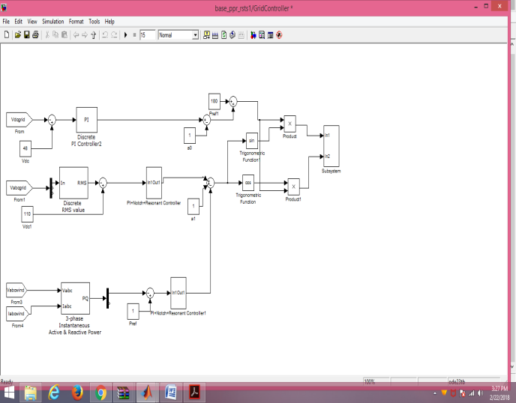
Fig.5.4 SIMULATION PROPOSED CONTROL DIAGRAM FOR GRID CONVERTER
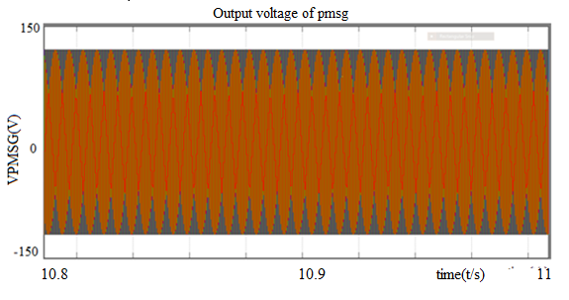
Fig.5.5(a) OUTPUT VOLTAGE OF PMSG

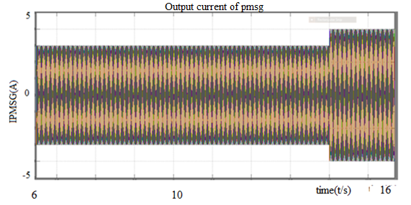
Fig 5.5(b) OUTPUT CURRENT OF PMSG
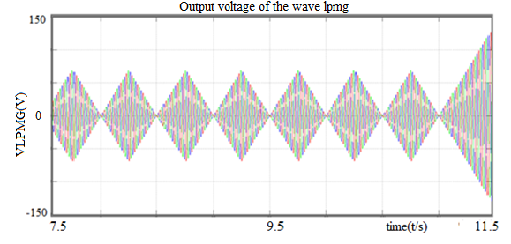
Fig 5.5(c) OUTPUT VOLTAGE OF THE WAVE LPMG
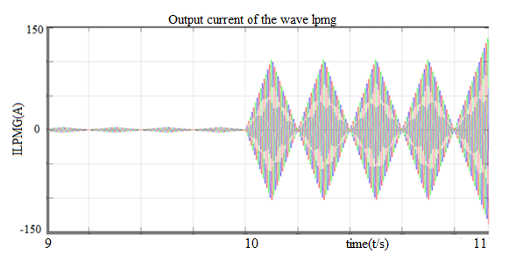
Fig.5.5(d) OUTPUT CURRENT OF THE WAVE LPMG
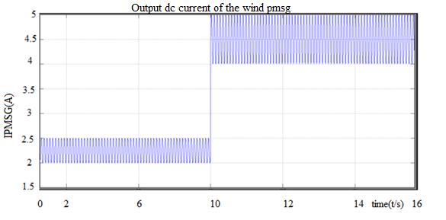
Fig 5.5(e).OUTPUT DC CURRENT OF THE WIND PMSG
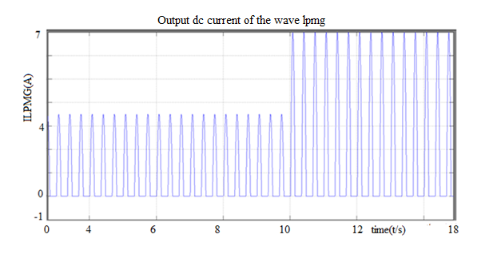
Fig5.5(f) OUTPUT DC CURRENT OF THE WAVE LPMG
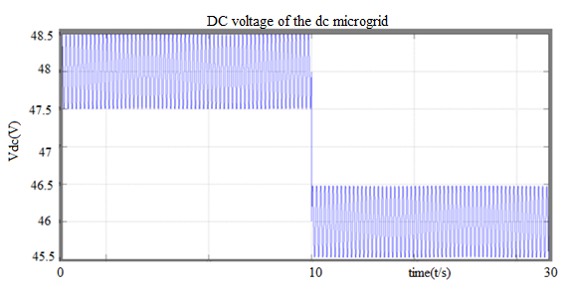
Fig 5.5(g) DC VOLTAGE OF THE DC MICROGRID
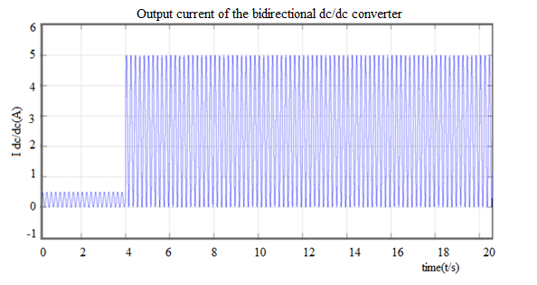
Fig5.5(h) OUTPUT CURRENT OF THE BIDIRECTIONAL DC/DC CONVERTER
6.CONCLUSION
An integration of both wind power and wave power generationsystems joined with a dc microgrid has been proposed. Alaboratory-grade test system has been presented in this project to examine the fundamental operating characteristics of thestudied integrated system fed to isolated loads using a dcmicrogrid. For simulation parts, the results of the root-
lociplot and the time-domain responses have revealed that thestudied integrated system with the proposed dc microgrid canmaintain stable operation under a sudden load-switching condition.Comparative simulated and measured results under a loadswitching have been performeda dc-coupled HPS has been studied with thethree kinds of energy sources: 1) WG as a renewable energygeneration system; 2) SCs as a fast-dynamic energy storagesystem; and 3) FCs with ELs and hydrogen tank as a longtermenergy storage system. The structure of the control systemis divided into three levels: 1) SCU; 2) ACU; and 3) PCU.Two power-balancing strategies have been presented and comparedfor the PCU: the grid-following strategy and the sourcefollowingstrategy. For both of them, the dc-bus voltage andthe grid power can be well regulated.
7.REFERENCES
[1] Y. Ito, Y. Zhongqing, and H. Akagi, “DC microgrid based distributionpowergeneration system,” in Proc. 4th IEEE Int. Power Electron. MotionControl Conf., 2004, vol. 3, pp. 1740–1745.
[2] S. K. Kim, J. H. Jeon, C. H. Cho, J. B. Ahn, and S. H. Kwon, “Dynamicmodeling and control of a grid-connected hybrid generation system withversatile power transfer,” IEEE Trans. Ind. Electron., vol. 55, no. 4,pp. 1677–1688, Apr. 2008.
[3] C. Abbey and G. Joos, “Supercapacitor energy storage for wind energyapplications,” IEEE Trans. Ind. Appl., vol. 43, no. 3, pp. 769–776,May 2007.
[4] X. Liu, P. Wang, and P. C. Loh, “A hybrid ac/dc microgrid and its coordinationcontrol,” IEEE Trans. Smart Grid, vol. 2, no. 2, pp. 278–286,Jun. 2011.
[5] H. Kakigano, Y. Miura, and T. Ise, “Low-voltage bipolar-type dc microgridfor super high quality distribution,” IEEE Trans. Power

Electron.,vol. 25, no. 12, pp. 3066–3075, Dec. 2010.
[6] M. G. D. S. Prado, F. Gardner, M. Damen, and H. Polinder, “Modeling andtest results of the Archimedes wave swing,” J. Power Energy, vol. 220,no. 8, pp. 855–868, Dec. 2006.
[7] B. Das and B. C. Pal, “Voltage control performance of AWS connected forgrid operation,” IEEE Trans. Energy Convers., vol. 21, no. 2, pp. 353–361,Jun. 2006.
[8] E. Tara et al., “Dynamic average-value modeling of hybrid-electric vehicularpower systems,” IEEE Trans. Power Del., vol. 27, no. 1, pp. 430–438,Jan. 2012.
[9] H. L. Do, “Nonisolated bidirectional zero-voltage-switching dc–dc converter,”IEEE Trans. Power Electron., vol. 26, no. 9, pp. 2563–2569,Sep. 2011.
[10] D. Salomonsson, L. Söder, and A. Sannino, “An adaptive control systemfor a dc microgrid for data centers,” IEEE Trans. Ind. Appl., vol. 44, no. 6,pp. 1910–1917, Nov./Dec. 2008.
[11] M. Lebbal, T. Zhou, B. Francois, and S. Lecoeuche, “Dynamically electrical
modelling of electrolyzer and hydrogen production regulation,” inProc. Int. Hydrogen Energy Congr. Exhib., Istanbul, Turkey, Jul. 2007.
[12] R. M. Dell and D. A. J. Rand, “Energy storage—A key technology forglobal energy sustainability,” Power Sources, vol. 100, no. 1/2, pp. 2–17,Nov. 2001.
[13] B. D. Shakyaa, L. Ayea, and P. Musgraveb, “Technical feasibility andfinancial analysis of hybrid wind–photovoltaic system with hydrogen storageforCooma,” Hydro. Energy, vol. 30, no. 1, pp. 9–20, Jan. 2005.
[14] O. Gabriel, C. Saudemont, B. Robyns, and M. M. Radulescu, “Control andperformance evaluation of a flywheel energy-storage system associatedto a variable-speed wind generator,” IEEE Trans. Ind. Electron, vol. 53,no. 4, pp. 1074–1085, Aug. 2006.
[15] R. Cardenas et al., “Control strategies for power smoothing using a flywheeldriven by a sensorless vector-controlled induction machine operatingin a wide speed range,” IEEE Trans. Ind. Electron., vol. 51, no. 3,pp. 603–614, Jun. 2004.
[16] P. Li, P. Degobert, B. Robyns, and B. Francois, “Participation in thefrequency regulation control of a resilient microgrid for a distributionnetwork,” Int. J. Integr. Energy Syst., vol. 1, no. 1, Jan. 2009.

