AN EFFICIENT WIDE BAND MM-AND SUB-MM-WAVE DIELECTRIC ROD WAVEGUIDE ANTENNA
*KIRAN.K, **K.YAMUNA
*PG Scholar, Department of ECE, KLR Engineering College, Palvancha, Telangana.
**Associate professor, Department of ECE, KLR Engineering College, Palvancha, Telangana.
ABSTRACT

The design of a dielectric bar waveguide (DRW) recieving wire for frequencies of 75– 325 GHz is exhibited. The ideal broadband recieving wire geometry is resolved utilizing numerical reproductions. A solitary DRW recieving wire is coordinated with metal waveguides of various sizes for various recurrence groups. Estimation comes about concur extremely well with the recreation comes about up to 325 GHz; the pick up of the recieving wire remains almost steady ( dB) over the entire recurrence extend measured from 75 to 325 GHz (160% relative data transmission). As far as possible is because of our constrained assembling capacity to create sharp radio wire tips. The arrival loss of the radio wire is superior to 15 dB.The radiation designs are almost free of recurrence. The 3 dB pillar width is 50 – 60 , and the 10 dB bar width is around 95 . This demonstrates the gap size of this end-fire radio wire diminishes as a component of recurrence, and this perception concurs well with the prior perception that the stage focal point of a DRW reception apparatus moves towards the recieving wire tip as an element of recurrence. Likewise the cross polarization was contemplated. The cross-polarization level is superior to 15 dB by any means frequencies.
Index Terms Antenna, dielectric rod waveguide, millimeter (mm) waves, sub millimeter (sub-mm) waves, THz waves.

I. INTRODUCTION

RESEARCH and improvement of coordinated circuits for frequencies of 0.1– 1 THz is a standout amongst the most difficult fields of radio building. THz recurrence frameworks are discovering enthusiasm for wideband interchanges, imaging frameworks, material spectroscopy, medicinal treatment, impact evasion radars and different applications, in spite of the issues in innovation and higher cost of parts contrasted and those of traditional microwave frameworks [1]. Dielectric bar waveguides (DRWs) are extremely encouraging transmission lines, when low misfortune dielectric materials are utilized. They can be joined with semiconductor gadgets (oscillators, locators, blenders, and so on.) in the half breed or potentially solid coordinated circuits and furthermore utilized as recieving

wires. These advancements offer another open door for latent and dynamic segment execution, permitting to diminish the inclusion misfortune and to expand the operational recurrence to 1 THz [2], [3]. As of late a few gadgets Manuscript got April 28, 2014; amended June 09, 2014, July 15, 2014; acknowledged July 15, 2014. Date of distribution August 11, 2014; date of current adaptation August 22, 2014. This work was bolstered by the Academy of Finland through the Academy Fellow Program and SMARAD Center of Excellence, and Graduate School in Electronics, Telecommunications and Automation. This work was done in the casing of the European activity on centering recieving wire frameworks bolstered by the ESF RNP New concentrate and EurAAP working gathering on Focusing frameworks.

In view of DRW were accounted for, for example, directional coupler [4], stage shifter [5], intensifier [6] and control sensor [3]. Furthermore, a DRW radio wire will be all the more effortlessly combined with future semiconductor THz sources than traditional recieving wires [7], and because of the little size of the reception apparatus it is less demanding to coordinate it into clusters with little dispersing between the components. Spread of modes in round DRW can be computed logically [8], however DRW with rectangular cross-segment can be portrayed just with rough techniques, for example, Marcatili's [9] or Goell's [10]. The distinction between the strategies is that Goell's approach is more precise while Marcatili's approach is less demanding to apply yet more surmised. The coveted mode in a rectangular DRW is a half breed mode [8]– [10]. is the overwhelming electric field part of the mode, and different segments are , and keeping in mind that and are immaterial. Computations help to gauge the ideal cross area of a rectangular DRW which can work in the single mode administration in the given recurrence go. The ideal cross segments for high permittivity silicon or GaAs DRW are 1.0 mm 0.5 mm for 75– 110 GHz run, 0.60 mm 0.30 mm for 110– 150 GHz run, and 0.30 mm 0.15 mm for 220– 325 GHz run [11]– [13].

The DRW radio wires can be energized from a rectangular metal waveguides, however the vital preferred standpoint of DRW is the likelihood of coordinating semiconductor gadgets into DRW, henceforth the DRW can be utilized to manage the radiation from other semiconductor sources, e.g., photograph blenders [7]. DRWcan be likewise combined with other printed radio wires, e.g., a ring opening [14]. By the kind of radiation DRW radio wires can be partitioned into two gatherings: end-fire reception apparatuses and broken wave recieving wires. Defective wave

DR Wantennas have intermittent discontinuities, which make vitality spill from the recieving wire [15]. The point of radiation from these recieving wires relies upon recurrence and they don't emanate to the drag locate bearing. The end-fire DRW reception apparatus, then again, emanates to the drag locate heading and its radiation design is practically free on recurrence [12]. Our present work considers DRW end-fire reception apparatuses utilizing rectangular metal waveguides for excitation.To be coordinated with a metal rectangular waveguide a DRW ought to have a coordinating decrease. DRW made of low permittivity materials as a rule have a similar cross area measurements as the rectangular metal waveguide and furthermore require structures, for example, a starting horn to diminish the misfortunes on the move [16]. In any case, it was demonstrated that high permittivity decreased DRWcan be coordinated with a rectangular metal waveguide with no extra structures [11], [17], [18]. The central method of the metal waveguide energizes the mode in the high-permittivity DRW, giving great coordinating and transmission.

II. ANTENNA DESIGN

The radio wire was outlined utilizing Ansoft HFSS programming utilizing the parameters of high-resistivity GaAs with and . In any case, the recieving wire can be produced using other low-misfortune, high-permittivity dielectrics, for example, silicon or sapphire. The greatest cross-segment of the reception apparatus is 1.0 mm 0.5 mm and it can be coordinated with various rectangular metal wave guides A schematic correlation between recieving wire under investigation and radio wire with cross area of 0.3 mm 0.15 mm intended for 220– 325 GHz extend and coordinated withWR-03metal waveguide is appeared in Fig. 2. As opposed to past investigations where the coordinating decrease of the recieving wire was completely
embedded into the waveguide [12], [13], here just the tip of the radio wire coordinating decrease is embedded into a waveguide of relating size. Coordinating of the reception apparatus with a metal waveguide relies upon the decreasing length. It was appeared in [11] that the reflection is lessened altogether as the decreasing length is expanded to more than 6 mm bringing about superior to dB. Along these lines the length of the coordinating decreasing is been 8 mm. It was appeared in [2] that as the radiation decreasing length increments, the side projections wind up plainly littler and the radiation design progresses toward becoming smaller, which concur with past perceptions [19]. Be that as it may, it is hard to make the recieving wires with long decreasing since the tip ends up plainly delicate. Subsequently, 15 mm decreasing length is by all accounts ideal.
The reenacted electrical field thickness circulations in the progress from metal WR-03 waveguide to a DRW radio wire and at the radiation decreasing are appeared in Figs. 3 and 4 at 300 GHz. The wave engenders from the metal waveguide to DRW and does not transmit assist beyond all detectable inhibitions space. In this manner it demonstrates that the radio wire can be coordinated with metal waveguides of various sizes without utilizing any changes. The DRW is curiously large, yet that does not influence the radiation or coordinating. inside the DRW for the instance of the radio wire under investigation with most extreme cross segment of 1.0 mm 0.5 mm and for the upgraded reception apparatus with cross area of 0.3 mm 0.15 mm which is intended to
work in a solitary mode administration [13]. It can be seen, that at (most extreme cross area) the electric field circulation is more extensive for the reception apparatus under examination, in any case it has just a single greatest in both - and - bearings. Moving along the decreasing the field turns out to be more gathered in the bar, and at mm, when the - measurement of the
two reception apparatuses agree, the field circulation in the – course is practically the same for the two recieving wires. The - measurement of the reception apparatus under examination is consistent, consequently the state of the field conveyance in the - bearing does not change along the bar and is more extensive than the field dissemination of the antenna with smaller cross section
III. ANTENNA MANUFACTURE
The antenna was made utilizing a dicing saw with a precious stone cutting edge of 20 m thickness. The radio wire was cut from a twofold side cleaned high-resistivity GaAs wafer of 500 m thickness. The measurements of the reception apparatus in the H-plane are characterized by the wafer thickness and the geometry of the radio wire in the E-plane is characterized by the cuts of the saw. At last the radio wire was cut with cross segment of 1.0 mm 0.5 mm with decreases of 8mm and 15 mm long. A photo and a magnifying lens shut everything down of the manufactured reception apparatus After cutting, the radio wire was mounted in a Styrofoam holder and this holder was connected to a situating stage, which permits the precise inclusion of the DRW recieving wire into the metal waveguide.
IV.SIMULATION RESULTS:
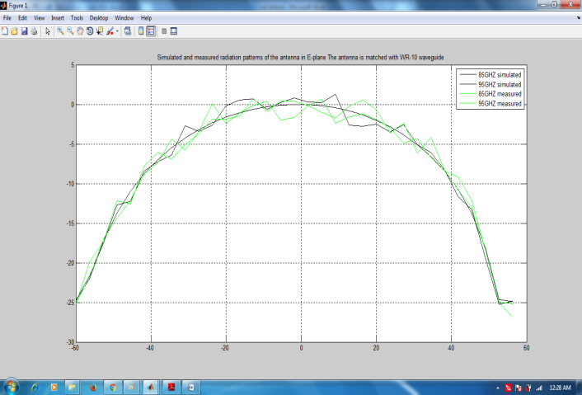
FIG:Simulated and measured radiation patterns of the antenna in E-plane The antenna is matched with WR-10 waveguide

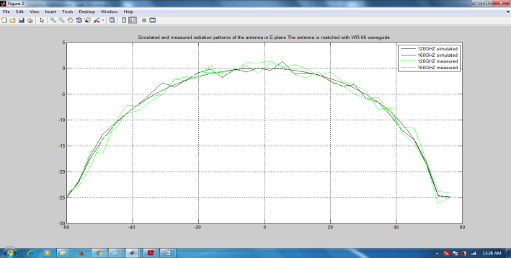
FIG:Simulated and measured radiation patterns of the antenna in E-plane The antenna is matched with WR-06 waveguide

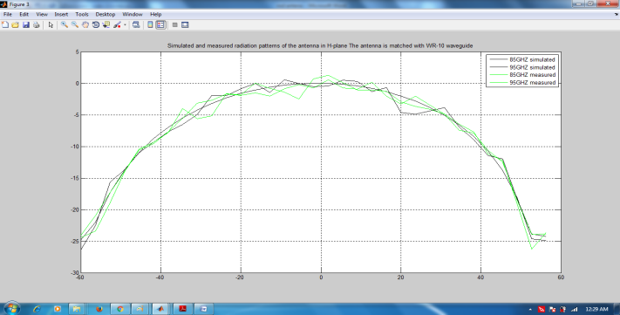
FIG:Simulated and measured radiation patterns of the antenna in H-plane The antenna is matched with WR-10 waveguide
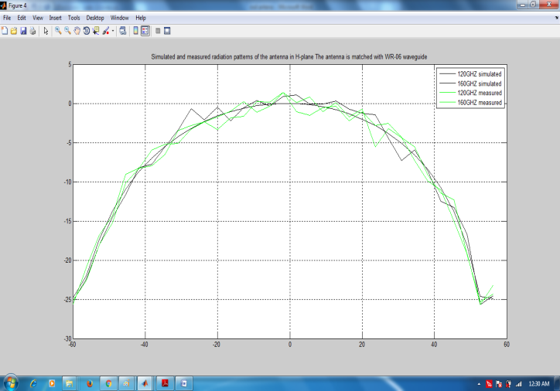
FIG:Simulated and measured radiation patterns of the antenna in H-plane The antenna is matched with WR-06 waveguide
V.ADVANTAGES APPLICATIONS
ADVANTAGES
- Optimization problem can be reduce
- High frequncy data can be transmitted
- Power consumption is low

APPLICATIONS
- Radar system
- Broad cast channel
- Television communication
- Imo communication
CONCLUSION
The dielectric bar radio wire that has been depicted can be all around coordinated to metal waveguides at frequencies from 75 to 325 GHz. The estimation information concur extremely well with expectations. A little inconsistency amongst measured and reenacted comes about is clarified by the nature of the tip of the recieving wire. The nature of the tips additionally confines the execution of the reception apparatus at frequencies over 325 GHz. The radio wire can be enhanced by utilizing a further developed and precise dicing saw. The radiation examples of the recieving wire are reliable at all utilized frequencies; the 3 dB shaft width of the radio wire is around 60 and the 10 Db bar width is around 95 prompting a reception apparatus pick up of around 10dB at all frequencies measured. This shows the gap size of this end-fire reception apparatus diminishes as a component of recurrence, and this perception concurs well with the prior perception that the stage focal point of a DRW recieving wire moves towards the radio wire tip as an element of recurrence. The most extreme cross polarization levels are of the request of 15 dB at various frequencies.
REFERENCES
[1] P. Siegel, “Terahertz technology,” IEEE Trans.Microw. Theory Techn., vol. 50, no. 3, pp. 910–928, Mar. 2002.

[2] A. A. Generalov, D. V. Lioubtchenko, and A. V. Räisänen, “Dielectric rod waveguide

antenna at 75–1100 GHz,” in Proc. 7th Eur. Conf. On Antennas Propag., Gothenburg, Sweden, Apr. 8–12, 2013.

[3] A. A. Generalov, D. V. Lioubtchenko, J. A. Mallat, V. Ovchinnikov, and A. V. Räisänen, “Millimeter-wave power sensor based on silicon rod waveguide,” IEEE Trans. THz Sci. Technol., vol. 2, no. 6, pp. 623–628, Nov. 2012.

[4] J. P. Pousi, S. N. Dudorov, D. V. Lioubtchenko, and A. V. Räisänen,“Frequency selective coupler forWband based on power transfer in dielectric rod waveguides,” in Proc. 4th Eur. Conf. on Antennas Propag., Barcelona, Spain, Apr. 11–16, 2010, paper 1840244.

[5] D. V. Lioubtchenko, J. P. Pousi, S. N. Dudorov, and A. V. Räisänen, “Millimetre-wave phase shifter based on dielectric rod waveguide,” in Proc. 38th Eur. Microw. Conf., Amsterdam, Netherlands, Oct. 28–31, 2008, pp. 1204–1206.

[6] J. P. Pousi, D. V. Lioubtchenko, S. N. Dudorov, and A. V. Räisänen, “Dielectric rod waveguide travelling-wave amplifier based onAlGaAs/ GaAs heterostructure,” in Proc. 38th Eur. Microw. Conf., Amsterdam, Netherlands, Oct. 28–31, 2008, pp. 1082–1085.

[7] B. Andres-Garcia, E. Garcia-Munoz, S. Bauerschmidt, S. Preu, S. Malzer, G. H. Döhler, W. Lijun, and D. Segovia-Vargas, “Gain enhancement by dielectric horns in the terahertz band,” IEEE Trans. Antennas Propag., vol. 59, no. 9, pp. 3164–3170, Sep. 2011.

[8] C. Yeh and F. Shimabukuro, The Essence of Dielectric Waveguides. New York, NY, USA: Springer, 2008.

[9] E. A. J. Marcatili, “Dielectric rectangular waveguide and directional coupler for

integrated optics,” Bell Syst. Tech. J., vol. 48, pp. 2071–2102, 1969.

[10] J. E. Goell, “A circular-harmonic computer analysis of rectangular dielectric waveguides,” Bell Syst. Tech. J., vol. 48, pp. 2133–2160, 1969.

[11] D. Lioubtchenko, S. Tretyakov, and S. Dudorov, Millimeter-Wave Waveguides. Amsterdam, the Netherlands: Kluwer Academic, 2003.

