POWER IN NOC THROUGH THE BLUEPRINT OF POWER EFFICIENT TECHNIQUE
*T.KIRAN, **M SHIVA REDDY
*PG Scholar, Dept of ECE, Mallareddy College of Engineering, Hyderabad, T.S, India.
**Assistant Professor, Dept of ECE, Mallareddy College of Engineering, Hyderabad, T.S, India.

ABSTRACT:
As era improves, the energy dissipated by means of way of the links of a community-on-chip(NoC) starts off evolved to deal with the power dissipated by using the alternative parts of the verbal exchange subsystem, particularly, the routers and the community interfaces (NIs).In this paper, we present a fixed of diagnosed coding schemes to reduce the functionality dissipated through the links of AN NoC. The proposed schemes place unit substantial and transparent with relation to the underlying undercover agent material (i.e., their utility does no longer need any modification of the routers and link structure). Experiments achieved on every artificial and actual web page traffic eventualities show the effectiveness of the planned schemes that could reduce no. Of transitions from scheme-I to scheme-II &amp; Scheme-II to Scheme-III that in terms reduce strength intake moreover as the vicinity moreover.
Keywords: network-on-chip (NoC), network interfaces (NIs), effectiveness.

1. INTRODUCTION:
The technology leads to quicker and more power relatively cheap gates, however, slower and further power hungry wires [1]. In reality, pretty five hundredth of the whole dynamic energy is dissipated in interconnects in modern-day processors, and this can be predicted to upward push to sixty five%–eighty% over consequent numerous years [2]. International interconnects length does no longer scale with smaller transistors and nearby wires. Chip period stays enormously steady due to the fact the carry out of the keeps to increase and RC postpone will boom exponentially. At 32/28 nm, as an instance, the RC get rid of in some unspecified time in the future of a 1-mm international cord on the minimal pitch is 25×
extra than the intrinsic eliminate of a -input NAND fan out of five [3]. If the raw computation electricity unit seems to be unlimited, because of the strength of instancing more and extra cores in the route of a unmarried Si die, scalability troubles. The easy plan of the projected method is cryptography the residences before they're injected into the community with the goal of minimizing the self-switching hobby and therefore the coupling switching pastime inside the links traversed via the flies. In truth, self-switching hobby and coupling switching interest are in rate for link energy dissipation. During this paper, we have a tendency to be looking for recommendation from the stop-toned scheme. This give up-to-forestall cryptography method takes benefit of the pipeline nature of the wormhole shift method. Note that because the same collection of flips passes via all of the links of the routing route, the cryptography call taken at the metallic element ought to offer identical electricity saving for all the links. For the projected the scheme, accomplice encoder, and a decoder block are added to the metal detail. Apart from the header flit, the encoder encodes the outgoing flits of the packet such that the capacity dissipated by the inter-router a thing-to-factor hyperlink is decreased. This cease-to-stop encoding method takes gain of the pipeline nature of the hollow shift method.
2. PREVIOUS STUDY:
In addition, the subject was supported the hop-with the aid of-hop technique, and Hence, encoding/interpreting is carried out in every node. The issue do not forget conferred indeed with lowering the coupling exchange. During this device, a complex encoder counts the quantity of kind I transitions with a weight steady of one and additionally the style of kind II transitions with the burden regular of two. If the quantity is greater than half of the to the advanced encoder, the technique really works at the styles whose complete inversion effects within the hyperlink electricity bargain while not considering the patterns whose whole inversions can also need to result in higher link power intake.
Therefore, the hyperlink electricity discount performed via this the technique is not due to the fact the big because of the reality it could be. This scheme grow to be conjointly supported the hop-thru-hop technique. In some different writing technique furnished in, groups of four bits each encoded with 5 bits. The encoded bits have been isolated mistreatment protective wires such the superiority of the patterns “101” and “010” were prevented. This way, no synchronic type II transitions in 2 adjoining integrate bits is brought about. This method efficaciously reduces the coupling switching interest. Though the approach reduces the functionality intake considerably, it will growth the data switch time, and consequently, the hyperlink strength intake. This is due to the actual reality that for every four bits, six bits are transmitted as a manner to boom the verbal exchange website on line site visitors. This method have turn out to be conjointly supported the hop-with the aid of-hop method. A writing approach that reduces the coupling exchange interest with the aid of the usage of taking the advent age of surrender-to-stop mystery writing for complete switching has been conferred in. It's supported reducing the coupling change hobby thru getting rid of totally kind II transitions. In this paper, we will be predisposed to give three thriller writing schemes. In situation depend I, we have a tendency to concentrate on lowering type I transition at the same time as in subject II, every sort I and II transitions are took under attention for finding out amongst 0.Five and whole invert, relying upon the quantity of trade bargain. Finally, in Scheme III, we will be inclined to take into account the real truth that type I transitions display in reality one-of-a-type behaviours inside the case of peculiar and even inverts and assemble the inversion which finally ends up in the pinnacle power saving.
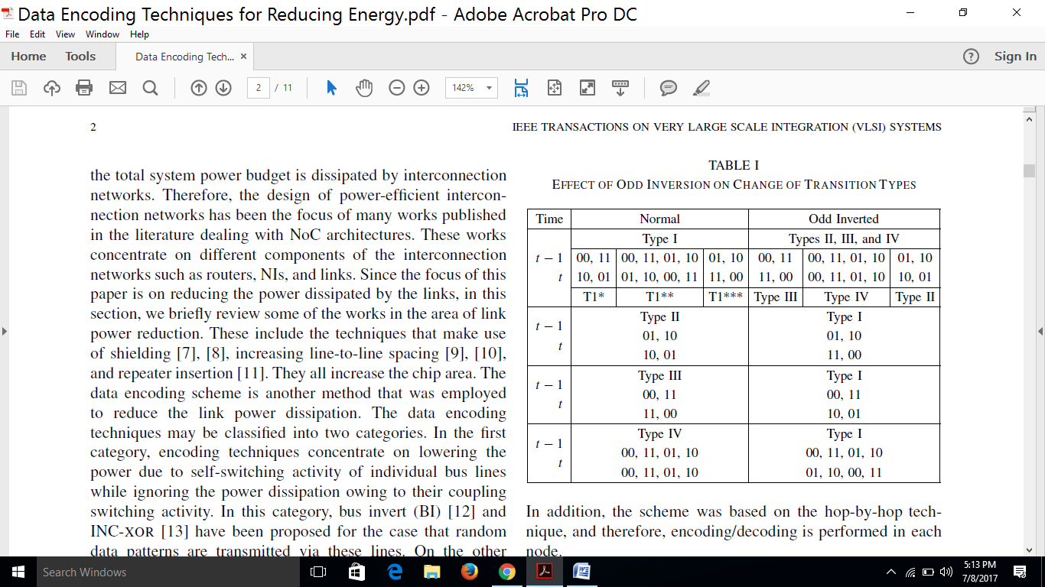
Fig.2.1. Effect of Odd Inversion on Change of Transition Types
3. PROPOSED ENCODING SCHEMES:
The projected cryptography layout this is predicated on the atypical insert state of affairs cited is proven in Fig. We will be predisposed to bear in mind a link breadth of w bits. If no encoding is employed, the body suits are looked after in w bits by means of the Ni and are transmitted via the hyperlink. In our method, one little bit of the link is employed for the inversion bit, that indicates if the flat traversing the link has been inverted or not. More specially, the Ni packs the body fits in w one bit. The cryptography precise judgment E, it really is included into the Ni, is answerable for figuring out if the inversion have to expose up and appearing the inversion if required. The decoder circuit simply inverts the acquired flat as soon because the inversion bit is excessive. In the projected cryptography subject remember II, we make use of every regular (as cited previously) and whole inversion. The entire inversion operation converts kind II transitions to type IV transitions. The problem matter compares the present records with the preceding one to decide whether or not or not or now not the unusual, whole, or no inversion of the present expertise will offer upward thrust to the link strength cut price.
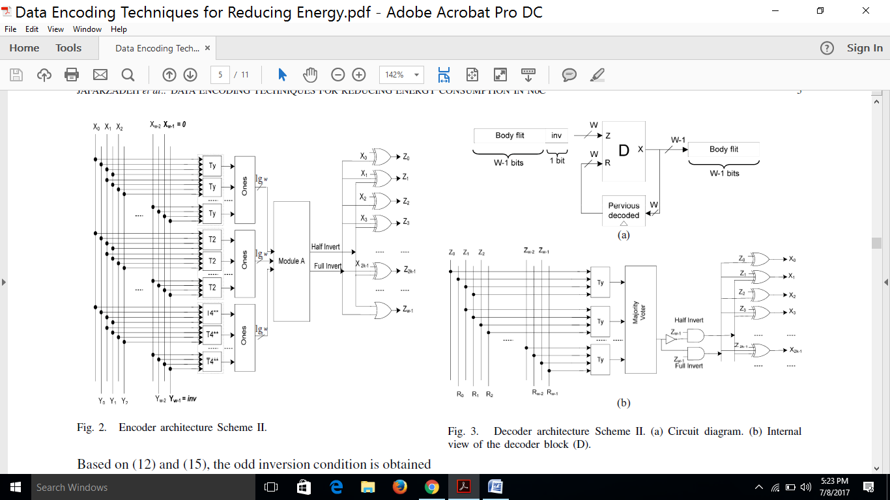
Fig.3.1.proposed diagram.
4. SIMULATION RESULTS:
The deliberate records cryptography schemes are assessed with the aid of indicates that of a cycle-correct intelligence agent simulator supported Noxim. The energy estimation fashions of Noxim encompass NIs, routers, and hyperlinks. The link energy dissipation changed into computed victimization (3) everywhere the terms T0→1, T1 and T2 were computed supported the facts received from the cycle accurate simulation. The next parameters had been used inside the simulations. The intelligence agent changed into clocked at seven-hundred MHz even as the baseline Ni with minimal buffering and supporting open middle protocol and superior bus protocols dissipated five.3 mW. The not unusual energy dissipated thru the wormhole-based completely router modified into five.7 mW. Supported a sixty 5-nm UMC technology, a complete capacitance of 592 off/mm emerge as assumed for an inter-router twine. Regarding 80th of this capacitance have become due to the XT. We assumed 2-mm 32-bit links and a packet period of 16 bytes (8 flats). Victimization the hard simulations, as quickly as the flies traversed the intelligence agent hyperlinks, the corresponding self and coupling switching sports sports had been calculated and used alongside side the self- and coupling capacitance of 0.237 and zero.947 of, severally, to calculate the strength (Vdd = zero.Nine V and Fc = seven-hundred MHz).
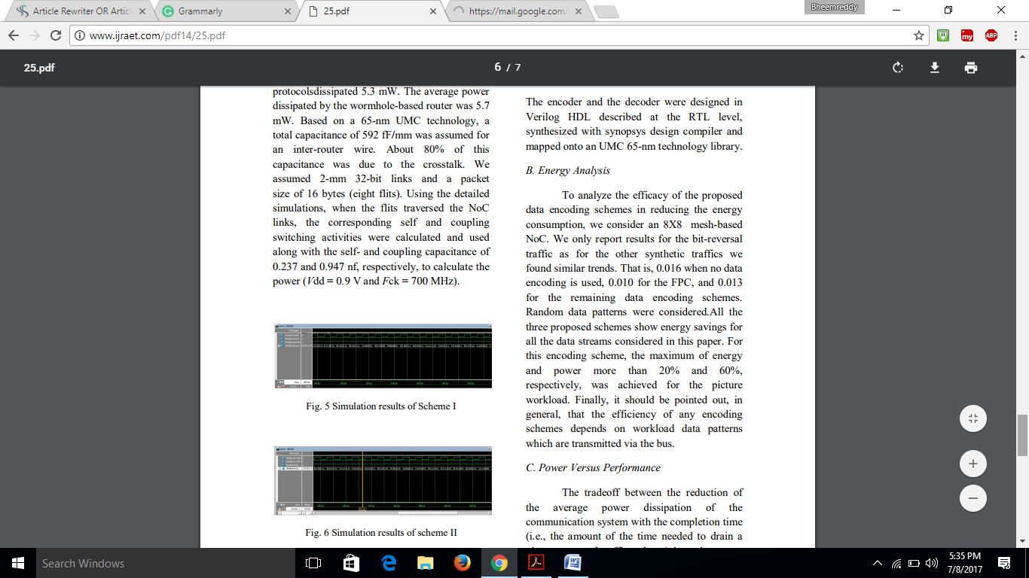
Fig.4.1. Simulation results of Scheme I
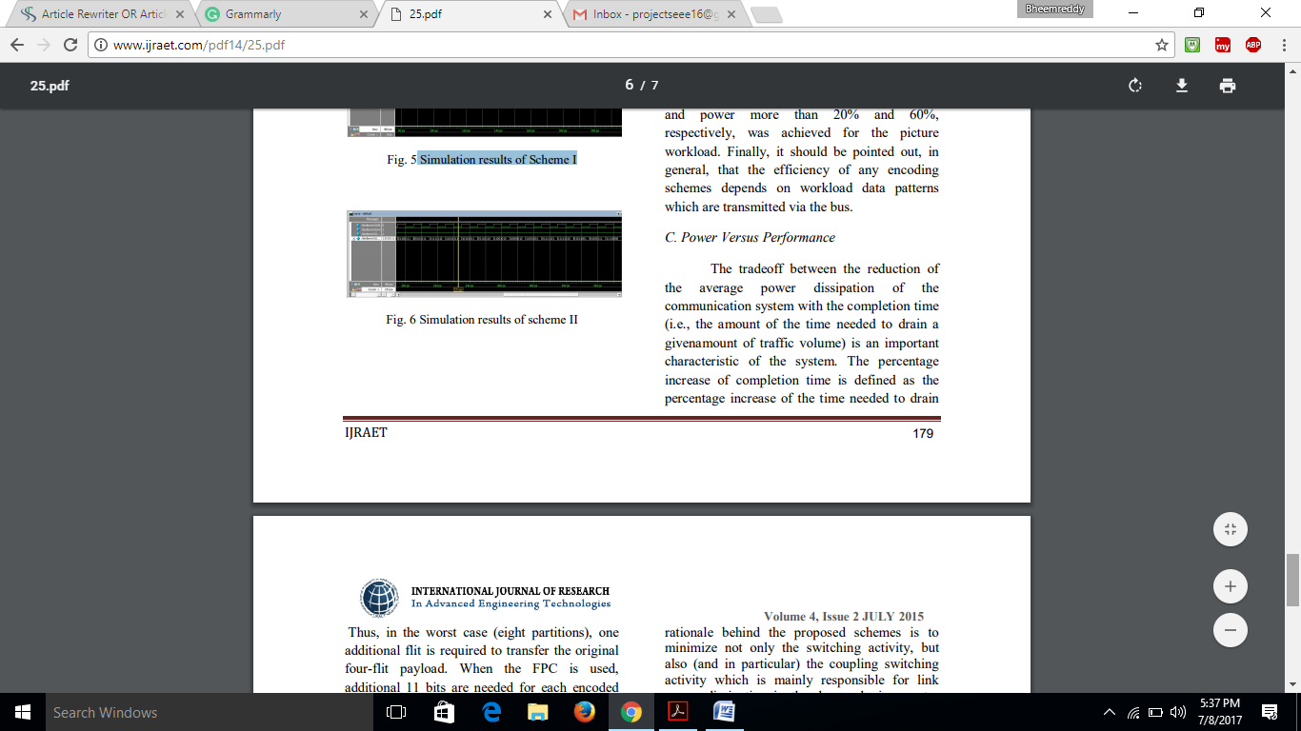
Fig.4.2. Simulation results of scheme II
5. CONCLUSION:
In this paper, we have were given were given a set of latest records coding schemes geared closer to lowering the strength dissipated via the hyperlinks of an intelligence officer. In fact, hyperlinks region unit responsible for a chief the fraction of the electricity dissipated by means of the communication machine. Additionally, there the contribution is expected to increase in destiny generation nodes. As in comparison to the previous encoding schemes deliberate within the literature, the rationale at the back of the planned schemes is to limit now not definitely the switch interest, however additionally (and specifically) the coupling transfer an hobby this is specially accountable for the link electricity dissipation within the deep sub micrometer generation regime. The planned coding schemes area unit agnostic with regards to the underlying intelligence officer structure inside the feel that their software does now not want any exchange neither within the routers nor in the links. An intensive analysis has been allotted to evaluate the impact of the encoder and decoder good judgment within the Ni. The encoders imposing the deliberate schemes had been assessed in phrases of strength dissipation and semiconductor region. The influences at the performance, strength, and energy metrics have been studied using a cycle- and bit accurate intelligence officer simulator underneath every artificial and real site visitor’s situations. Overall, the making use of the proposed encoding schemes permit reduced no. Of transitions from scheme-I to scheme-II &amp; Scheme-II to Scheme-III that reduces electricity intake in addition as area conjointly.

REFERENCES:
[1] International Technology Roadmap for Semiconductors. (2011) [Online]. Available: http://www.Itrs.Internet
[2] M. S. Rahaman and M. H. Chowdhury, “Crosstalk rejection and blunders correction coding for coupled RLC interconnects,” in Proc. IEEE Int. Symp. Circuits Syst., May 2009, pp. 141–a hundred and forty four.
[3] W. Wolf, A. A. Jerraya, and G. Martin, “Multiprocessor device-on-chip MPSoC technology,” IEEE Trans. Comput.-Aided fashion Integr. CircuitsSyst., vol. 27, no. 10, pp. 1701– 1713, Oct. 2008.
[4] L. Benini and G. De Micheli, “Networks on Chips: a substitute SoC Paradigm,” Computer, vol. 35, no. 1, pp. 70–seventy eight, Jan. 2002.
[5] S. E. Lee and N. Bagherzadeh, “A variable frequency hyperlink for a power aware network-on-chip (NOC),” Integr. VLSI J., vol. 42, no. 4, pp. 479–485, Sep. 2009.
[6] D. Yeh, L. S. Peh, S. Borkar, J. Barringer, A. Agarwal, andW. M. Hwu, “Thousand-center chips Roundtable,” IEEE fashion take a look at Comput., vol. 25, no. 3, pp. 272–278, May–Jun. 2008.
[7] A. Vittal and M. Marek-Sadowska, “Crosstalk discount for VLSI,” IEEE Trans. Comput.-Aided fashion Integr. Circuits Syst., vol. 16, no. 3, pp. 290–298, Mar. 1997. [8] M. Ghoneima, Y. I. Ismail, M. M. Khellah, J. W. Tschanz, and V. De, “Formal derivation of premier active protecting for low-strength on-chip buses,” IEEE Trans. Comput.-Aided style Integr. Circuits Syst., vol. 25, no. Five, pp. 821–836, May 2006.
[9] L. Macchiarulo, E. Macii, and M. Poncino, “Wire placement for crosstalk energy diminution in address buses,” in Proc. Style Autom. Test Eur. Conf. Exhibit., Mar. 2002, pp. 158–162.
[10] R. Ayoub and A. Orailoglu, “A unified transformational technique for discounts in fault vulnerability, power, and noise noise and put off on processor buses,” in Proc. Style Autom. Conf. Asia Pacific Ocean, vol. 2. Jan. 2005, pp. 729–734.

