EFFICIENT FUZZY CONTROL DC-DC CONVERTER DESIGNED FOR POWER FACTOR CORRECTION OF BLDC DRIVE

*K.ARUNA, **P.ANUSHA
*PG Scholar, Dept of EEE, Vikas College of Engineering &Technology, Nunna, Krishna (Dt); A.P, India.
**Assistant Professor, Dept of EEE, Vikas College of Engineering &Technology, Nunna, Krishna (Dt); A.P, India.

ABSTRACT- This paper presents a Power Factor Corrected (PFC) of Brushless DC motor (BLDC) drive power quality solution for low power applications. A PFC DC-DC converter, eliminates the use of diode bridge rectifier and, thus improves the power factor at the ac mains. The conventional fuzzy logic controller has been used for the speed control of BLDC motor drive. The performance of conventional Fuzzy controller is compared under variable reference speed and load disturbance for different parameters of BLDC motor drive. The obtained power quality indices are found within the acceptable limits of power quality standards. This project deals with a power factor correction (PFC) based Cuk converter fed brushless DC motor (BLDC) drive as a cost effective solution for low power applications. The speed of the BLDC motor is controlled by varying the Dc bus voltage of voltage source inverter(VSI) which uses a low frequency switching of VSI (electronic commutation of BLDC motor) for low switching losses. A diode bridge rectifier (DBR) followed by a Cuk converter working in discontinuous conduction mode (DCM) is used for control DC link voltage with unity power factor at AC mains. The fuzzy based controller system is used for general purpose industrial applications. Performance of the PFC DC-DC converter is evaluated in four different operation condition of discontinuous and continuous conduction mode (CCM) and a comparison is made to select a best suited mode of operation. The switching loss in VSI is minimized by an electronic commutation of Brushless DC motor (BLDCM) is used to operate in a low-frequency operation. This paper is Fuzzy control is used in the DC-DC converter to reduce the source current THD.
KEYWORDS— Power Quality (PQ), Power Factor Correction (PFC), Bridgeless converters, cuk Converter, Bridgeless isolated cuk converter, Brushless dc motor(BLDC) .

I. INTRODUCTION
The day by day increasing demand for energy can create problems for the power distributors, like grid instability. In recent years brushless dc (BLDC) motors are widely used applications including appliances, automotive, aerospace, consumer, medical, automated industrial equipment and instrumentation because of their high starting torque, high efficiency, reliability, lower maintenance compared to its brushed dc motor. In a BLDC motor, the rotor magnets generate the magnetic flux, so BLDC motors achieve higher efficiency. [1] [2] Therefore, BLDC motors may be used in high end white goods (refrigerators, washing machines, dishwashers, etc.), high-end fans, and pumps

and in other appliances which require high reliability and efficiency. BLDC motors have many advantages over brushed DC motors and induction motors, like higher efficiency and reliability, lower acoustic noise, smaller and lighter, greater dynamic response, better speed versus torque characteristics, higher speed range, longer life. Since the specific torque is higher it can be very useful in the applications were space and weight are critical factors. And also the BLDC motor is electrically commutated by power switches instead of brushes it has so many advantages such as no brushes/commutator maintenance, no brush friction to reduce useful torque, no mechanical limitation imposed by brushes or commutator, no arcs from brushes to generate noise, causing EMI problems.[3] The BLDC motor drive is fed from single-phase ac supply through a diode bridge rectifier (DBR) followed by a high value of smoothening capacitor at dc link which draws a pulsed current, with a peak higher than the amplitude of the fundamental input current at ac mains due to an uncontrolled charging and discharging of the dc link capacitor.[4] This causes in poor power quality (PQ) at ac mains in terms of poor power factor (PF), high total harmonic distortion (THD) of ac mains current, and high crest factor (CF). Therefore, a Power Factor correction (PFC) converter is inevitable for Brushless DC Motor Drive in order to improve the power quality. [5] There are many existing topologies regarding power factor correction in BLDC motor drive. Some of the existing topologies consist of a Single Ended Primary Inductance Converter (SEPIC) and buck-boost converter based BLDC motor drive which has higher losses in the voltage source inverter due to conventional PWM switching and large number of voltage and current sensors are used that additionally adds to the cost of the converter. And in another topology a cuk converter fed BLDC motor drive with a variable DC link voltage is used that reduces the switching losses since it uses only the fundamental switching frequency, but it has a major disadvantage that it requires three sensors. So it is not used for low power rating and low-cost applications.[6]-[8] The above used topologies consist of bridge converters and it also contributes switching losses so bridgeless topologies are preferred. The usage of diode rectifiers that cause more switching stresses are eliminated by bridgeless converters.[9] And also some topologies with bridgeless converters like bridgeless boost, cuk, buck-boost, SEPIC converters are there. But all these power factor correction techniques have some limitations. They cannot be used for low power applications.[10] So the proposed PFC technique below is designed in such a way that is suited for low power applications.[11]-[14] The objective of the paper is to use zeta converter fed BLDC motor drive in order to improve the power quality at the supply by reducing the total harmonic distortion factor and increasing power factor to unity. And also by adjusting the dc link voltage of the voltage source inverter (VSI) feeding a BLDC motor, the speed of the BLDC motor is controlled.
II.BRIDGELESS CONVERTERS
A.Types of Bridgeless converter
Bridgeless means Diode Bridge is eliminated at front end. It reduces the number of semiconductor components. Switching loss and power losses is reduced. It usually occurs in a diode bridge and as a result overall system efficiency is improved. The occurrence of two semiconductors switches in the current path throughout interval it consequence in a smaller amount conduction losses [19].
(a) Bridgeless Boost converter
Figure 1 shows the Bridgeless Boost Converters. A bridgeless boost converter with low common mode noise is presented in this paper. The numbers of components are condensed by the magnetic components such as transformer and inductor on same core.
Bridgeless power factor correction (PFC) circuit topology is used to maximize the power supply efficiency and conduction loss is reduced and the number of semiconductor components in the current path is condensed. By replace a couple of bridge rectifiers and employ an boost inductor is implemented.
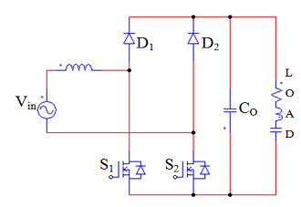
Fig.1. Bridgeless Boost Converter

In bridgeless type, one rectifier is get rid of from the contour path reduce the conduction loss. The further type work mutually in continuous conduction mode (CCM) and discontinuous conduction mode (DCM). This figure 1 utilize the totem-pole collection in the reverse recovery
performance of the anti parallel diode. It can work only in DCM mode .It makes CCM operation impractical. High common-mode noise produced in realistic application is vulnerable by a lofty frequency switching. This implementations does not bear from the lofty noise problem [19].
Bridgeless boost rectifier has several realistic problem. It has elevated output voltage than the crest input voltage, deficient in galvanic isolation and elevated initiate and inrush currents. An extra converter or isolation transformer is necessary for small output voltage purpose, for instance telecommunication or computer to step-down the voltage. Three semiconductors in current transmission path throughout all switching cycle is still suffers [1].

(b) Bridgeless Buck-Boost Converter
Figure 2 shows the Bridgeless Buck-Boost Converter. This converter is considered to work in DICM to offer natural PFC at AC supply. Rate of BLDC motor is prohibited by single voltage sensor. The commutation of motor provides a compact switching losses and frequency switching is specified by means of this commutation. In BL configuration eradication of the diode bridge rectifier diminish the conduction losses related in it.
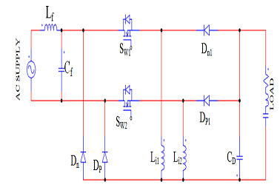
Fig.2. Bridgeless Buck Boost Converter
Due to the usage of a smaller amount of apparatus and a single switch single stage PFC converter has high effectiveness when evaluate to two stage converters. The ranking of the apparatus used in the converter create a serious concern since it straightly affects the modes of converter. Two modes are continuous conduction mode (CCM) and discontinuous conduction mode (DCM) .The current or the voltage in the inductor remains uninterrupted in CCM mode [2].
It Sense dc linkage voltage and supply voltage. single voltage sensor is needed for DCM. Hence, for low-power applications DCM mode is preferred. Bridgeless Buck –Boost converter has pulsed input current and hence it require input filter. It has peak input current in power component. power transient response makes it less efficient [15].
(d) Bridgeless SEPIC Converter
Figure 3 shows the Bridgeless SEPIC Converter. In bridgeless sepic converter extraordinary intend of dc side inductor is required to bear dc current and elevated rate of wrinkle current. It requires three additional passive element. It adds the amount and mass of converter. It twice the output voltage and amount of output filter is increased.
While working in Continuous conduction mode Voltage and current loop is necessary for usual PFC converters. When the converter function in discontinuous conduction mode the power circuit is easy and current loop is not necessary for the proposed converter. In Buck converter offline small voltage power provisions is chosen to have worse output than the input voltage.
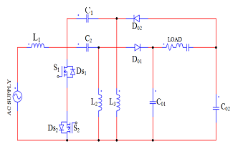
Fig.3. Bridgeless SEPIC Converter

On the other hand, the buck converter has irregular input current and an further passive filter is used to filter the current. To determine this trouble, single ended primary inductor converter (SEPIC) and Cuk converters is used. Control circuit is necessary in CCM mode, but in DCM, converter can work at permanent duty cycle to accurate the input power factor (PF) [11].
In the power flow path three semiconductor devices is already exist. To bear the dc current and high-frequency wrinkle current a unique design of dc-side inductor is essential. The bridgeless rectifier is projected to conquer these problems. Therefore to contour input current towards the sinusoidal waveform additional passive filter is needed. The converter is working in DCM due to the continuous input current.
Three additional passive elements of this converter have add the mass and volume of converter. It twice the output voltage and volume of output filter is increased. Bridgeless SEPIC converter is establish to conquer these limits while compared to conservative SEPIC PFC. However the converter has no supplementary elements.
(e) Bridgeless ZETA Converter
Figure 4 shows the Bridgeless ZETA Converter. single voltage sensor is used for devious voltage. PWM (Pulse Width Modulation) is the method used conventionally.VSI is novel scheme for calculating the speed and voltage. In BL-Zeta converter voltage follower technique is used in
favor of voltage control which is operating in DCM (Discontinuous Conduction Mode).The concert of projected drive for a various choice of speed and voltage is satisfactory.
Switches stresses and heat sink design are also analyzed for their selection. To progress the power quality of BLDC it cannot be used for feeding. Boost converter with two stage is mostly chosen to work in DCM mode and for voltage control a buck-boost converter

has been generally used. Two independent controls are essential for two stages. owing to multiple stages losses is increased.
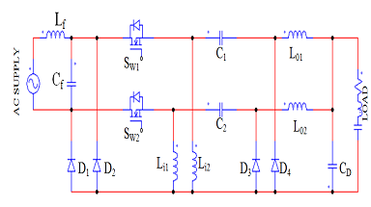
Fig.4. Bridgeless ZETA Converter
To overcome these disadvantages PFC converters with single stage is utilized for voltage control. stresses in voltage and current is take place across the switch. Stresses across the switch is low in CCM mode but current multiplier approach is complex and two-voltage sensor and one-current sensor totally three sensors are required. Voltage follower approach for DCM mode is simple.
Single voltage sensor is required but higher stresses occur across the switch. For a low power rating DCM mode is preferred. It limit stresses across the switch, whereas for high power ratings CCM mode is used. Generally two switches are accomplish alternatively for positive and negative half cycle. Power Factor Correction of Zeta converter is extensively used for diverse applications. For the improvement of BLDC motor Bridgeless configuration in Zeta converter is still unexplored in low cost.
BL-Zeta converter with reduced sensor is offered. High efficiency is achieved by reduced switching and conduction losses. In the front end converter suitable rating of MOSFET (Metal Oxide Semiconductor Field Effect Transistors) is used. whereas for low frequency operation IGBT (Insulated Gate Bipolar Transistors) are used in VSI. Therefore switches and heat sink are selected. Commutation of BLDC motor electronically is

achieved with fundamental frequency switching. Due to ringing high voltage stress is caused by the resonance [17].
(f) Bridgeless CUK Converter
Figure 5 shows the Bridgeless CUK Converter. CUK converter in fact is a grouping of buck and boost converter. The process during each sub-interval is discussed. Current Injected Equivalent Circuit Approach (CIECA) is a new technique that represents the minute and bulky indicator. Power factor correction (PFC) circuit produces more unusual concern for the earlier period.
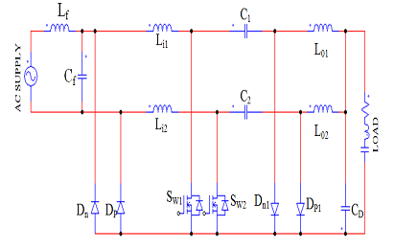
Fig.5. Bridgeless CUK Converter
Due to its capacity switch-mode power supply (SMPS) draws energy from the mains efficiently. Two diode rectifiers are conduct repeatedly in usual converter but in bridgeless converter one diode rectifier is conduct, particularly in trigger state. Efficiency of the converter is enhanced by soft-switching technique and reducing the energy loss in all component.
Though, in Boost converter output voltage intensity is elevated for all time than the input voltage. The voltage intensity is about 350V or additional for a general PFC converter, whereas the majority of the electronic

applications control at 5V to 50V DC for all time. To decrease intensity of voltage another cuk converter is introduce. Thus the converter
is proficient to offer inferior voltage at output [8]. A latest bridgeless Cuk converter is projected. Foremost compensation of Cuk converter has prominent feature of input and output current. The main cause to validate the position of inductance at the input and output of converter is that these two currents would never be turned OFF suddenly. During each phase the amount of input diode is fewer compare to usual Cuk Converter. For instance in any case two diode is perform for normal bridgeless PFC.
In this converter one diode is conduct at all instance. The amount of apparatus used to extend the converter is further when compare to the other Cuk converter types. It is because of two Cuk converters are subsisting throughout the half-line period. Advantages of this converter such as continuous input and output current. For voltage control voltage follower approach is used. Output voltage can be either superior or fewer than input voltage.
It defend against the inrush current taking place at initial or surplus current. It has worse current ripple .Fewer range of heat sink is used for the switch. Non- isolated converter cannot withstand high voltage. It create unwanted current loop problem. It suppresses electrical noise [8].

(g) Bridgeless ISOLATED CUK converter
Bridgeless isolated cuk converter means there is an electrical isolation and no electron flow between two circuits. It withstands high voltage between windings. It prevent unwanted current loop [5].Isolation between electrical system prevent current flow. They do not conduct directly. High frequency isolation is present in this isolation transformer. It is bidirectional and it eliminates losses and corono free operation. It withstand high vibration and voltage [6].

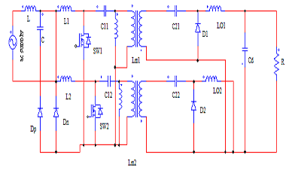
Fig.6. Bridgeless ISOLATED CUK Converter
Energy can be exchanged between the section by means of inductance, capacitance or electromagnetic waves. It is used for safety, preventing accidental current from reaching ground through person body. Bridgeless isolated cuk converter is used for wind, solar, fuel, hybrid vehicles, industrial drives and transportation [12]. Comparative analysis of different types of Bridgeless topologies for PFC in BLDC drives is shown in Table 1.

TABLE 1
Comparative Analysis of Bridgeless PFCConverter Topologies
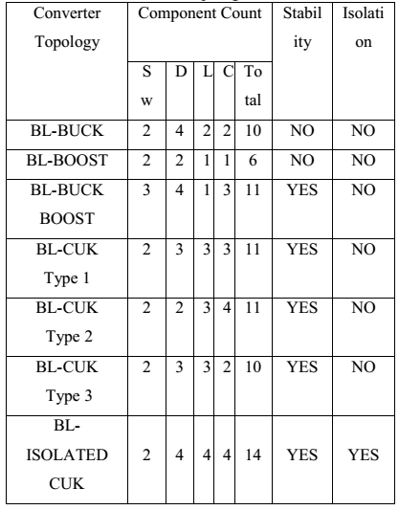

Bridgeless isolated Cuk converter has the following advantages:
- There is an electrical isolation and no electron flow between two circuits.
- It withstands high voltage between windings.
- It prevent unwanted current loop.
- Isolation between electrical systems prevents current flow. They do not conduct directly. High frequency isolation is present in this isolation transformer. It is bidirectional and it eliminates losses and corono free operation.
- It withstands high vibration and voltage.
- Energy can be exchanged between the sections by means of inductance, capacitance or electromagnetic waves.
- It is used for safety, preventing accidental current from reaching ground through person body.
Stability and isolation is more in Bridgeless isolated cuk converter when compare to other converter.

III. FUZZY LOGIC CONTROLLER
The word Fuzzy means vagueness. Fuzziness occurs when the boundary of piece of information is not clear-cut. In 1965 Lotfi A. Zahed propounded the fuzzy set theory. Fuzzy set theory exhibits immense potential for effective solving of the uncertainty in the problem. Fuzzy set theory is an excellent mathematical tool to handle the uncertainty arising due to vagueness. Understanding human speech and recognizing handwritten characters are some common instances where fuzziness manifests. Fuzzy set theory is an extension of classical set theory where elements have varying degrees of membership. Fuzzy logic uses the whole interval between 0 and 1 to describe human reasoning. In FLC the input variables are mapped by sets of membership functions and these are called as “FUZZY SETS”.

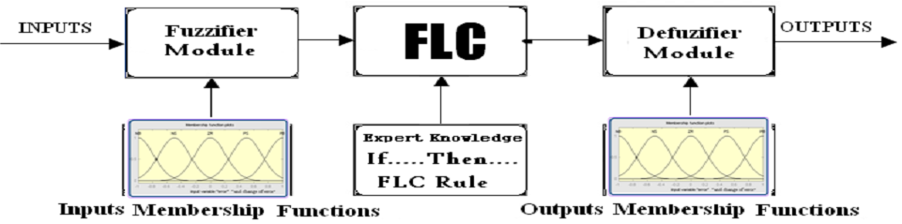
Fig.7.Fuzzy Basic Module
Fuzzy set comprises from a membership function which could be defines by parameters. The value between 0 and 1 reveals a degree of membership to the fuzzy set. The process of converting the crisp input to a fuzzy value is called as “fuzzificaton.” The output of the Fuzzier module is interfaced with the rules. The basic operation of FLC is constructed from fuzzy control rules utilizing the values of fuzzy sets in general for the error and the change of error and control action.
The results are combined to give a crisp output controlling the output variable and this process is called as “DEFUZZIFICATION.”
TABLE I : FUZZY REULES
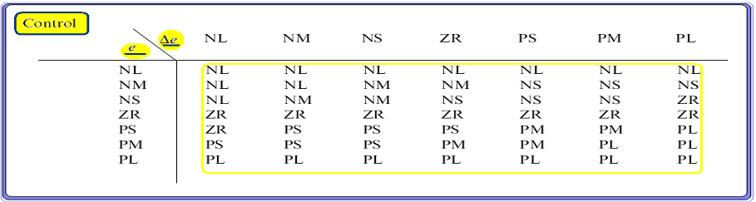

IV. MATLAB/SIMULATION RESULTS
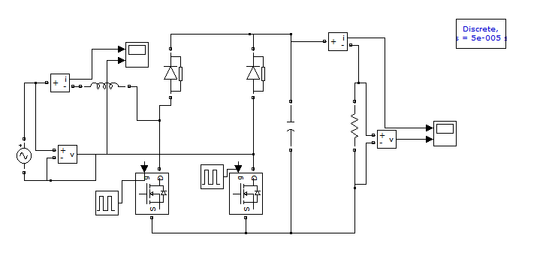
Fig 8 Simulink diagram of bridge less boost converter

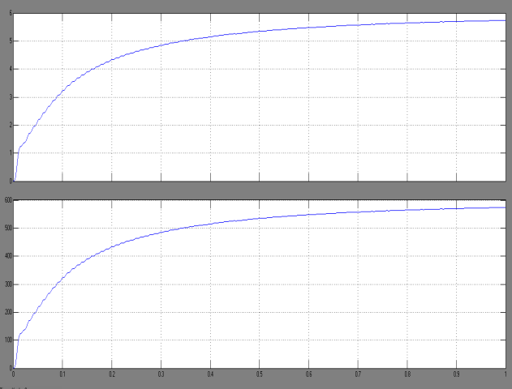
Fig 9 output current and voltage wave forms of bridge less boost converter

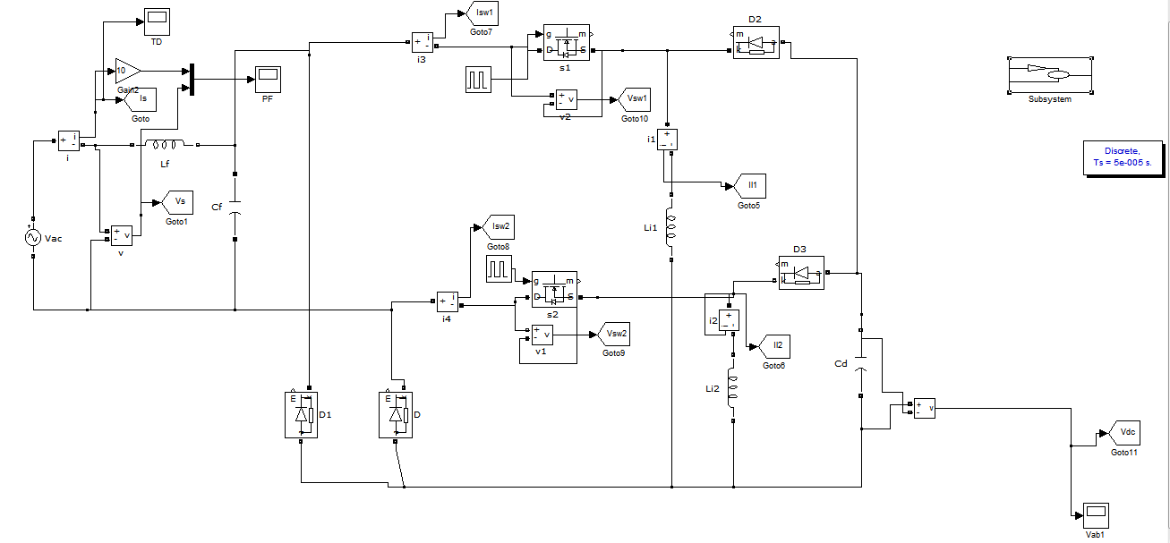
Fig 10 Simulink diagram of bridge less buck boost converter

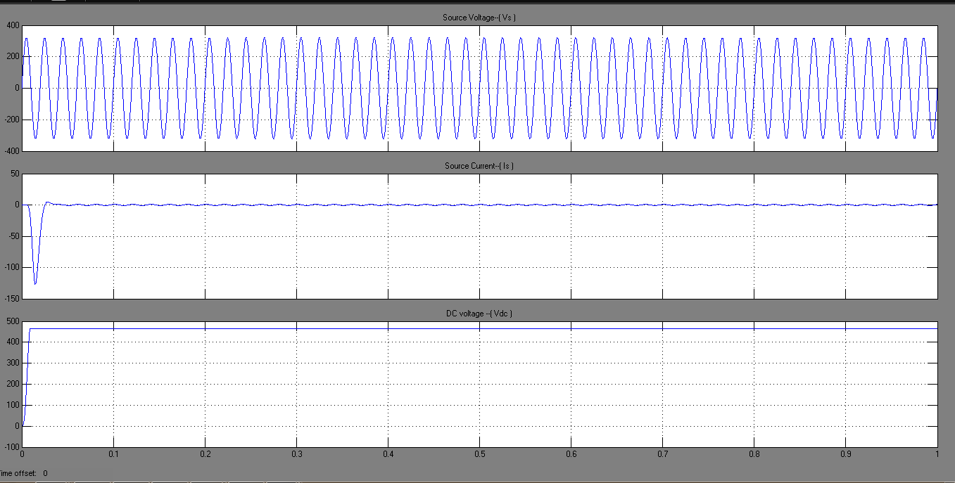
Fig 11 source voltage and source current and vdc voltage wave forms of bridge less buck boost converter
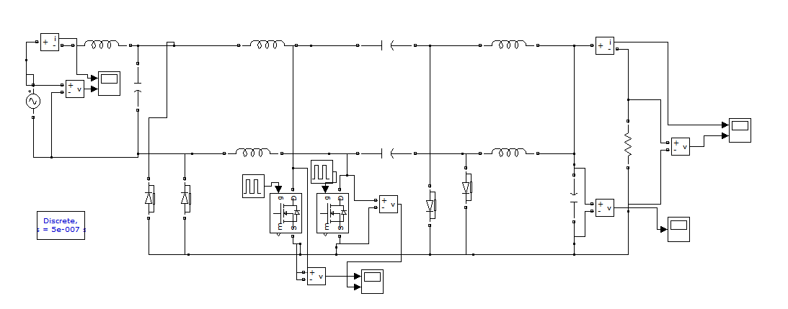
Fig 12 Simulink diagram of bridge less cuk converter

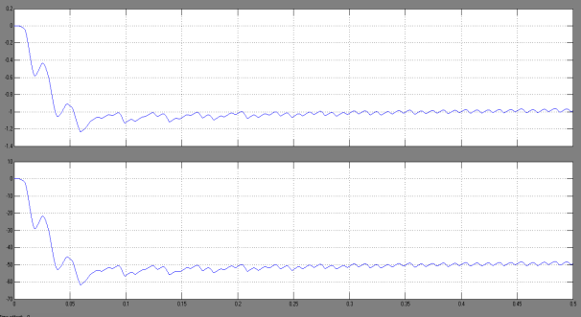
Fig 13 output current and voltage wave forms of bridge less cuk converter

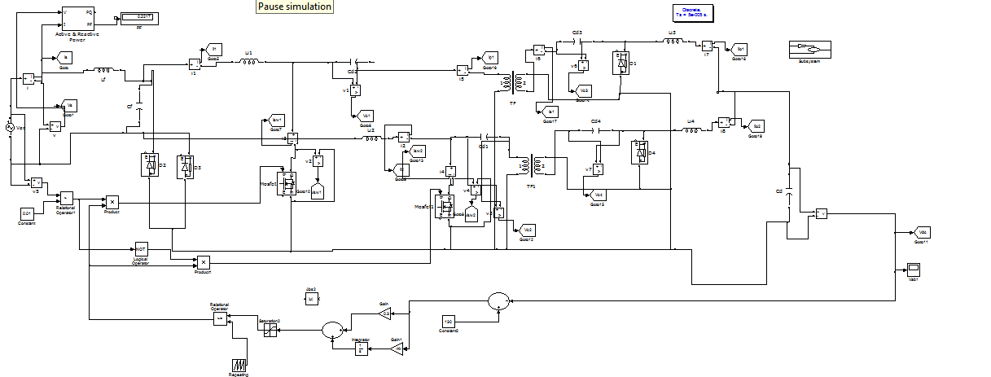
Fig 14 Simulink diagram of bridge less isolated cuk converter

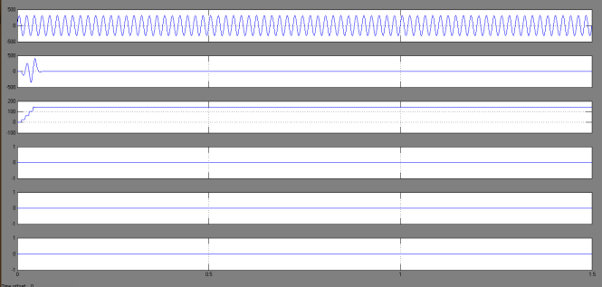
Fig 15 source voltage and source current and vdc voltage wave forms of bridge less isolated cuk converter
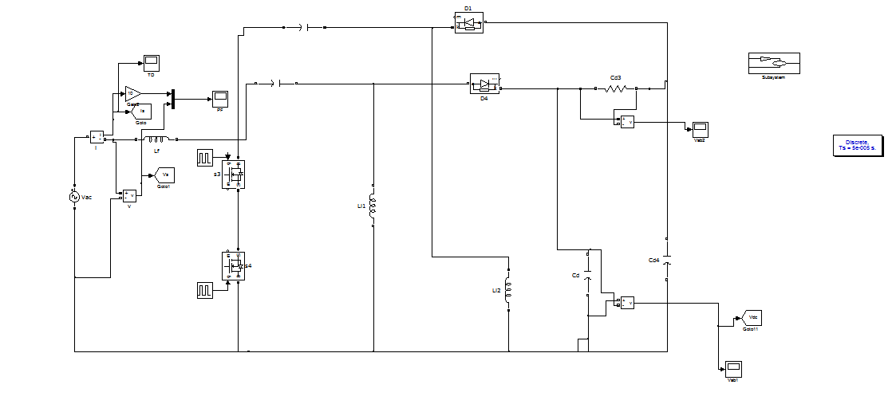
Fig 16 Simulink diagram of bridge less sepic converter

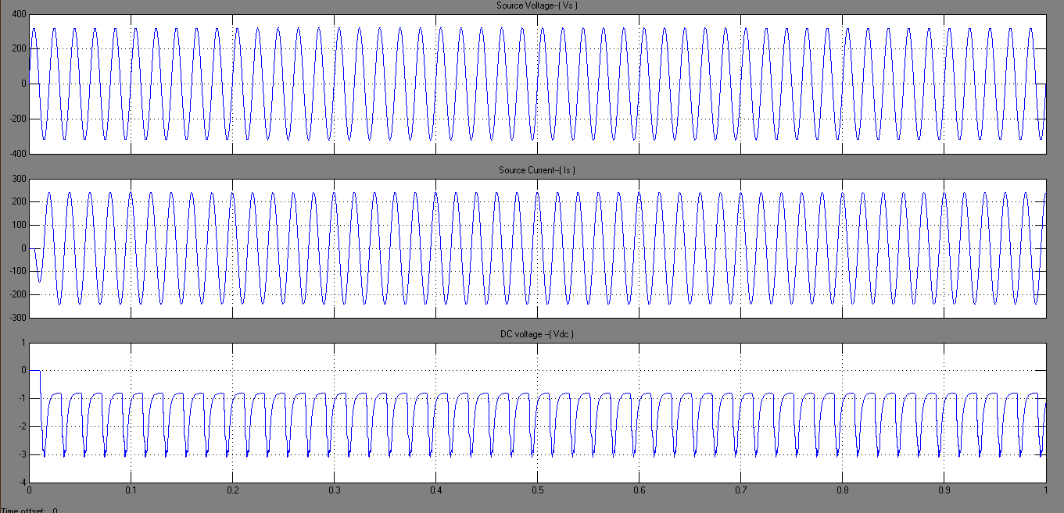
Fig 17 source voltage and source current and vdc voltage wave forms of bridge less sepic converter
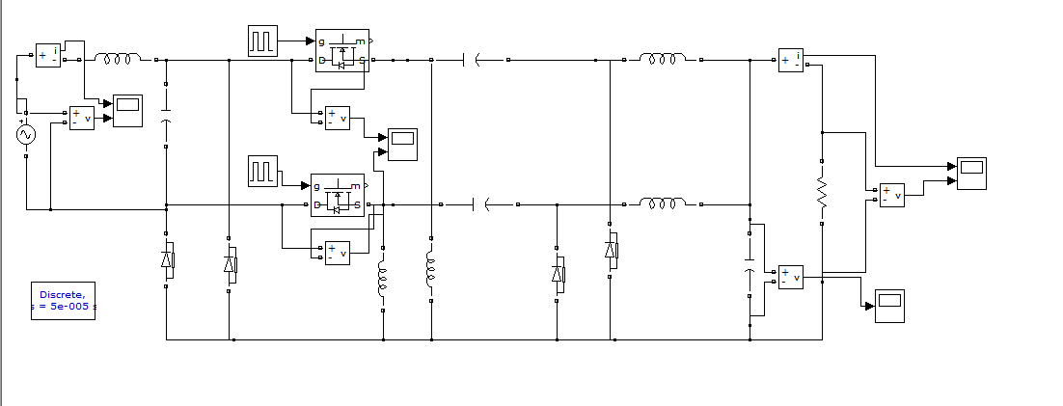
Fig 18 Simulink diagram of bridge less zeta converter

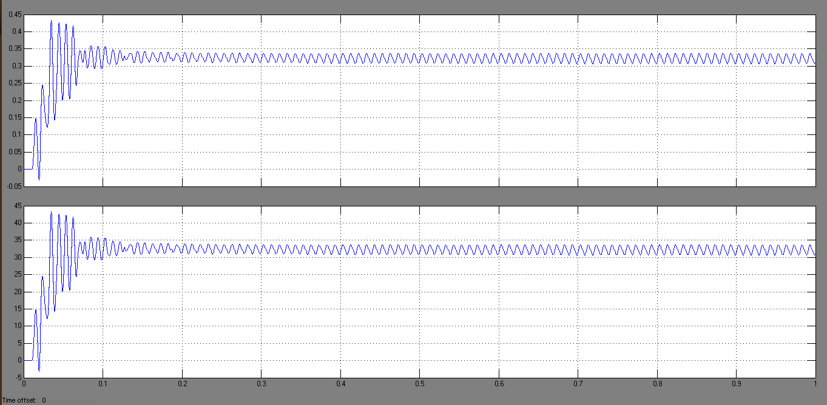
Fig 19 source voltage and source current wave forms of bridge less zeta converter

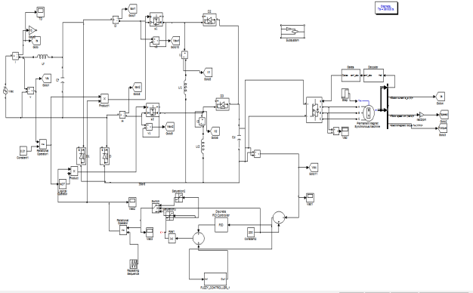
Fig 20 Simulink diagram of fuzzy based bridge less zeta converter

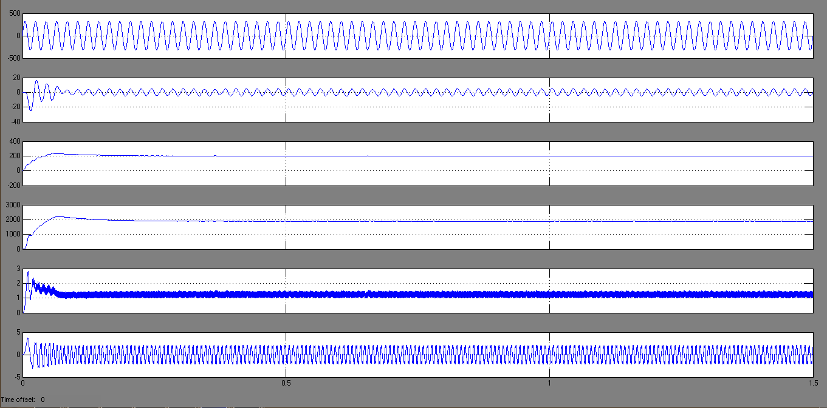
Fig 21 source voltage and source current and vdc voltage wave forms of fuzzy based bridge less zeta converter

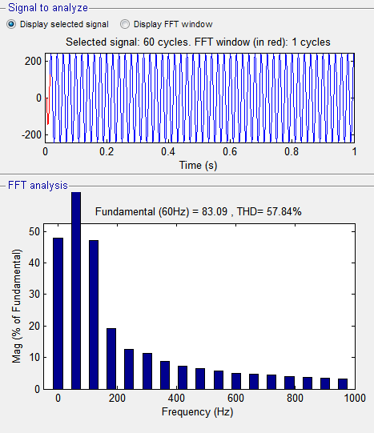
Fig.22. THD waveforms for the existing with PI controller

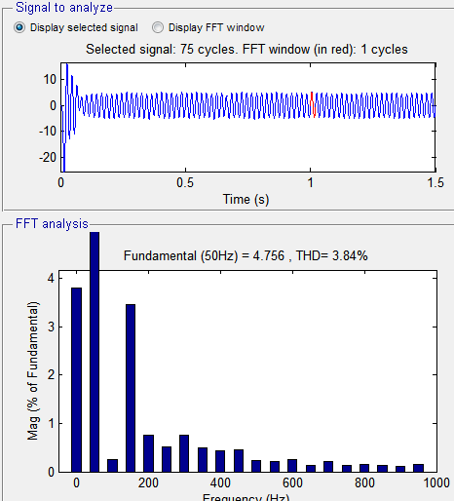

Fig.23. THD waveforms for the proposed with fuzzy controller

V.CONCLUSION
Comparative analysis of different types of Bridgeless topologies for PFC in BLDC drives has been discussed. Bridgeless isolated cuk converter is most suitable. It gives the high efficiency output, power factor near to unity, reduced torque ripples and good speed response for the BLDC drives while compare to the conventional PFC converters.

REFERENCES
[1] Abbas A. Fardoun, Esam H. Ismail, Ahmad J. Sabzali and Mustafa A. Al-Saffar, “New Efficient Bridgeless Cuk Rectifiers for PFC Applications,” IEEE Trans. on Power Electronics. 2012; 27(7), pp.3292-3301.
[2] B. Singh and S. Singh, “Single-phase power factor controller topologies for permanent magnet brushless DC motor drives,” IET Power Electron., 2010, 3( 2), pp. 147–175.
[3] B. Singh and V. Bist, “An Improved Power Quality Bridgeless Cuk Converter Fed BLDC Motor Drive for Air Conditioning System,” IET Power Electron. , vol. 6, no. 5, pp. 902–913, 2013.
[4] Bhim Singh and Vashist Bist, “A BL-CSC Converter-Fed BLDC Motor Drive With Power Factor Correction,” IEEE trans. on industrial electronics, 62(1), January 2015.
[5] DakshinaMurthy-Bellur and Marian K. Kazimierczuk, “Isolated Two-Transistor Zeta Converter With Reduced Transistor Voltage Stress,” IEEE trans. on circuits and systems, 58(1), pp.41-45, January 2011.
[6] Dominik Bortis, Lukas F¨assler and Johann W. Kolar, “Comprehensive Analysis and Comparative Evaluation of the Isolated True Bridgeless Cuk Single-Phase PFC Rectifier System,”

International Conference on Power Electronics June 2013.
[7] Jongbok Baek, Jongwon Shin, Paul Jang, and Bohyung Cho, “A Critical Conduction Mode Bridgeless Flyback Converter,” International Conference on Power Electronics June 2011.
[8] M. Mahdavi h. farzaneh-fard, “Bridgeless CUK power factor correction rectifier with reduced conduction losses,” IET Power Electron., 2012, 5(9), pp. 1733–1740.
[9] M. R. Sahid, A. H. M. Yatim and Taufik, “A New AC-DC Converter Using Bridgeless SEPIC,” IEEE conferences. 2010, pp.286-290.
[10] M. R. Sahid, A. H. M. Yatim, “A bridgeless Cuk PFC converter,” IEEE Applied Power Electronics Colloquium (IAPEC) 2011; pp.81-85.
[11] Mohammad Mahdavi and Hosein Farzanehfard, “Bridgeless SEPIC PFC Rectifier with Reduced Components and Conduction Losses,” IEEE Trans. on industrial Electronics 2011; 58(9): pp.4153-4160.
[12] Mohd Rodhi Sahid and Abdul Halim Mohd Yatim, “An isolated bridgeless AC-DC converter with high power factor,” IEEE International Conference on Power and Energy 2010.
[13] Rajan Kumar and Bhim Singh, “BLDC Motor Driven Solar PV Array Fed Water Pumping System Employing Zeta Converter,” IEEE conferences. 2013: pp.1-6.
[14] V. Bist and B. Singh, “PFC Cuk Converter Fed BLDC Motor Drive,” IEEE Trans. Power Electron., IEEE Early Access, 2014.
[15] Vashist Bist and Bhim Singh, “An Adjustable-Speed PFC Bridgeless Buck–Boost Converter-Fed BLDC Motor Drive,” IEEE Trans. on industrial Electronics. 2014; 61(6), pp.2665-2677.

[16] Vashist Bist, Bhim Singh, “A PFC Based BLDC Motor Drive Using a Bridgeless Zeta Converter,” IEEE conferences. 2013: pp.2553-2558.
[17] Vashist Bist, Bhim Singh, “A reduced sensor PFC BL-Zeta converter based VSI fed BLDC motor drive,” Electric Power Systems Research. 2013; 98: pp.11– 18.
[18] Vashist Bist, Bhim Singh, “Power Quality Improvement in PFC Bridgeless-Luo Converter Fed BLDC Motor Drive,” IEEE conferences. 2013; pp.1-8.
[19] Y. Jang and M. M. Jovanovich, “A Bridgeless PFC Boost Rectifier With Optimized Magnetic Utilization,” IEEE Trans. Power Electron, 24 (1) ,pp.85-93,Jan.2009.
[20] Yie-Tone Chen, Member, IEEE and Sheng-Zhi Mo, “A Bridgeless Active-Clamp Power Factor Correction Isolated SEPIC Converter with Mixed DCM/CCM Operation,” IEEE Conference on Power Electronics June 2013.

