DESIGN OF SOLAR PV ARRAY-FED WATER PUMPING SYSTEM BY USING ZETA CONVERTER BASED CLOSED-LOOP CONTROL OF BLDC MOTOR DRIVE
*B.BABU, **A. SHIVA
*PG Scholar, Dept of EEE, Aditya College of Engineering, Surampaleml,E.g (Dt), Andhra Pradesh, India.
**Assistant Professor, Dept of EEE, Aditya College of Engineering, Surampaleml,E.g (Dt), Andhra Pradesh, India.

ABSTRACT: This paper proposes a solar photovoltaic (SPV) array fed water pumping system utilizing a zeta converter as an intermediate DC-DC converter in order to extract the maximum available power from the SPV array. Controlling the zeta converter in an intelligent manner through the incremental conductance maximum power point tracking (INC-MPPT) algorithm offers the soft starting of the brushless DC (BLDC) motor employed to drive a centrifugal water pump coupled to its shaft. Soft starting i.e. the reduced current starting inhibits the harmful effect of the high starting current on the windings of the BLDC motor. A fundamental frequency switching of the voltage source inverter (VSI) is accomplished by the electronic commutation of the BLDC motor, thereby avoiding the VSI losses occurred owing to the high frequency switching. A new design approach for the low valued DC link capacitor of VSI is proposed. The proposed water pumping system is designed and modeled such that the performance is not affected even under the dynamic conditions. Suitability of the proposed system under dynamic conditions is demonstrated by the simulation results using MATLAB/Simulink software.
Key words: Brushless dc (BLDC) motor, incrementalconductance maximum power point tracking (INC-MPPT), solarphotovoltaic (SPV) array, voltage-source inverter (VSI), water pump, zeta converter
I. INTRODUCTION
Severe environmental protection regulations, shortage offossil fuels and eternal energy from the sun have motivated theresearchers towards the solar photovoltaic (SPV) array generatedelectrical power for various applications [1]. Water pumping is receiving wide attention nowadays amongst all the applicationsof SPV array. To enhance the efficiency of SPV array and hencethe whole system regardless of the operating conditions, itbecomes essential to operate SPV array at its maximum power point by means of a maximum power point tracking (MPPT)algorithm [2-4]. Various DC-DC converters have been alreadyemployed to accomplish this action of MPPT. Nevertheless, a Zeta converter [5 -9] based MPPT is still unexplored in any kindof SPV array based applications. An incremental conductance(INC) MPPT algorithm [2] is used in this work in order togenerate an optimum value of duty cycle for the IGBT (Insulated Gate Bipolar Transistor) switch of Zeta converter such that theSPV array is constrained to operate at its MPP. Variousconfiguration of Zeta converters such as self-lift circuit, re-liftcircuit, triple-lift circuit and quadruple-lift circuit using voltagelift(VL) techniquehave been reported in aforementionedtopologies have high voltage transfer gain but at the cost ofincreased number ofcomponents and switching devices. Therefore, thesetopologies of Zeta converter do not suit the proposed waterpumping system.
The PV inverters dedicated to the small PV plants must be characterized by a large range for the input voltage in order to accept different configurations of the PV field. This capability is assured by adopting inverters based on a double stage architecture where the first stage, which usually is a dc/dc converter, can be used to adapt the PV array voltage in order to meet the requirements of the dc/ac second stage, which is used to supply an ac load or to inject the produced power into the grid. This configuration is effective also in terms ofcontrollability because the first stage can be devoted to track the maximum power from the PV array, while the second stage is used to produce ac current with low Total Harmonic Distortion (THD).
BLDC motors are preferred over DC motors and inductionmotors due to their advantages like long operating life,higher efficiency, low maintenance and better speedtorque characteristics. Stator windings of BLDC motorsare energized in a sequence from an inverter. A bulkierDC link capacitor is connected in between the dc-dcconverter and inverter to get a constant voltage at the inputof inverter, thus to make the voltage ripple free.But theDC link capacitor is bulkier in size and its life time isaffected by operating temperature. Moreover the cost isabout 5-15% of overall cost of BLDC motor drive. As anattempt to reduce the cost of motor, DC link capacitor canbe eliminated at the expense of torque ripple. Thus a newtorque ripple compensation technique is proposed tocompensate for the torque ripple associated with theelimination of the DC link capacitor. In this method,torque ripple compensation technique is proposed to asolar PV array fed DC link capacitor free BLDC motor.
The permanent magnet brushless DC (BLDC) motor isemployed to drive a centrifugal water pump coupled to itsshaft. The BLDC motor is selected because of its merits [7,9]useful for the development of suitable water pumping system.This electronically commutated BLDC motor [9-11] is suppliedby a voltage source inverter (VSI) which is operated byfundamental frequency switching resulting in low switchinglosses [12-15]. Suitability of the proposed SPV array fed waterpumping system subjected to various operating andenvironmental conditions is demonstrated by satisfactorysimulated results using MATLAB/Simulink environment.
The existing literature exploring SPV array-based BLDCmotor-driven water pump is based on a configuration shown in Fig.1. A dc–dc converter is used for MPPT of an SPVarray as usual. Two phase currents are sensed along with Hallsignals feedback for control of BLDC motor, resulting in anincreased cost. The additional control scheme causes increasedcost and complexity, which is required to control the speedof BLDC motor. Moreover, usually a voltage-source inverter(VSI) is operated with high-frequency PWM pulses, resultingin an increased switching loss and hence the reduced efficiency.
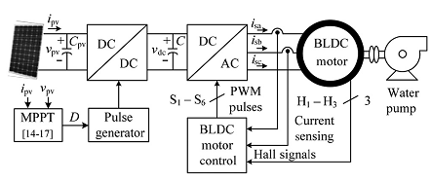
Fig.1. Conventional SPV-fed BLDC motor-driven water pumping system

II. CONFIGURATION OF PROPOSED SYSTEM
The structure of proposed SPV array-fed BLDC motordriven water pumping system employing a zeta converter is shown in Fig.3.2. The proposed system consists of (left toright) an SPV array, a zeta converter, a VSI, a BLDC motor,and a water pump. The BLDC motor has an inbuilt encoder.The pulse generator is used to operate the zeta converter. Astep-by-step operation of proposed system is elaborated inSection III in detail.

III. OPERATION OF PROPOSEDSYSTEM
The SPV array generates the electrical power demanded bythe motor-pump. This electrical power is fed to the motorpump via a zeta converter and a VSI. The SPV array appearsas a power source for the zeta converter as shown in Fig.2.Ideally, the same amount of power is transferred at the output of zeta converter which appears as an input source for theVSI. In practice, due to the various losses associated with a dc–dc converter [23], slightly less amount of power is transferredto feed the VSI. The pulse generator generates, through INCMPPT algorithm, switching pulses for insulated gate bipolartransistor (IGBT) switch of the zeta converter. The INC-MPPTalgorithm uses voltage and current as feedback from SPV arrayand generates an optimum value of duty cycle. Further, it generates actual switching pulse by comparing the duty cycle with ahigh-frequency carrier wave. In this way, the maximum powerextraction and hence the efficiency optimization of the SPVarray is accomplished.
The VSI, converting dc output from a zeta converter into ac,feeds the BLDC motor to drive awater pump coupled to itsshaft. The VSI is operated in fundamental frequency switchingthrough an electronic commutation of BLDC motor assisted byits built-in encoder. The high frequency switching losses arethereby eliminated, contributing in an increased efficiency ofproposed water pumping system.
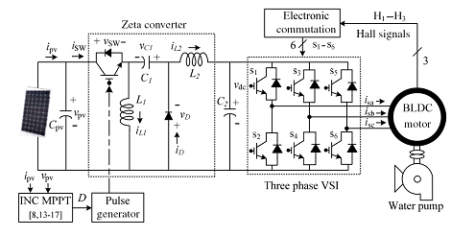
Fig.2. Proposed SPV-zeta converter-fed BLDC motor drive for water pump

IV. DESIGN OF PROPOSEDSYSTEM
Various operating stages shown in Fig.2 are properlydesigned to develop an effective water pumping system, capable of operating under uncertain conditions. A BLDC motor of2.89-kW power rating and an SPV array of 3.4-kW peak powercapacity under standard test conditions (STC) are selected todesign the proposed system. The detailed designs of variousstages such as SPV array, zeta converter, and water pump aredescribed as follows.
A. Design of SPV Array
As per above discussion, the practical converters are associated with various power losses. In addition, the performanceof BLDC motor-pump is influenced by associated mechanicaland electrical losses. To compensate these losses, the size ofSPV array is selected with slightly more peak power capacity to ensure the satisfactory operation regardless of powerlosses. Therefore, the SPV array of peak power capacity ofP_{mpp}=3.4 kW under STC (STC: 1000 W/m², 25ºC,AM 1.5), slightly more than demanded by the motor-pumpis selected and its parameters are designed accordingly.SolarWorld make Sunmodule Plus SW 280 mono [24] SPVmodule is selected to design the SPV array of an appropriatesize. Electrical specifications of this module are listed in Table 3.1 and numbers of modules required to connect in series/parallelare estimated by selecting the voltage of SPV array at MPPunder STC asV_{mpp}= 187.2V.
TABLE1
Specifications ofSunmoduleplusSW 280monoSPV Module
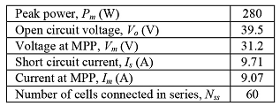
The current of SPV array at MPPI_{mpp}is estimated as
(1)
The numbers of modules required to connect in series are asfollows:
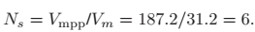 (2)
The numbers of modules required to connect in parallel areas follows:
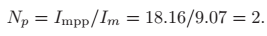 (3)
Connecting six modules in series, having two strings in parallel, an SPV array of required size is designed for the proposedsystem.

B. Design of Zeta Converter
The zeta converter is the next stage to the SPV array. Itsdesign consists of an estimation of various components such asinput inductorL₁, output inductor L₂, and intermediate capacitor C₁. These components are designed such that the zetaconverter always operates in CCM resulting in reduced stresson its components and devices. An estimation of the duty cycleDinitiates the design of zeta converter which is estimated as [6]
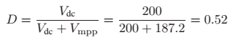 (4)
WhereV_{dc}is an average value of output voltage of the zeta converter (dc link voltage of VSI) equal to the dc voltage rating ofthe BLDC motor.
An average current flowing through the dc link of the VSII_{dc}is estimated as
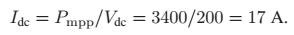 (5)
Then,L₁,L₂, andC₁ are estimated as
(6)
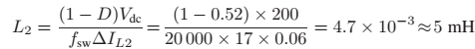 (7)
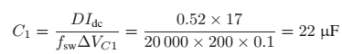 (8)
Wheref_{sw} is the switching frequency of IGBT switch of thezeta converter;ΔI_{L1}is the amount of permitted ripple in thecurrent flowing throughL₁,sameasI_{L1}=I_{mpp}; ΔI_{L2}is theamount of permitted ripple in the current flowing throughL₂,same as IL2=Idc; ΔVC1 is permitted ripple in the voltageacrossC₁,sameasV_{C1}=V_{dc}.

C. Estimation of DC-Link Capacitor of VSI
A new design approach for estimation of dc-link capacitor ofthe VSI is presented here. This approach is based on a fact that sixth harmonic component of the supply (ac) voltage is reflectedon the dc side as a dominant harmonic in the three-phase supplysystem [25]. Here, the fundamental frequencies of output voltage of the VSI are estimated corresponding to the rated speedand the minimum speed of BLDC motor essentially required pumping the water. These two frequencies are further used to estimate the values of their corresponding capacitors. Out of thesetwo estimated capacitors, larger one is selected to assure a satisfactory operation of proposed system even under the minimumsolar irradiance level.
The fundamental output frequency of VSI corresponding tothe rated speed of BLDC motorω_{rated}is estimated as
(9)
The fundamental output frequency of the VSI correspondingto the minimum speed of the BLDC motor essentially requiredto pump the water(N= 1100r/min)ω_{min}is estimated as
(10)
Wheref_{rated} andf_{min}are fundamental frequencies of outputvoltage of VSI corresponding to a rated speed and a minimumspeed of BLDC motor essentially required to pump the water,respectively, in Hz;N_{rated}is rated speed of the BLDC motor;Pis a number of poles in the BLDC motor.
The value of dc link capacitor of VSI atω_{rated}is as follows:
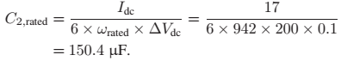 (11)
Similarly, a value of dc link capacitor of VSI atω_{min}is asfollows:
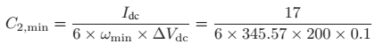(12)
WhereΔV_{dc}is an amount of permitted ripple in voltage acrossdc-link capacitorC₂.Finally, C₂= 410µF is selected to design the dc-linkcapacitor.

D Design of Water Pump
To estimate the proportionality constantKfor the selectedwater pump, its power–speed characteristics [26], [27] isused as
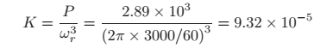 (13)
WhereP=2.89 kWis rated power developed by the BLDC motor and ω_{r} is rated mechanical speed of the rotor (3000r/min) in rad/s.
A water pump with these data is selected for proposedsystem.
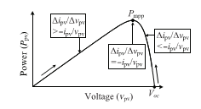
Fig.3. Illustration of INC-MPPT with SPV array P_{pv}−v_{pv} characteristics.

TABLE.2 Switching States for Electronic Commutation of BLDC Motor
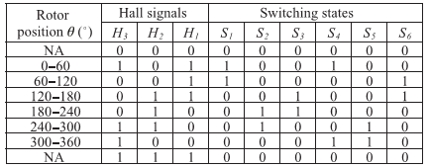

V. CONTROL OFPROPOSEDSYSTEM
The proposed system is controlled in two stages. These two control techniques, viz., MPPT and electronic commutation, are discussed as follows.

A. INC-MPPT Algorithm
An efficient and commonly used INC-MPPT technique [8],[13] in various SPV array based applications is utilized in orderto optimize the power available from a SPV array and to facilitate a soft starting of BLDC motor. This technique allows perturbation in either the SPV array voltage or the duty cycle.The former calls for a proportional-integral (PI) controller togenerate a duty cycle [8] for the zeta converter, which increasesthe complexity. Hence, the direct duty cycle control is adaptedin this work. The INC-MPPT algorithm determines the direction of perturbation based on the slope of Ppv−vpv curve, shown in Fig.3. As shown in Fig.3, the slope is zero at MPP, positive on the left, and negative on the right of MPP, i.e.,
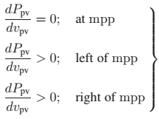(14)
Since
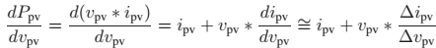 (15)
Therefore, (14) is rewritten as
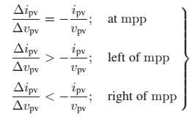 (16)
Thus, based on the relation between INC and instantaneousconductance, the controller decides the direction of perturbation as shown in Fig. 3, and increases/decreases the dutycycle accordingly. For instance, on the right of MPP, the dutycycle is increased with a fixedperturbation size until the direction reverses. Ideally, the perturbation stops once the operatingpoint reaches the MPP. However, in practice, operating pointoscillates around the MPP.
As the perturbation size reduces, the controller takes moretime to track the MPP of SPV array. An intellectual agreementbetween the tracking time and the perturbation size is held tofulfill the objectives of MPPT and soft starting of BLDC motor.In order to achieve soft starting, the initial value of duty cycle isset as zero. In addition, an optimum value of perturbation size(ΔD=0.001)is selected, which contributes to soft startingand also minimizes oscillations around the MPP.

B. Electronic Commutation of BLDC Motor
The BLDC motor is controlled using a VSI operated throughan electronic commutation of BLDC motor. An electronic commutation of BLDC motor stands for commutating the currentsflowing through its windings in a predefined sequence using decoder logic. It symmetrically places the dc input current atthe center of each phase voltage for 120º. Six switching pulsesare generated as per the various possible combinations of threeHall-effect signals. These three Hall-effect signals are producedby an inbuilt encoder according to the rotor position.
A particular combination of Hall-effect signals is producedfor each specific range of rotor position at an interval of60º[5], [6]. The generation of six switching states with theestimation of rotor position is tabularized in Table II. It is perceptible that only two switches conduct at a time, resultingin 120ºconduction mode of operation of VSI and hence thereduced conduction losses. Besides this, the electronic commutation provides fundamental frequency switching of the VSI;hence, losses associated with high-frequency PWM switching are eliminated. A motor power company makes BLDC motor[28] with inbuilt encoder is selected for proposed system andits detailed specifications are given in the Appendixes.

VI. CLOSED LOOP SPEED CONTROL OF BLDC MOTOR
In the sensored BLDC drive, hall sensors or a shaft encoder is used to obtain the rotor position information. The drivecontrol system consists of an outer speed loop for speed control and an inner current loop for current control.Conventionally three separate current sensors are used to measure the phase currents. But here only one current sensoris used, which is placed on the DC link.

A. Speed control
The speed control block uses a Proportional Integral(PI) controller. A PI controller attempts to correct the errorbetween a measured process variable and desired set point by calculating and then outputting a corrective action thatcan adjust the process accordingly. The PI controller calculation involves two separate modes the proportional modeand the integral mode. The proportional mode determine the reaction to the current error, integral mode determines thereaction based recent error. The weighted sum of the two mode output as corrective action for the control element. ThePI controller is widely used in the industry due to its ease in design and simple structure. The PI controller algorithmcan be implemented as
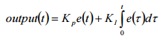 (17)
Here the input to speed controller is the speed error. The output of the controller is considered as a reference torque. Alimit is put on the speed controller output depending on permissible maximum winding currents.

VII. MATLAB/SIMULATION RESULTS
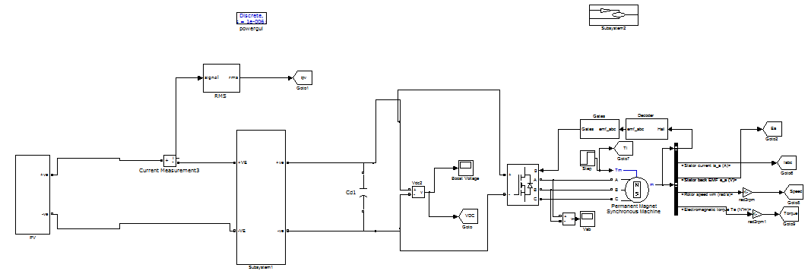
Fig. 4 Matlab/Simulink circuit of Starting and steady-state performances of the proposed SPV arraybased zeta converter-fed BLDC motor drive for water pump

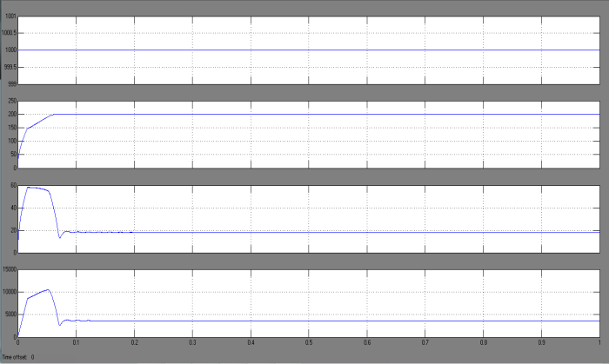
(a)
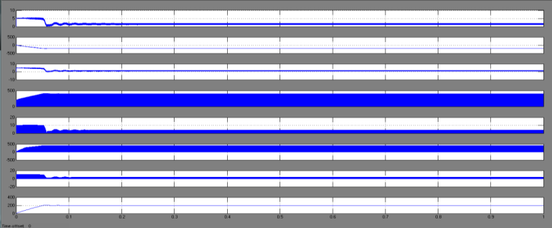
(b)
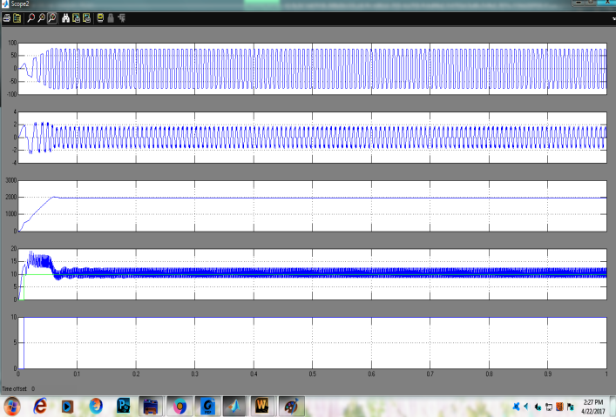
(c)
Fig.5 Starting and steady-state performances of the proposed SPV arraybased zeta converter-fed BLDC motor drive for water pump. (a) SPV arrayvariables. (b) Zeta converter variables. (c) BLDC motor-pump variables.

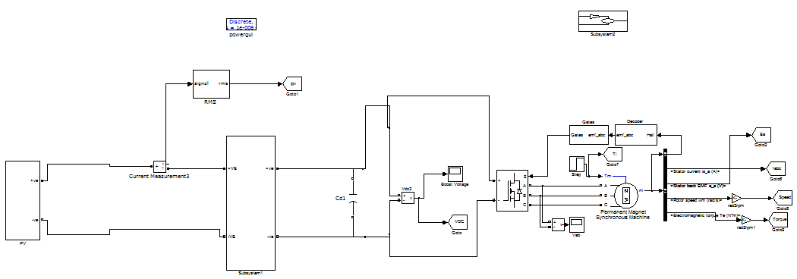
Fig.6 Matlab/Simulink circuit for Dynamic performance of SPV array-based zetaconverter-fed BLDC motor drive for water pump
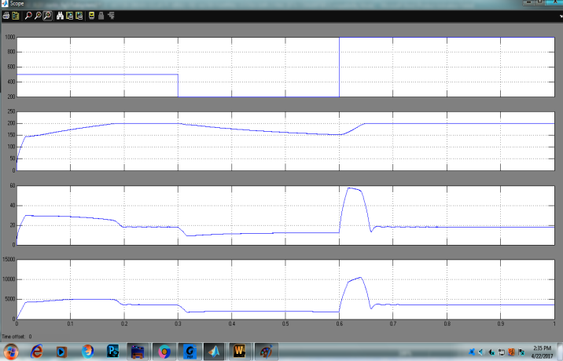
(a)
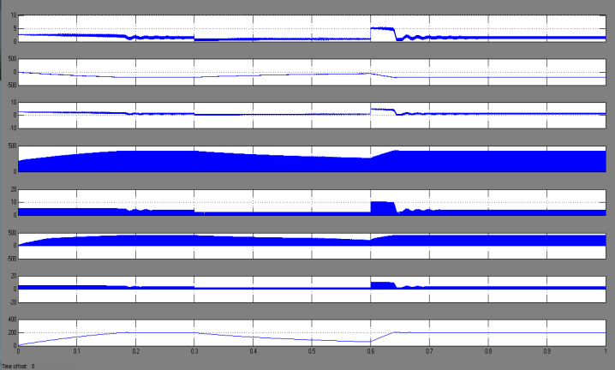
(b)
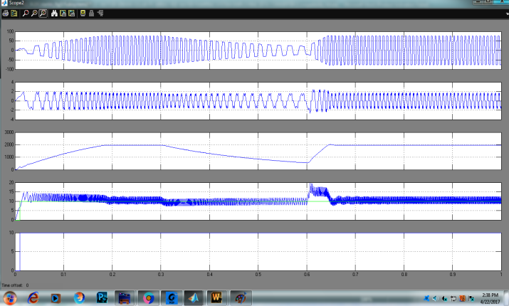
(c)
Fig.7 Dynamic performances of the proposed SPV array-based zeta converter-fed BLDC motor drive for water pump. (a) SPV array variables. (b) Zeta converter variables. (c) BLDC motor-pump variables.

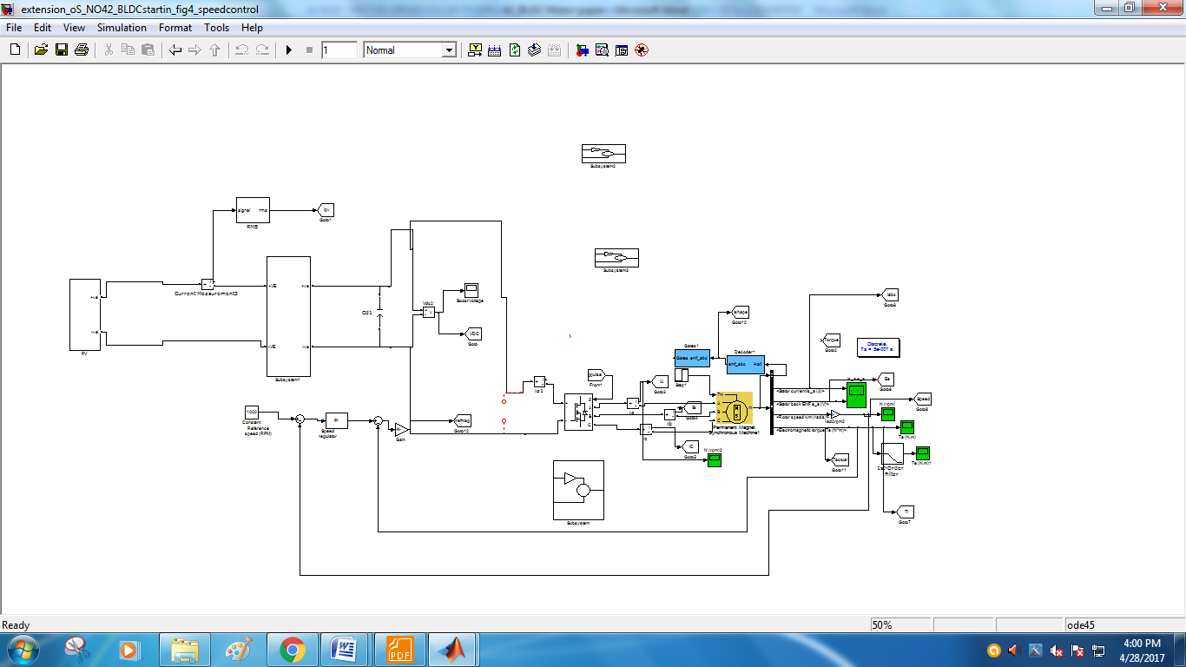
Fig.8 Matlab/Simulink circuit of SPV array-based zetaconverter-fed BLDC motor drive Closed loop control for water pumping system.

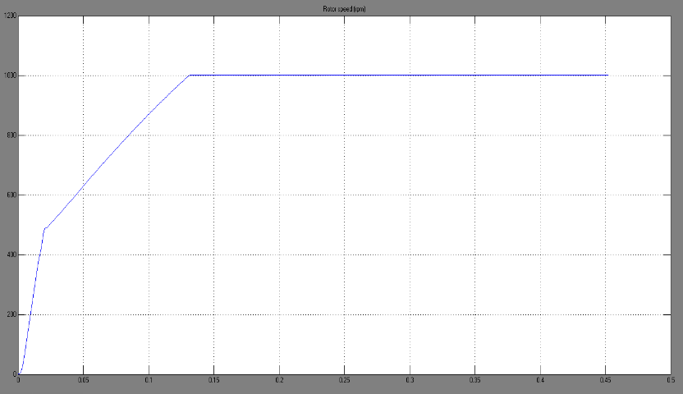
Fig.9 Speed.

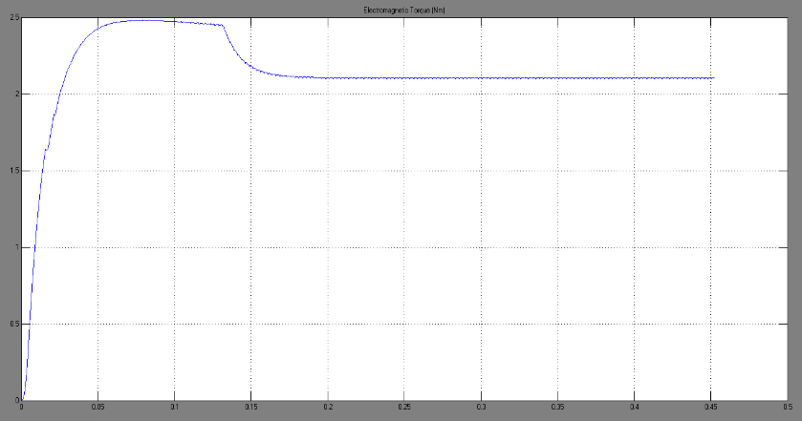
Fig.10 Torque.

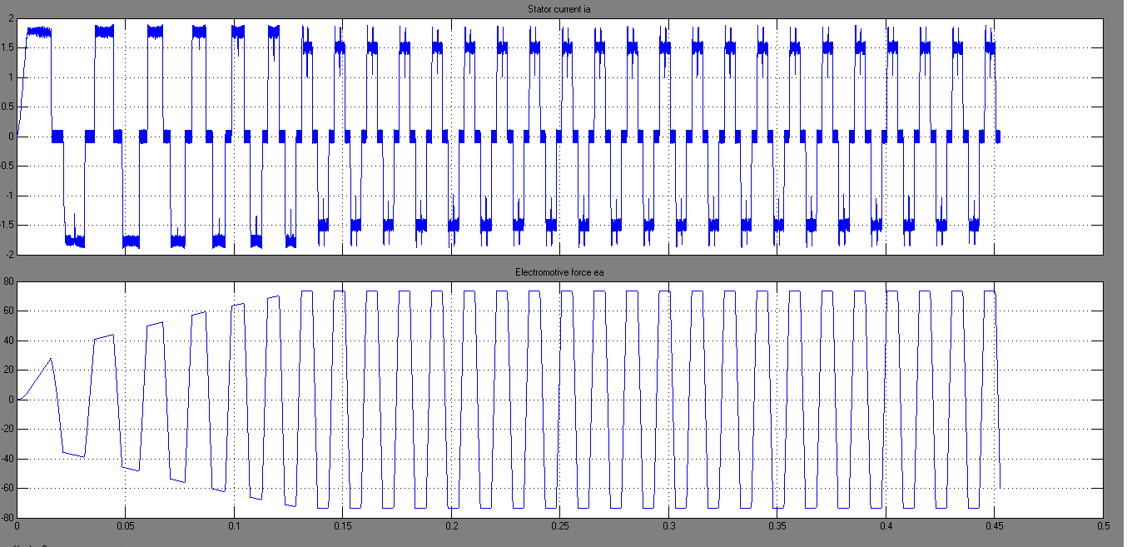
Fig.11 Stator current and emf.

VIII CONCLUSION
A solar photovoltaic array fed Zeta converter based BLDCmotor has been proposed to drive water-pumping system. Theproposed system has been designed, modeled and simulatedusing MATLAB along with its Simulink and simpowersystemtoolboxes. Simulated results have demonstrated thesuitability of proposed water pumping system. SPV array hasbeen properly sized such that system performance is notinfluenced by the variation in atmospheric conditions and theassociated losses and maximum switch utilization of Zeta converter is achieved. Zeta converter has been operated inCCM in order to reduce the stress on power devices. Operatingthe VSI in conduction mode with fundamental frequencyswitching eliminates the losses caused by high frequencyswitching operation. Stable operations of motor-pump systemand safe starting of BLDC motor are other important featuresof the proposed system.

REFERENCES
[1] M. Uno and A. Kukita, “Single-switch voltage equalizer using multistacked buck–boost converters for partially-shaded photovoltaic modules,”IEEE Trans. Power Electron., vol. 30, no. 6, pp. 3091–3105, Jun.2015.

[2] R. Arulmurugan and N. Suthanthiravanitha, “Model and design of afuzzy-based Hopfield NN tracking controller for standalone PV applications,”Elect. Power Syst. Res., vol. 120, pp. 184–193, Mar. 2015.

[3] S. Satapathy, K. M. Dash, and B. C. Babu, “Variable step size MPPTalgorithm for photo voltaic array using zeta converter—A comparativeanalysis,” inProc. Students Conf. Eng. Syst. (SCES), Apr. 12–14, 2013,pp. 1–6.

[4] R. Kumar and B. Singh, “BLDC motor driven solar PV array fed waterpumping system employing zeta converter,” inProc. 6th IEEE India Int.Conf. Power Electron. (IICPE), Dec. 8–10, 2014, pp. 1–6.

[5] B. Singh, V. Bist, A. Chandra, and K. Al-Haddad, “Power factor correction in bridgeless-Luo converter-fed BLDC motor drive,” IEEE Trans.Ind. Appl., vol. 51, no. 2, pp. 1179–1188, Mar./Apr. 2015.

[6] B. Singh and V. Bist, “Power quality improvements in a zeta converterfor brushless dc motor drives,” IET Sci. Meas. Technol., vol. 9, no. 3,pp. 351–361, May 2015.

[7] R. F. Coelho, W. M. dos Santos, and D. C. Martins, “Influence of powerconverters on PV maximum power point tracking efficiency,” inProc.10th IEEE/IAS Int. Conf. Ind. Appl. (INDUSCON), Nov. 5–7, 2012,pp. 1–8.

[8] M. A. Elgendy, B. Zahawi, and D. J. Atkinson, “Assessment of the incremental conductance maximum power point tracking algorithm,”IEEETrans. Sustain. Energy, vol. 4, no. 1, pp. 108–117, Jan. 2013.

[9] M. Sitbon, S. Schacham, and A. Kuperman, “Disturbance observerbased voltage regulation of current-mode-boost-converter-interfaced photovoltaic generator,”IEEE Trans. Ind. Electron., vol. 62, no. 9, pp. 5776–5785, Sep. 2015.

[10] R. Kumar and B. Singh, “Buck–boost converter fed BLDC motor drivefor solar PV array based water pumping,” inProc. IEEE Int. Conf. PowerElectron. Drives Energy Syst. (PEDES), Dec. 16–19, 2014, pp. 1–6.

[11] A. H. El Khateb, N. Abd. Rahim, J. Selvaraj, and B. W. Williams, “DCto-dc converter with low input current ripple for maximum photovoltaicpower extraction,”IEEE Trans. Ind. Electron., vol. 62, no. 4, pp. 2246–2256, Apr. 2015.

[12] D. D. C. Lu and Q. N. Nguyen, “A photovoltaic panel emulator usinga buck–boost dc/dc converter and a low cost micro-controller,”SolarEnergy, vol. 86, no. 5, pp. 1477–1484, May 2012.

[13] Z. Xuesong, S. Daichun, M. Youjie, and C. Deshu, “The simulationand design for MPPT of PV system based on incremental conductancemethod,” inProc. WASE Int. Conf. Inf. Eng. (ICIE), Aug. 14–15, 2010,vol. 2, pp. 314–317.

[14] A. R. Reisi, M. H. Moradi, and S. Jamasb, “Classification and comparisonf maximum power point tracking techniques for photovoltaic system: Areview,”Renew. Sustain. Energy Rev., vol. 19, pp. 433–443, Mar. 2013.

[15] B. Bendib, H. Belmili, and F. Krim, “A survey of the most used MPPTmethods: Conventional and advanced algorithms applied for photovoltaicsystems,”Renew. Sustain. Energy Rev., vol. 45, pp. 637–648, May 2015.

