AN EFFICIENT WIRELESS TRACKING SYSTEM FOR AT-HOME MEDICAL INSTRU-MENTATION DURING NATURAL DISASTERS
*T.ANAND, **M.KIRAN
*PG Scholar, ES, Dept of ECE, Kakinada Institute of Engineering and Amp; Technology-II, Korangi, A.P.
**Associate Professor, Dept of ECE, Kakinada Institute of Engineering and Amp; Technology-II, Korangi, A.P.

ABSTRACT:
Electricity-operated durable medical equipment (DME), such as ventilators, dialysis machines, and patient monitoring devices, are life-supporting machines used extensively by patients at home. While convenient and economical, at-home use of DME is susceptible to power outages. especially the ones caused by natural disasters that often occur in large area and for a long duration. There is little existing technology allowing hospitals to monitor DME-dependent patients without using the current infrastructure, such as the landlines, the cell towers, Ethernet cable or the Internet. Reported herein is a novel wireless system that utilizes a radio ad hoc network to automatically report the patient’s information and location, and the DME information and status to a nearby hospital when a power outage is detected. This system consists of two parts: a hospital-based receiving device, called the Base Station node, and multiple transmitting devices, called User Nodes, each connected to the DME at patients’ homes.

Keywords: SENSORS, GPS, ZIGBEE.

I. INTRODUCTION
Durable medical equipment (DME) is any medical device used at home by patients for monitoring and/or treating diseases. There are two types of DME: passive equipment and active equipment, the latter reliant on electricity to operate. Life-supporting active DME include dialysis machines, ventilators, oxygen concentrators, etc. At-home use of DME is not only convenient and economical, but also leads to a better quality of life for the patient. at-home DME are equipped with integrated batteries to keep them functioning during power outages, their rechargeable batteries typically last only 1 hour with lead-acid batteries and2-3 hours with newer lithium-ion batteries. Thus, there is a critical need for a means of communication between the medical staff at a hospital and patients at home
II. PROPOSED METHOD
In this paper we present a novel system using GPS, ZIGBEE are attached to person.ECG is used to measure the heart beat rate of the person. GPS will turn on to find out the location in the form of latitude and longitude. Once the controller gets the information from these devices information to specialist node as well as nearby hospital zones using ZIGBEE. Our system is designed by using ARM 32-bit micro processor and developing for elderly people. The main advantage of this system is it reduces unnecessary wastage of memory storage as well as it saves power.

III.HARDWARE SYSTEM
To solve the communication issue when the infrastructure is disabled and help DME-dependent patients, it was proposed to engineer a novel DME tracking and reporting system based on wireless odes with radios following the Zigbee specifications operating at the frequency band of 2.4 GHz and consuming little power, though transmitting at short distances and at low data rates. This system would comprise of two parts: multiple transmitting devices located in patients’ homes and connected to patients’ DME, called User Nodes, for gathering relevant live data to be transferred to the hospital and one central receiving device located in a local hospital, called the Base Station, for collecting the patient and DME information sent by the User Nodes. The system would have a modular design and scalable implementation, providing flexibility for further optimizations (for example, substituting the current radio module with other radios that have the same interface).Furthermore, each User Node would also have the feature of an internal rechargeable battery, charging when power line voltage is present, at which time the User Nodes are only able to relay other nodes’ information. When a break of AC power supply is detected at a certain location, the user node would send information towards the Base Station in the hospital. The information includes patient information (i.e., name, age, dissease, type and brand of DME being used, etc.), GPSlocation of the patient and DME, and the power outage status (i.e. how long the DME has been running using battery power And how much battery life is remaining). All patient data and information would be encrypted with symmetric-key encryption so that only the administering hospital could receive and decrypt the information in compliance of the HIPAA laws
Micro controller: This section forms the control unit of the whole project. This section basically consists of a Microcontroller with its associated circuitry like Crystal with capacitors, Reset circuitry, Pull up resistors (if needed) and so on. The Microcontroller forms the heart of the project because it controls the devices being interfaced and communicates with the devices according to the program being written.
ARM7TDMI: ARM is the abbreviation of Advanced RISC Machines, it is the name of a class of processors, and is the name of a kind technology too. The RISC instruction set, and related decode mechanism are much simpler than those of Complex Instruction Set Computer (CISC) designs.
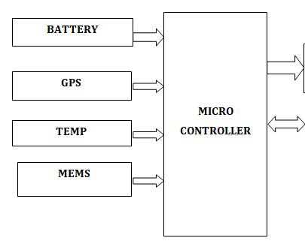
Liquid-crystal display (LCD) is a flat panel display, electronic visual display that uses the light modulation properties of liquid crystals. Liquid crystals do not emit light directly. LCDs are available to display arbitrary images or fixed images which can be displayed or hidden, such as preset words, digits, and 7-segment displays as in a digital clock

Fig 1. Block diagram

III. BOARD HARDWARE SYSTEM FEATURES

Temperature sensor
A thermistor is a type of resistor whose resistance is dependent on temperature. Thermistors are widely used as inrush current limiter, temperature sensors (NTC type typically), self-resetting over current protectors, and self-regulating heating elements. The TMP103 is a digital output temperature sensor in a four-ball wafer chip-scale package (WCSP). The TMP103 is capable of reading temperatures to a resolution of 1°C.
GPS
Global Positioning System (GPS) technology is changing the way we work and play. You can use GPS technology when you are driving, flying, fishing, sailing, hiking, running, biking, working, or exploring. With a GPS receiver, you have an amazing amount of information at your fingertips. Here are just a few examples of how you can use GPS technology.
ZIGBEE
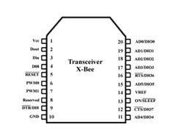
Zigbee modules feature a UART interface, which allows any microcontroller or microprocessor to immediately use the services of the Zigbee protocol. All a Zigbee hardware designer has to do in this caseis ensure that the host’s serial port logic levels are compatible with the XBee’s 2.8- to 3.4-V logic levels. The logic level conversion can be performed using either a standard RS-232 IC or logic level translators such as the 74LVTH125 when the host is directly connected to the XBee UART. The X- Bee RF Modules interface to a host device through a logic-level asynchronous Serial port. Through its serial port, the module can communicate with any logic and voltage Compatible UART; or through a level translator to any serial device.Data is presented to the X-Bee module through its DIN pin, and it must be in the asynchronous serial format, which consists of a start bit, 8 data bits, and a stop bit. Because the input data goes directly into the input of a UART within the X-Bee module, no bit inversions are necessary within the asynchronous serial data stream. All of the required timing and parity checking is automatically taken care of by the X-Bee’s UART.

Fig 2: ZIGBEE pin diagram

MEMS
Micro-Electro-Mechanical Systems (MEMS) is the integration of mechanical elements, sensors, actuators, and electronics on a common silicon substrate through micro fabrication technology. While the electronics are fabricated using integrated circuit (IC) process sequences (e.g., CMOS, Bipolar, or BICMOS processes), the micro mechanical components are fabricated using compatible "micromachining" processes that selectively etch away parts of the silicon wafer or add new structural layers to form the mechanical and electromechanical devices. MEMS promises to revolutionize nearly every product category by bringing together silicon- based microelectronics with micromachining technology, making possible the realization of complete systems-on-a-chip. MEMS is an enabling technology allowing the development of smart products, augmenting the computational ability of microelectronics with the perception and control capabilities of micro sensors and micro actuators and expanding the space of possible designs and applications

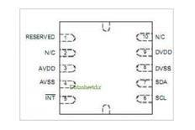

Fig 3: MEMS IC

IV.RESULT
The requirement for securely transmitting patient data, location information, and the status of DME to a nearby hospital during power outages.
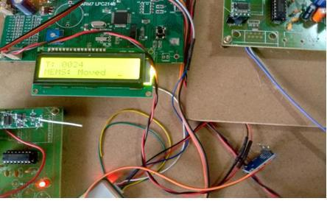

Fig 4 A Wireless system for at home medical equipment during natural disasters

ADVANTAGES:
It is used to provide the security.
Automatic monitoring system.
It avoids potential human errors.

APPLICATIONS:
Accident detection for older people.
Medical applications

V.CONCLUSION
Given testing data, it was found that the prototype design of the DME tracking system was feasible to implement and would meet the requirement for securely transmitting patient data, location information, and the status of DME to a nearby hospital during power outages. Although the maximum radio range for the current pilot prototype was found to be 90 m, the advantage of modular design allows this proof-of-concept system to be easily scalable by simply employing more powerful radio modules or having specially placed forwarding nodes to facilitate the forwarding of information from more distant homes. In a medium patient density situation, for instance, a radio with an indirect (i.e. non line-of-sight) range of >4.70 km could be employed. Additionally, the implementation of this DME tracking system is relatively inexpensive, utilizing commercially available low cost general-purpose microcontrollers and general-purpose radios. When produced in one circuit in mass production, the cost will be even lowered. This novel DME tracking system provides a critical link between the DME-dependent patients and the hospital during natural disasters. Further research and optimization of this system is underway.

REFERENCES

- B. Norman. What Will You Do if the Power Goes Out? http://alsn.mda.org/article/what-will-you-do-if-power-goes-out

- HHS Press Office. HHS selects winners in idea challenge for emergency response. http://www.hhs.gov/news/press/2014pres/02 /20140220a.html

- GPS Trackers for Today’s World. http://www.pocketfinder.com/

- Zoombak Personal GPS Locators. The next generation Zoombak is e Zoom.
http://www.securusgps.com/zoombak.aspx

- Spark Fun Xbee shield. https://www.sparkfun.com/products/12847

- Teensy USB Development Board. https://www.pjrc.com/teensy/

- ZigBee® Alliance. http://www.zigbee.org/

8. Zig Bee.
http://en.wikipedia.org/wiki/ZigBee

- Health Information Privacy. http://www.hhs.gov/ocr/privacy/

