FOCUS THE EFFECT OF PARTIAL REPLACEMENT OF NATURAL SAND AND ROBO SAND
¹S. PRANAY KUMAR, ²K.NARESH, ³M.MADHAN KUMAR, ⁴K SAI KIRAN
^{1,2,3,4}Department of Civil Engineering, Malla Reddy Engineering College And Management Sciences, Kistapur, Medchal.
ABSTRACT
Nowadays the construction industry within the India is going through one of the essential problem that is herbal satisfactory mixture. And courtroom presented overall ban on excavation of first-class aggregate from river due to the fact to be able to have an effect on environment and alternate the river course. Cement, sand and combination are primary needs for any construction industry. Sand is a high material used for coaching of mortar and concrete and which plays a chief role in mix design. Now a day’s erosion of rivers and thinking about environmental problems, there's an absence of river sand. The nonavailability or scarcity of river sand will have an effect on the development industry; therefore there may be a need to discover the brand new alternative material to replace the river sand, such that excess river erosion and damage to environment is avoided. Many researchers are finding exclusive substances to update sand and one of the primary substances is quarry stone dirt (synthetic/Robo/M -SAND). using distinctive percentage of this robo sand along side sand the desired concrete mix maybe received. substitute of natural first-class mixture is completed with synthetic fine mixture by way of 20%, 40% 60% and additionally the compressive strength of that concrete dice is discovered. This paper gives a review of the specific alternatives to herbal sand in guidance of concrete and the physical and mechanical homes and power component on concrete.

Keywords: Robo, Natural sand, cement, concrete, course aggregate, Physical Properties, Mechanical Properties.

- INTRODUCTION

Concrete, sand and total are fundamental requirements for any development industry. Sand is a noteworthy material utilized for planning of mortar and concrete and assumes a most essential part in blend outline. By and large utilization of characteristic sand is high, because of the huge utilization of cement and mortar. Henceforth the request of normal sand is high in creating nations to fulfill the quick foundation development. The creating nation like India confronting lack of good quality normal sand and especially in India, regular sand stores are being spent and making genuine risk condition and also the general public. Quick extraction of sand from stream bed causing such a large number of issues like losing water holding soil strata, developing of the waterway quaint little inns

bank slides, loss of vegetation on the bank of streams, irritates the oceanic life and also bothers horticulture because of bringing down
the water table in the well and so on are a portion of the illustrations. The overwhelming
abuse of stream sand for development purposes in Sri Lanka has prompted different hurtful issues. Choices for different stream sand choices, for example, seaward sand, quarry clean and sifted sand, Physical and compound properties of fine total influence the toughness, workability and furthermore quality of solid, so fine total is a most vital constituent of cement and bond mortar. By and large stream sand or pit sand is utilized as fine total in mortar and cement. Together fine and coarse total make around 75-80 % of aggregate volume of cement and subsequently it is critical to fine appropriate compose and great quality total close-by site Recently common sand is turning into an expensive material due to its request in the development business because of this condition investigate started for shoddy and effectively accessible elective material to normal sand. A few choices materials have just been utilized as a substitution of common sand, for example, fly-cinder, quarry tidy or limestone and siliceous stone powder, separated sand, copper slag are utilized as a part of cement and mortar blends as an incomplete or full substitution of normal sand
Even however seaward sand is really utilized as a part of numerous nations, for example, the UK, Sri Lanka, Continental Europe, But in India and Singapore the majority of the records in regards to utilization of this elective discovered mostly as a lesser degree of training in the development field. Because of deficiency of waterway sand and additionally its high the Madras High Court confinements on sand mining in streams Cauvery and Tamirabharani And Andhra Pradesh government has limited mining of characteristic sand in stream Godavari, The administration of Telangana quit utilizing normal sand government developments the announcement had given by legislature of Telangana bureau for utilizing ROBO SAND/M-SAND and began a mindfulness program among individuals for utilization of simulated sand set up of common sand (T. Harish Rao Minister for Irrigation, Marketing and Legislative Affairs ). The actualities like in India is relatively same in others nations too. So hence he have to locate an elective cement and mortar total material to waterway sand in development works has accepted more noteworthy significance now a days. Analyst and Engineers have turned out with their own plans to diminish or completely supplant the utilization of waterway sand and utilize late developments, for example, M-Sand (fabricated sand), robot silica or sand, stone crusher tidy, sifted sand, treated and sieved sediment expelled from supplies and in addition dams other than sand from other. water bodies. Then again, need in required quality is the real restriction in a portion of the above materials. Presently a day's reasonable infrastructural development requires the elective material that ought to fulfill specialized necessities of fine total and also it ought to be accessible locally with expansive sum. Today Indian Standards are extensively utilized for guaranteeing nature of development of structures and different structures, which are currently a-days to a great extent subject to solid developments. Department of Indian Standards, the National Standards Body of the nation, thinking about the shortage of sand and coarse totals from normal sources, has developed number of options which are eventually gone for preservation of regular assets separated from advancing utilization of different waste materials without trading off in quality. These measures incorporate allowing in the Concrete Code (IS 456) as additionally in the National Building Code of India, the utilization of slag - a loss from steel industry, fly powder - a loss from warm power plants, pounded over-consumed blocks and tiles - squander from dirt block and tile industry, in plain bond concrete as an other option to sand/common total, subject to satisfying the prerequisites of the Code. This Code, further, empowers utilization of fly fiery remains and ground granulated impact heater slag as part substitution of customary Portland bond in plain and in addition strengthened bond concrete. This part substitution could be of the request of 35% and 70% for fly fiery remains and slag separately along these lines bearing a huge scale sparing of common limestone holds which would have generally drained if there should arise an occurrence of the utilization of standard Portland bond without such substitution. Not just this, the Code features how toughness of cement can be enhanced with the utilization of these supplementary cementations materials. The Indian Standard on solid blend configuration (IS10262) has been moved up to incorporate direction and cases of planning concrete blends utilizing fly fiery debris and slag. Arrangements for consistence for essential nature of cement influenced utilizing fly fiery remains and slag to have been properly secured for the makers of prepared blended cement in the Indian Standard Code of training for RMC (IS 4926).

2. Alternative Materials to River Sand
The world is resting over a landfill of waste hazardous materials which may substitutes for natural sand. Irrespective of position, location, scale, type of any structure, concrete is the base for the construction activity. Some of the researchers did the work to find the alternatives for natural sand and they concluded about different industrial waste and their ability to replace the much sought after natural river bed sand.

A. Copper Slag
At present about 33 million tons of copper slag is generating annually worldwide among that India contributing 6 to 6.5 million tones. 50 % copper slag can be used as replacement of natural sand in to obtain mortar and concrete with required performance, strength and durability. (Khalifa S. Al-Jabri et al 2011). In India a study has been carried out by the Central Road Research Institute (CRRI) shown that copper slag may be used as a partial replacement for river sand as fine aggregate in concrete up to 50 % in pavement concrete without any loss of compressive and flexural strength and such concretes shown about 20 % higher strength than that of conventional cement concrete of the same grade.

B. Washed Bottom Ash (WBA)
Currently India is producing in over 100 million tons of coal ash. From which total ash produced in any thermal power plant is approx 15 –20 per cent of bottom ash and the rest is fly ash. Fly ash has found many users but bottom ash still continues to pollute the environment with unsafe disposal mechanism on offer. The mechanical properties of special concrete made with 30 per cent replacement of natural sand with washed bottom ash by weight has an optimum usage in concrete in order to get a required strength and good strength development pattern over the increment ages.

C. Quarry Dust
About 20 to 25 per cent of the total production in each crusher unit is left out as the waste material-quarry dust. The ideal percentage of the replacement of sand with the quarry dust is 55 per cent to 75 per cent in case of compressive strength. He further says that if combined with fly ash (another industrial waste), 100 per cent replacement of sand can be achieved. The use of fly ash in concrete is desirable because of benefits such as useful disposal of a byproduct, increased workability, reduction of cement consumption, increased sulfate resistance increased resistance to alkalisilica reaction and decreased permeability. However, the use
of fly ash leads to a reduction in early strength of concrete. Therefore, the concurrent use of quarry dust and fly ash in concrete will lead to the benefits of using such materials being added and some of the undesirable effects being negated.
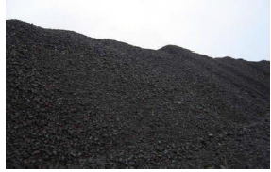
Fig.1. Copper slag
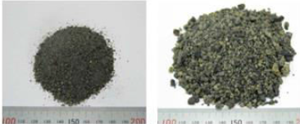
Fig.2. Washed Bottom Ash
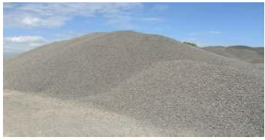
Fig.3. Quarry Dust

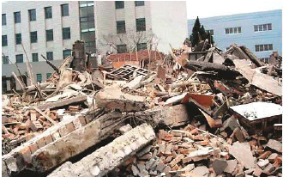
Fig.4. Construction and Demolition waste

D. Construction and Demolition waste
There is no documented quantification of amount of construction and demolition (C&D) waste being generated in India. Municipal Corporation of Delhi says it is collecting 4,000 tones of C&D waste daily from the city which amounts to almost 1.5 million tons of waste annually in the city of Delhi alone. Even if we discount all the waste which is illegally dump around the city, 1.5 million of C&D waste if recycled can significantly substitute demand for natural sand by Delhi. Recycled sand and aggregate from C&D waste is said to have 10-15 per cent lesser strength then normal concrete and can be safely used in non-structural applications like flooring and filling. Delhi already has a recycling unit in place and plans to open more to handle its disposal problem. Construction and demolition waste generated by the construction industry and which posed an environmental challenge can only be minimized by the reuse and recycling of the waste it generates

3. Materials Used

The properties of various materials used in making the concrete (M25) are discussed in the following sections.

A. Cement
Ordinary Portland cement of 43 grades satisfying all the requirements of IS 8112-1989 was used in making the concrete slab panels and cubes in the experimental work.See Table I.

B. Natural (River) Sand
The natural sand having fineness modulus of 2.78 and conforming to zone II as per IS: 383-1970 was used for the experimentation after washing it with clean water. The specific gravity of this natural sand was found to be 2.55. The water absorption and moisture content values obtained
for the sand used was found to be 6% and 1.0% respectively.

C. Artificial sand (Robo sand)
The crushed sand having fineness modulus of 2.81 and conforming to zone II as per IS: 383-1970 was used for the experimentation after washing it with clean water. The specific gravity of this artificial sand was found to be 2.66. The water absorption and moisture content values obtained for the sand used was found to be 6.5% and 1.0% respectively.See Table II.

D. Coarse Aggregate
Crushed stone aggregates of 20mm size obtained from local quarry site were used for the experimentation. The fineness modulus of coarse aggregates was found to be 6.3with a specific gravity of 2.76 the water absorption and moisture content values obtained for the sand used was found to be 2.5% and 0.5% respectively.

Table I. Typical properties of Cement 43 grade IS 8112-1989
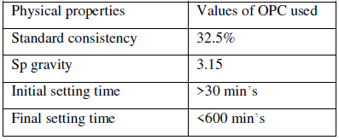
Table II. Properties of Fine aggregate
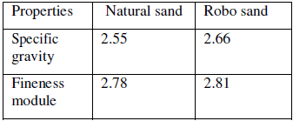

E. Robo sand and properties
The artificial/robo sand produced by proper machines can be a better substitute to river sand. The sand must be of proper gradation (it should have particles from 150 microns to 4.75 mm in proper proportion). Robo sand is a purified form of quarry dust with is extracted from manufacturing of coarse aggregate which mostly in the form of chips. These baby chips are crushed to the specified size of 0-4.75mm as required. In fact both natural sand and robo sand look similar. They don’t differ in many properties like water absorption. But now there they started manufacturing separate for sand.

F. General Requirements of Manufactured Sand
All the sand particles should have higher crushing strength. The surface texture of the particles should be smooth. The edges of the particles should be grounded. The ratio of fines below 600 microns in sand should not be less than 30%. There should not be any organic impurities. Silt in sand should not be more than 2%, for crushed sand. In manufactured sand the permissible limit of fines below 75 microns shall not exceed 15%.

G. Properties of Robo sand
Table III. Average properties from all manufacturing units (Robo silica Pvt. Ltd.)
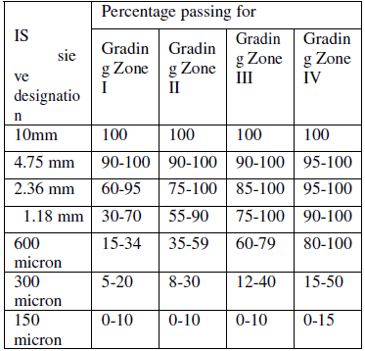

H. Fineness Modulus and Zone classification
The results of aggregate sieve analysis are expressed by a number called Fineness Modulu that is obtained by adding the sum of the cumulative percentages by mass of a sample aggregate retained on each of a specified series of sieves and dividing the sum by 100. The specified sieves are: 150μm (No. 100), 300μm (No. 50), 60μm (No. 30), 1.18 mm (No. 16), 2.36 mm (No. 8), 4.75 mm (No. 4), 9.5 mm , 19.0 mm , 37.5 mm , 75 mm , and 150 mm. Fineness modulus of Natural sand = 278 ÷ 100 = 2.78 Fineness modulus of Robo = 281 ÷ 100 = 2.81
As per the above results the Natural sand(NS) and Robo Sand (RS)both are of Zone –II. And fineness module of Natural sand is 2.78 and Robo sand is 2.81.
Table IV. IS classification of zones (IS 383-1970)
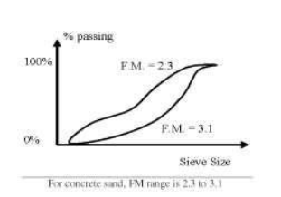
Fig.5. Graph showing fineness modules range for Concrete
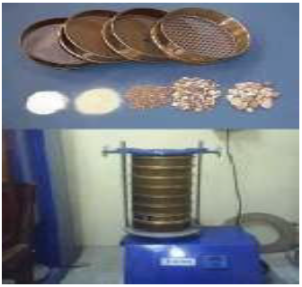
Fig.6. Sieve Analysis of Fine aggregate and Coarse Aggregate

Table V.Fineness modulus and Zone classification
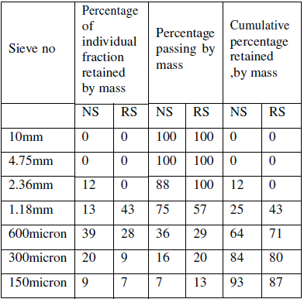

4. Types of mixes:

A. Standard mixes
The nominal mixes of fixed cement-aggregate ratio (by volume) vary widely in strength and may result in under- or over-rich mixes. For this reason, the minimum compressive strength has been included in many specifications. These mixes are termed standard mixes. IS 456-2000 has designated the concrete mixes into a number of grades as M10, M15, M20 M25, M30, M35 and M40. In this designation the letter M refers to the
mix and the number to the specified 28 day cube strength of mix in N/mm2. The mixes of grades M10, M15, M20 an M25 correspond approximately to the mix proportions (1:3:6), (1:2:4), (1:1.5:3) and (1:1:2) respectively.

B. Design Mixes
In these mixes the performance of the concrete is
specified by the designer but the mix proportions are determined by the producer of concrete, except that the minimum cement content can be laid down. This is most rational approach to the selection of mix proportions with specific materials in mind possessing more or less unique characteristics. The approach results in the production of concrete with the appropriate properties most economically. However, the designed mix does not serve as a guide since this does not guarantee the correct mix proportions for the prescribed performance.

C. Factors affecting the choice of mix proportions
• Compressive strength (CS)
• Workability-The workability of concrete for satisfactory placing and compaction is related to the size and shape of section, quantity and spacing of reinforcement and technique used for transportation, placing and compaction.
• Durability
• Nominal size of aggregate- Maximum nominal size of aggregates to be used in concrete may be as large as possible within the limits prescribed by IS 456:2000.
• Quality control-The cement content is to be limited from shrinkage, cracking and creep.
5. Design Mix(Based on BIS method)

Table VI. Test data for Materials
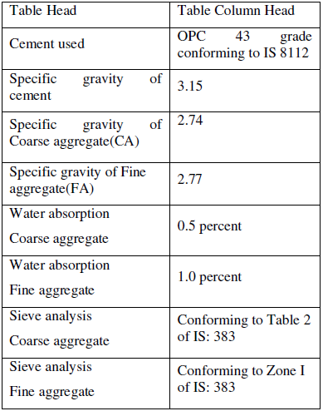
A. Target Mean Strength for Mix
Proportioning Ft = fck+ 1.65 s
Where
fck = Target average compressive strength at 28days,
fck= Characteristic compressive strength at 28 days,
s= Standard deviation
From Table 1 standard deviation, s= 4 N/mm² (IS 4562000)
Therefore , target strength = 25 + 1.65 x 4 = 31.6 N/mm²
- Calculation of Cement Content Water cement ratio = 0.44
Cement content = 182/0.44 = 413.63 kg/m³ =414 kg/m³
From Table 5 of IS: 456, minimum cement content for severe exposure condition = 414 kg/m³> 300 kg/m³, hence OK.
- Calculation for CA and FA Volume of concrete = 1 m³
Volume of cement = 414 / (3.15 X 1000) = 0.1301 m³
Volume of water = 182 / (1 X 1000) = 0.1820 m³
Total weight of other materials except coarse aggregate = 0.1301 + 0.1820 = 0.3121 m³
Volume of coarse and fine aggregate = 1 – 0.3121 = 0.6879 m³
Volume of F.A. = 0.6879 X 0.33 = 0.2332 m3 (Assuming 33% by volume of total aggregate)
Volume of C.A. = 0.6879 – 0.2334 = 0.4335 m³
Therefore weight of FA = 0.2334 x 2.55 x 1000 = 595.17 kg/ m³
Say weight of F.A. = 595 kg/ m³
Therefore weight of C.A. = 0.4335 X 2.76 X 1000 = 1196 kg/ m³
Say weight of C.A. = 1196 kg/ m³ Weight of water =178.542 kg
Water: cement: F.A.: C.A. = 0.44 : 1 : 1.43 : 2.88
- The compressive strength for 7 days and change in strength with reference mix
After curing of cubes for 7 days, the concrete moulds of 150x150x150 mm is tested with a compressive testing machine or universal testing machine. Apply the load gradually without shock and continuously at the rate of 140kg/cm²/minute till the specimen fails. The results are shown in Table VIII.

Table VII. Properties of concrete
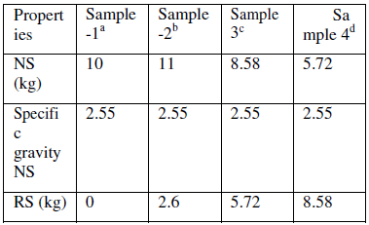
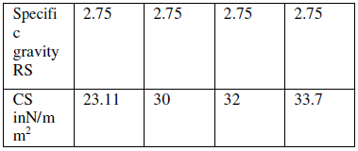

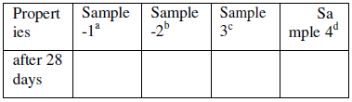

0% robo sand
20% replacement with robo sand
40% replacement with robo sand
60% replacement with robo sand
Table VIII. The compressive strength for 7 days.(N/mm²)

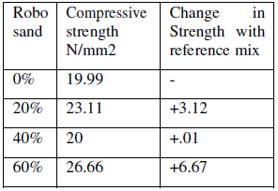

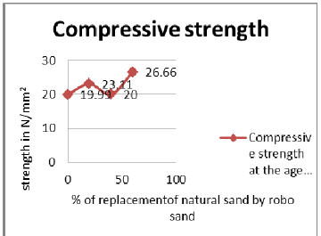

Fig. 7. Graph showing the compressive strength
of concrete cured for 7 days
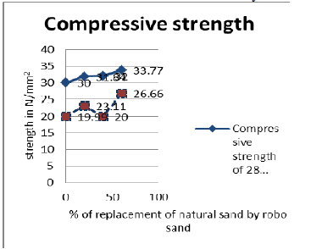
Fig. 8. Graph showing the compressive strength
of concrete cured for 7 days and 28 days

6. Conclusion
The effect of partial replacement of Natural sand by Robo sand on the compressive strength of cement concrete of grade M25 (1:1.4:2.88 –Design mix) with water cement ratio as 0.44 are studied. Results are compared with reference mix of 0% replacement of Natural sand by Robo sand. The compressive strength of cement concrete with 20%, 40%, 60%replacement of Natural sand by Robo sand reveals higher strength as compared to reference mix. The overall strength of concrete linearly increases for 0%,20%, 40%, 60% replacement of Natural sand by Robo sand as compared with reference mix. Robo sand has a potential to provide alternative to Natural sand and helps in maintaining the environment as well as economical balance. Non-availability of natural
sand at reasonable cost, forces to search for alternative material. Robo sand qualifies itself as suitable substitute for river sand at reasonable cost. The Robo sand found to have good gradation and better bonding which is comparatively less in natural sand. According to price – service ratio the use of robo sand gives effective results, as far as we concern the cost of Robo sand is 30-50% less in market which is good for production of economical concrete. The service of robo sand is also as good enough for as Natural sand concrete.

References
[1] M.S. Shetty, Text book of concrete technology (theory and practice) S.Chand & Company Ltd
[2] IS: 10262-1982. Recommended Guidelines for Concrete Mix. Bureau of Indian Standards, New Delhi.
[3] IS: 456-2000. Recommended Guidelines for plain cement Concrete Mix & Reinforced cement concrete. Bureau of Indian Standards, New Delhi.
[4] IS 383-1979 Recommended Guidelines for fine aggregate . Bureau of Indian Standards, New Delhi.
[5] IS 8112: Specification for 43 grade ordinary Portland cement , Bureau of Indian Standards, New Delhi.
[6] M.C Nataraja, Fellow of Indian Concrete Institute, Chennai Journals of CIVIL ENGINEERING
[7] Dilip K. Kulkarni. INTERNATIONAL JOURNAL OF CIVIL AND STRUCTURAL ENGINEERING Volume 3, No 3, 2013. Indian Institute of Technology, Bombay.
[8] Ahmed. A.E. and El-Kourd, A.A. Properties of Concrete Incorporating Natural and Crushed Stone Very Fine Sand. ACI Materials Journal, Vol. 86, No.4. pp.417- 424 (1989).
[9] Marek, C.R. Vulcan Materials Company. Importance of Fine Aggregate Shape and Grading on Properties of Concrete. Paper presented at Centre for Aggregate Research, March 2-4 (1995).
[10] Celik, T. and Marar, K. Effects of Crushed Stone Dust on Some Properties of Concrete. Cement and Concrete Research. Vol. 26, No. 7. pp. 1121-1130 (1996)
[11] Murdock, L.J. The Workability of Concrete. Magazine for Concrete Research No. 36, pp. 135- 144 (1960) Hudson B.P., (1997), Manufactured sand for concrete, The Indian concrete Journal, pp 237-240.

