Energy Source Fed Asymmetric In PWM Full Bridge Converter for A Grid Connected Applications

*T.Mounika, **D.PRASADA RAO
*PG Scholar, Dept of EEE, Ellenki college of Engineering & Technology, Patelguda; Sangareddy (Dt); Telangana, India.
**Assistant Professor, Dept of EEE, Ellenki College of Engineering & Technology, Patelguda; Sangareddy (Dt); Telangana, India.

ABSTRACT-

This paper presented Asymmetrical PWM controlled grid connected system, the asymmetrical PWM control develops high efficient controllable system. The proposed converter achieves ZVS and ZCS switching, can be implemented with asymmetrical full bridge high gain converter, power management system is designed for the proposed system to manage power flow among different Source. Grid connected renewable energy systems are one of the critical points of interest for the selection of custom power devices. The role of custom power devices (CPDs) in enhancing the integration of renewable and providing quality power in grid connected system. A grid-tie control system is proposed for asymmetrical PWM converter with both active and reactive power flow capability in a wide range under two types of renewable energy and distributed generation Source. Power conditioning system (PCS) is Reactive power command is generated by distributed generation (DG) control site for both systems. Asymmetrical full bridge PWM leads to better performance in terms of less output current ripple and harmonics, no zero-crossing distortion. Generally, the renewable energy Source generate low-voltage energy. The renewable energy Source that depend on environment conditions especially generate fluctuating low-voltage energy. Thus, a frontend converter for fluctuating low-voltage energy is required between the low-voltage source and load requiring high voltage. Proposed converter is fed with an inverter and integrated with AC grid.

I INTRODUCTION
With the exhaustion of the global resource and the environmental pollution, the research on the renewable energy Source such as fuel cells and photovoltaic cells has been gradually increased in industrial fields [1]. Generally, the renewable energy Source generate low-voltage energy. The photovoltaic cells that depend on environment conditions especially generate fluctuating low-voltage energy. Thus, a frontend converter for fluctuating low-voltage energy is required between the low-voltage source and load requiring high voltage as shown in Fig.1. The power capacity of these front-end converters is normally less than 250 W. As the cell technology advances, the power capacity of front-end converter should be increased. It can also reduce the cost per watt due to the increased power capacity. Thus, the increased power rating of the front-end converter is required to cope with large power rating of the advanced cells and lower the cost per watt of the renewable energy system [5]. Among the front-end converters, forward/flyback converters that use an active-clamp with voltage doublers, LLC converters, and phase-shift full bridge (PSFB) converters are typically the common topologies considered for increasing power capacity [6]. An active clamp circuit successfully realizes the zero-voltage switching (ZVS) for the switches by utilizing the leakage inductance, the magnetizing inductance, and the parasitic capacitance. Especially, forward/fly back converters that use the active-clamp with voltage doublers provide the zero-current switching (ZCS) of the diodes of the transformer secondary side due to the resonant current formed with the leakage inductance and the resonant capacitor. However, forward/ flyback converters have a much higher voltage stress across the primary switches of the transformer than the input voltage. Therefore, the MOSFET with low on-resistance R_{DS} (on) cannot be employed [17]. With variable frequency control, LLC resonant converter can be employed in all applications with variable input and output voltages, demand of high efficiency and power density. However, due to very wide bandwidth, the frequency has to be increased very high to achieve enough voltage gain controllability. Especially, conventional LLC resonant topology as the front-end converter of the micro inverter is hardly implemented because it is difficult to maintain high efficiency over fluctuating input voltage with different load conditions [18]. The PSFB converters are widely used for high efficiency in the medium power applications. Because its structures are simple and switches are operated with soft switching without additional components . However, under the fluctuating input voltage, the full-bridge converter with the phase-shift control scheme is not appropriate because its control scheme has some serious disadvantages such as a narrow ZVS range of the lagging leg switches, duty cycle loss, large circulating current loss, and voltage spikes across the output diodes. In particular, the large voltage spike is a very serious problem in the applications that require high voltage [21]. To overcome the problem of the narrow ZVS range under the fluctuating input voltage, the freewheeling period is more required. Then, the conduction loss of the primary side is increased by the considerable circulating current. The turn-off switching losses of the lagging leg switches are also increased. Additionally, ZVS operation of the lagging leg switches cannot be guaranteed under the light load condition due to the insufficient energy that is stored in the leakage inductor. Therefore, to solve the problems of ZVS operation, additional devices are generally added. However, these devices that are employed to extend ZVS range can result in increasing the conduction losses and duty-cycle loss . The PSFB converter in [24] provides a wide ZVS range of the lagging leg switches and reduces the circulating current during the freewheeling period due to the resonance between the leakage inductance and the output capacitor. However, the limited resonant frequency can cause excessive current stresses. Thus, the conventional PSFB converter with the additional clamping circuit is also not suitable for fluctuating input voltage. As mentioned above, the conventional PSFB converters cannot satisfy high efficiency in fluctuating input voltage because additional devices for ZVS operation result in the complex circuit structure and the power losses.
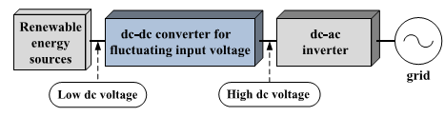
Fig.1. Renewable energy conversion system.
This project proposes a full-bridge converter with asymmetrical pulse-width modulated (APWM) control that is fixed frequency method, which achieves ZVS turn-on of the switches and ZCS turn-off of the output diode by utilizing resonance of the components. The voltage stresses across the power switches (S₁–S₄) of the primary side are clamped to the input voltage and the voltage stress of the output diode is also reduced without any voltage spike. Generally, APWM control scheme has the stress with unbalance of the output components and the reverse recovery problem of the secondary side of the transformer. However, in the proposed APWM full-bridge converter, these problems can be eliminated by ZCS turn-off. The circulating current loss is also removed at the primary side of the transformer because there is no freewheeling period, which is especially profitable for high efficiency under fluctuating input voltage than the conventional front-end converters. Thus, the proposed APWM full-bridge converter is more suitable for applications requiring high efficiency over fluctuating input voltage.
II ANALYSIS OF A PWM FULL-BRIDGE CONVERTER
1 Circuit Configuration and Operation Principle
A circuit configuration of the highly efficient APWM full bridge converter for low input voltage range is shown in Fig.3.2. The configuration of the proposed converter is basically similar to that of the conventional full-bridge converter except for the dc blocking capacitor and the secondary side of the transformer. The primary side of the transformer consists of the primary winding turns N_{p}, the four switches, and the dc blocking capacitor C_{b}. The secondary side has the secondary winding N_{s}, the output diode D_{o}, and the output capacitor C_{o}.
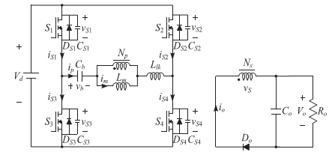
Fig.2.Circuit diagram of the proposed APWM full-bridge converter.
To analyze the steady-state operation of the proposed APWM full-bridge converter, the following assumptions are made.
- The transformer is modeled as an ideal transformer with the primary winding turns N_{p}, the secondary winding turns N_{s}, the magnetizing inductance L_{m}, and the leakage inductance L_{lk}
- All switches S₁–S₄ are considered as ideal switches except for their body diodes and output capacitors (C_{S1}=C_{S2}=C_{S3}=C_{S4}= C_{oss}).
- The dc blocking capacitor C_{b} and the output capacitor C_{o} are large enough to neglect the voltage ripple on it, so the voltages across C_{b} and C_{o} are constant.
While the switch S₁ (S₄) operates with a duty ratio D, depending on the input voltage and load condition, the switch S₂ (S₃) operates with a duty ratio 1−D. In other words, the switches S₁ (S₄) and S₂ (S₃) are operated asymmetrically. Therefore, the circulating current loss of the primary side can be eliminated because the proposed converter has no freewheeling period. Fig.3. 3 represents the operating modes, and Fig.3.4 represents the theoretical waveforms of the proposed converter under a steady-state condition. The operation of the proposed converter can be divided into six modes during a switching period T_{s}.
Mode 1 [t₀, t₁]: At t₀, the switches S₂ and S₃ are turned off. The primary current i_{p} discharges the output capacitances C_{S1} and C_{S4} of the switches S₁ and S₄ and charges the output capacitances C_{S2} and C_{S3} of switches S₂ and S₃. The interval of this mode is very short and negligible because the output capacitances C_{oss} of the switches are very small. Thus, the primary current i_{p} and the magnetizing current i_{m} are regarded as constant value.
Mode 2 [t₁, t₂]: At t₁, when the voltages v_{S1} and v_{S4} across the switches S₁ and S₄ become zero, the negative current flows through their body diodes D_{S1} and D_{S4} before the switches S₁ and S₄ are turned on. Then, ZVS operation is achieved with the turn-on of the switches S₁ and S₄, and the resonance occurs between the dc blocking capacitor C_{b} and the primary inductor L_{m} + L_{lk} of the transformer, but resonance effect does not appear because the resonant period is much longer than one switching period T_{s}. Thus, by the difference between the voltages of the input and the dc blocking capacitor C_{b}, the direction of the primary current i_{p} is changed and kept almost linearly as follows:
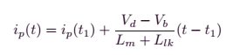 (1)
Where V_{d} is the input voltage and V_{b} is the average voltage across the dc blocking capacitor C_{b}.
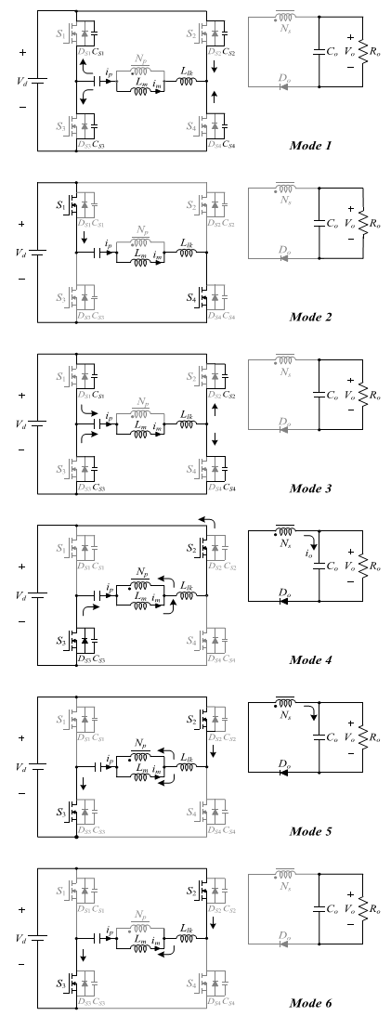
Fig.3. Operating modes of the proposed converter.

Mode 3 [t₂, t₃]: At t₂, the switches S₁ and S₄ are turned off. The primary current ip charges the output capacitances C_{S1}, C_{S4} of S₁, S₄ and discharges the output capacitances C_{S2}, C_{S3} of S₂, S₄. Similar to Mode 1, the primary current i_{p} and the magnetizing current i_{m} are regarded as constant value.
Mode 4 [t₃, t₄]: At t₃, similar to Mode 2, ZVS turn-on of the switches S₂ and S₃ is achieved. The energy stored in the magnetizing inductance is delivered to the secondary side of transformer, and the voltage across the magnetizing inductance L_{m} is clamped by the reflected output voltage as
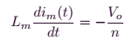 (2)
Where n=N_{s}/N_{p}. Because the difference between the primary current i_{p} and the magnetizing current i_{m} is reflected in the output current i_{o}, the magnetizing current i_{m} is decreased as
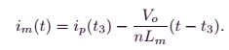 (3)
The resonance occurs between the dc blocking capacitor C_{b} and the leakage inductance L_{lk} of the transformer. The voltage across the leakage inductance L_{lk} of primary side is the difference between V_{d} + V_{b} and the reflected output voltage V_{o}/n from the secondary side. Thus, the state equations can be written as follows:
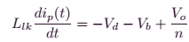 (4)
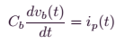 (5)
Solving (4) and (5), the primary current i_{p} is
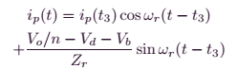 (6)
Where the resonant angular frequency ω_{r} and the impedance Z_{r} of the resonant circuit are
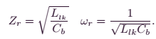 (7)

Mode 5 [t₄, t₅]: At t₄, the primary current i_{p} becomes zero and changes its direction. Also, the magnetizing current im changes its direction during this interval. The output current i_{o} approaches zero at the end of this mode with resonant characteristics. When the output current i_{o} becomes zero, this mode ends.
Mode 6 [t₅, t₆]: At t₅, because the resonance launched in Mode 4 is ended, the output current i_{o} becomes zero. However, the output diode D_{o} is maintained to on-state until the switches S₂ and S₃ are turned off. During this mode, the primary current i_{p} is equal to the magnetizing current i_{m}. Thus, ZCS turn-off of the output diode D_{o} is achieved.
2 Steady-State Analyses
While the switches S₁ and S₄ operate with a duty ratio D, the difference between the input voltage V_{d} and the average voltage V_{b} of the dc blocking capacitor C_{b} is applied on the inductor of the transformer primary side. While the switches S₂ and S₃ operate with a duty ratio 1−D, the reflected output voltage V_{o}/n is applied on the inductor of the transformer primary side and the output diode D_{o} is turned-on. Since the resonant period of the resonant network is much longer than the dead-time duration, equations of the primary current i_{p} from (1) and (2) are derived as follows:
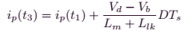 (8)
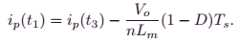 (9)
From the resonance of the primary side in Modes 4 and 5, since the leakage inductance L_{lk} is much smaller than the magnetizing inductance L_{m}, the leakage inductance L_{lk} is negligible. Therefore, the following equation can be obtained:
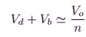 (10)
From (8) to (10), the voltage gain between the input voltage V_{d} and output voltage V_{o} is expressed as follows:
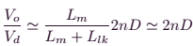 (11)
Because the leakage inductance L_{lk} is negligible, the average voltage V_{b} of the dc blocking capacitor C_{b} is expressed from (10) and (11) as shown in
(12)
Due to the charge balance of the dc blocking capacitor C_{b}, the average value of the primary current I_{p} is zero in the steady state. Thus, the relation between the average values of the magnetizing current I_{m} and average output current I_{o} can be determined as follows:
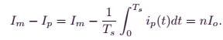 (13)
From Fig.4, the average magnetizing current I_{m} can also be obtained by
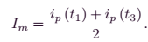 (14)
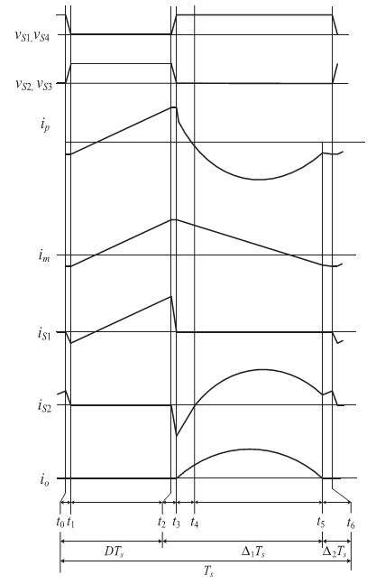
Fig.4.Theoretical waveforms of the proposed converter.

the currents i_{p} (t₁) and ip (t₃) are given by
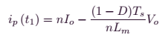 (15)
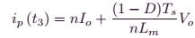 (16)
Using (3.13)–(3.16), the resonant current (3.6) can be represented by
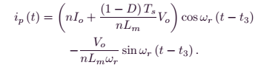 (17)
III SOFT-SWITCHING CONDITIONS
1 ZVS Condition of the Power Switches
For ZVS turn-on of S₁ and S₄, the primary current i_{p} (t₁) should be negative before S₁ and S₄ are turned on. Thus, from (15), ZVS condition can be expressed as follows:
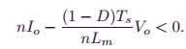 (18)
Equation (18) is arranged by the min–max theorem as
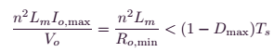 (19)
Where I_{o,max} is the maximum output current, R_{o,min} = V_{o}/I_{o,max} is the minimum output resistance, and D_{max} is the maximum duty ratio of the switches S₁ and S₄ under the minimum input voltage V_{d,min}. From (11), D_{max} can be described as
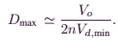 (20)
According to the variations of the input voltage V_{d} and turn ratio, the duty ratio of the switches S₁ and S₄. Thus, from (3.19) and (3.20), the magnetizing inductance L_{m} should be designed to satisfy ZVS condition as follows:
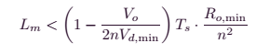 (21)
Where T_{s} is a switching period. According to the variation of the duty ratio D, the critical magnetizing inductance value L_{m} to satisfy the ZVS turn-on condition of the switches The ZVS turn-on condition of the switches S₂ and S₃ can be expressed with the same manner of ZVS condition of the switches S₁ and S₄. Thus, ZVS operation of S₂ and S₃ can be achieved when the primary current i_{p} (t₃) is positive. From (3.16), ZVS condition of S₂ and S₃ is expressed as follows:
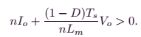 (22)
The left side terms of (3.22) are always positive regardless of load variations. Therefore, ZVS operation of the switches S₂ and S₃ can always is satisfied.
Another ZVS turn-on operation requires a sufficient dead time between two switch pairs to absolutely discharge the voltage across the output capacitance C_{oss} of the switches. Because i_{p} (t₁) = i_{m} (t₁) is regarded as constant value during the dead time, the minimum dead time Δt_{dead} can be calculated as
 (23)
From (3.15) and (3.16), the primary current i_{p} (t₃) is always larger than the absolute value of the primary current i_{p} (t₁). Therefore, (3.23) can be simplified as
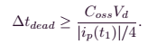(24)
The primary current i_{p} (t₁) should be negative for ZVS operation. Thus, (3.24) can be expressed as shown in
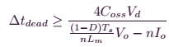(25)
The minimum dead time Δt_{dead} should be considered in the practical design of the magnetizing inductance because Δt_{dead} is always smaller than (1−D_{max}) T_{s}.
III ZCS Condition of the Output Diode
To achieve the ZCS turn-off condition of the output diode _{Do}, the resonant angular frequency ωr should be larger than the critical angular frequency ω_{rc}. Because the critical condition is ip (Ts) = i_{m} (T_{s}) at Δ₂T_{s} = 0 and D = D_{max}, the critical angular frequency ω_{rc} can be described considering the negligible dead-time duration of the power switches as follows:
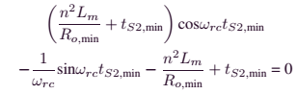(26)
Where t_{S2,min} is the minimum turn-on duration of the switches S₂ and S₃. The magnetizing inductance L_{m} is generally designed for the magnetizing current i_{m} (t₁) to be a small negative value to minimize the conduction loss of the converter. By this assumption, (3.26) can be obtained as follows:
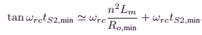(27)
From (3.21), (3.27) is expressed as shown in
(28)
Thus, the critical angular frequency ω_{rc} can be calculated using a numerical method as shown in
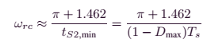(29)
From (3.29), the dc blocking capacitance C_{b} must satisfy the following relation:
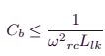(30)
According to the variation of the duty ratio D, the critical resonant capacitance C_{b} to satisfy the ZCS turn-off condition of the output diode D_{o}.
This paper presents a single-phase five-level photovoltaic (PV) inverter topology for grid-connected PV systems with a novel pulse width-modulated (PWM) control scheme. Two reference signals identical to each other with an offset equivalent to the amplitude of the triangular carrier signal were used to generate PWM signals for the switches. A digital proportional-integral current control algorithm is implemented in DSP TMS320F2812 to keep the current injected into the grid sinusoidal and to have high dynamic performance with rapidly changing atmospheric conditions. The inverter offers much less total harmonic distortion and can operate at near-unity power factor. The proposed system is verified through simulation and is implemented in a prototype, and the experimental results are compared with that with the conventional single-phase three-level grid-connected PWM inverter.
A grid-connected photovoltaic power system or grid-connected PV system is an electricity generating system that is connected to the utility grid. A grid-connected PV system consists of solar panels, one or several inverters, a power conditioning unit and grid connection equipment. They range from small residential and commercial rooftop systems to large utility-scale solar power stations. Unlike stand-alone power systems, a grid-connected system rarely includes an integrated battery solution, as they are still very expensive. When conditions are right, the grid-connected PV system supplies the excess power, beyond consumption by the connected load,
Residential, grid-connected rooftop systems which have a capacity more than 10 kilowatts can meet the load of most consumers.^{[2]} They can feed excess power to the grid where it is consumed by other users. The feedback is done through a meter to monitor power transferred. Photovoltaic wattage may be less than average consumption, in which case the consumer will continue to purchase grid energy, but a lesser amount than previously. If photovoltaic wattage substantially exceeds average consumption, the energy produced by the panels will be much in excess of the demand. In this case, the excess power can yield revenue by selling it to the grid. Depending on their agreement with their local grid energy company, the consumer only needs to pay the cost of electricity consumed less the value of electricity generated. This will be a negative number if more electricity is generated than consumed.^{[3]} Additionally, in some cases, cash incentives are paid from the grid operator to the consumer. Connection of the photovoltaic power system can be done only through an interconnection agreement between the consumer and the utility company. The agreement details the various safety standards to be followed during the connection.
V.MATLAB/SIMULATION RESULTS
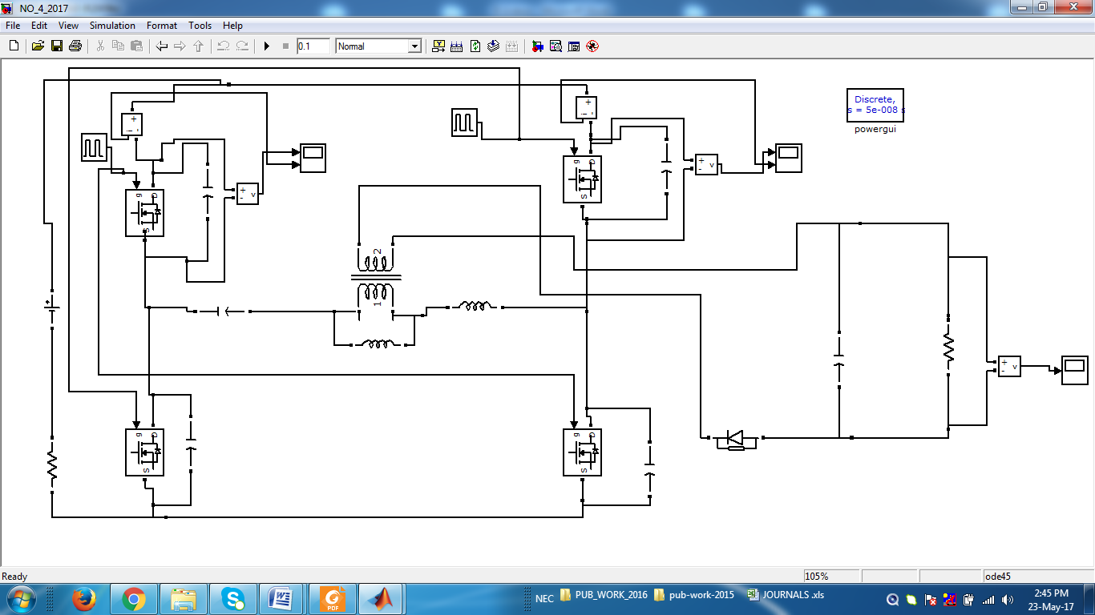
Fig 5 Matlab/simulation Circuit diagram of the proposed APWM full-bridge converter.
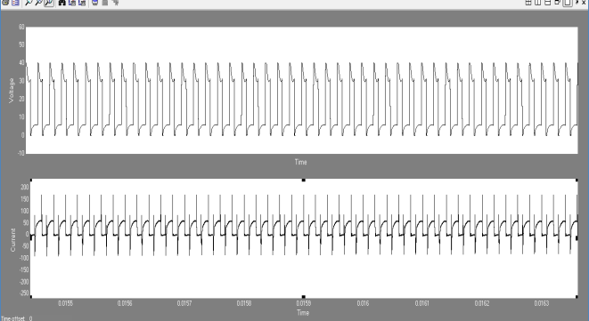
(a)
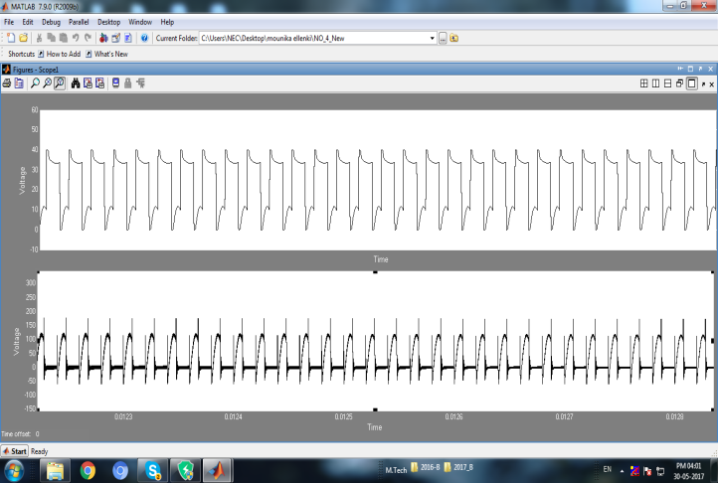
(b)
Fig 6 Simulation waveforms for ZVS turn-on of the switches S1 and S2 at Vd = 40 V and Po = 400 W. (a) vS1 and iS1. (b) vS2 and iS2.

Fig 7 Simulation wave form of Output voltage
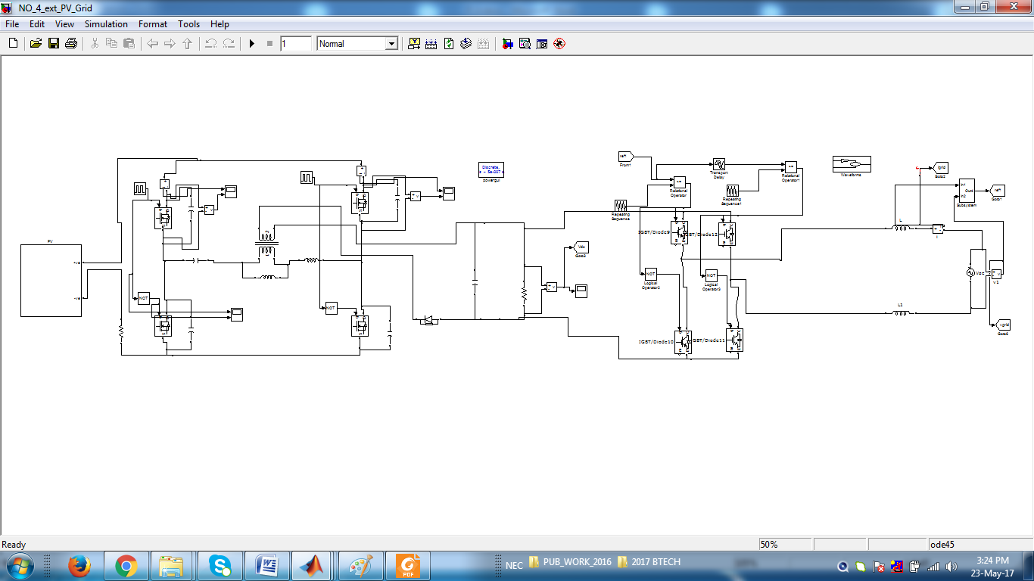
Fig 8 Matlab/simulation Circuit diagram of the proposed APWM full-bridge converter with PV Grid
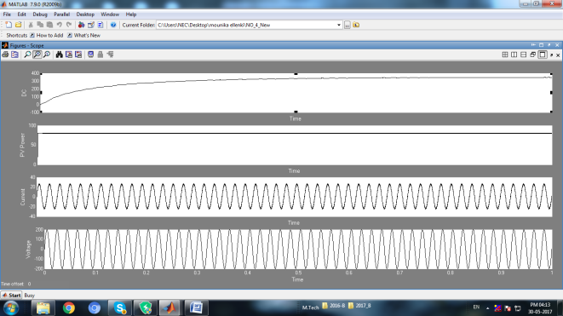
Fig 9 Simulation wave form of APWM full-bridge converter with PV Grid with DC voltage, grid voltage & current

CONCLUSION
In this paper, APWM full-bridge converter for the renewable energy conversion systems that can grid connected system fluctuate between the input voltage of 40 and 80 V has been proposed. All power switches operate under ZVS and output diode operates under ZCS without extra components. Also, all power switches are clamped to the input voltage. Thus, the proposed converter has the structure to minimize power losses. These advantages make the PV Grid is proposed converter suitable for fluctuating input voltage on renewable energy conversion systems. The prototype of the APWM full-bridge converter is provided to validate the proposed concept with PV Grid. Maximum efficiency of 96.8% is obtained at the input voltage of 50 V and the rated power of 400 W

REFERENCES
[1] J. Zhang, H. Wu, X. Qin, and Y. Xing, “PWM plus secondary-side phase-shift controlled soft-switching full-bridge three-port converter for renewable power systems,” IEEE Trans. Ind. Electron., vol. 62, no. 11, pp. 7061–7072, Nov. 2015.
[2] K. C. Tseng, J. Z. Chen, J. T. Lin, C. C. Huang, and T. H. Yen, “High step-up interleaved forward-flyback boost converter with three winding coupled inductors,” IEEE Trans. Power Electron., vol. 30, no. 9, pp. 4696–4703, Sep. 2015.
[3] A. K. Rathore, A. K. S. Bhat, and R. Oruganti, “Analysis, design and experimental results of wide range ZVS active-clamped L-L type current fed dc/dc converter for fuel cells to utility interface,” IEEE Trans. Ind. Electron., vol. 59, no. 1, pp. 473–485, Jan. 2012.
[4] A. I. Bratcu, I. Munteanu, S. Bacha, D. Picault, and B. Raison, “Cascaded dc–dc converter photovoltaic systems: Power optimization issues,” IEEE Trans. Ind. Electron., vol. 58, no. 2, pp. 403–411, Feb. 2011.
[5] B. R. Lin and J. Y. Dong, “New zero-voltage switching DC–DC converter for renewable energy conversion systems,” IET Power Electron., vol.5, no. 4, pp. 393–400, Apr. 2012.
[6] Y. Shin, C. Kim, and S. Han, “A pulse frequency modulated full bridge DC/DC converter with series boost capacitor,” IEEE Trans. Ind. Electron., vol. 58, no. 11, pp. 5154–5162, Nov. 2011.
[7] I.-H. Cho, K. Cho, and G. Moon, “A new phase-shifted full-bridge converter with maximum duty operation for server power system,” IEEE Trans. Power Electron., vol. 26, no. 12, pp. 3491–3500, Dec. 2011.
[8] Z. Chen, Q. Zhou, J. Xu, and X. Zhou, “Asymmetrical pulse-width modulated full-bridge secondary dual resonance DC–DC converter,” J. Power Electron., vol. 14, no. 6, pp. 1224–1232, Nov. 2014.
[9] Z. Ye, P. K. Jain, and P. C. Sen, “A full-bridge resonant inverter with modified phase-shift modulation for high-frequency AC power distribution systems,” IEEE Trans. Ind. Electron., vol. 4, no. 2, pp. 242–247, Oct. 2007.
[10] Y. C. Hsieh and C. S. Huang, “Li-ion battery charger based on digitally controlled phase-shifted full-bridge converter,” IET Power Electron., vol. 5, no. 6, pp. 755–764, Oct. 2009.
[11] Y. Jang and M. M. Jovanovi´ c, “A new family of full-bridge ZVS converters,” IEEE Trans. Power Electron., vol. 19, no. 3, pp. 701–708, May 2004.
[12] S. H. Lee, C. Y. Park, J. M. Kwon, and B. H. Kwon, “Hybrid-type full-bridge DC-DC converter with high efficiency and wide input range,” IEEE Trans. Power Electron, vol. 30, no. 8, pp. 4156–4164, Aug. 2015.
[13] B. R. Lin, J. Y. Dong, and J. J. Chen, “Analysis and implementation of a ZVS/ZCS DC–DC switching converter with voltage step-up,” IEEE Trans. Ind. Electron., vol. 58, no. 7, pp. 2962–2971, Jul. 2011.
[14] H. Wu, P. Xu, and Y. Xing, “Series-input interleaved forward converter with a shared switching leg for wide input voltage range applications,” IEEE Trans. Ind. Electron., vol. 60, no. 11, pp. 5029–5039, Nov. 2013.
[15] S. Lim, J. Ranson, D. M. Otten, and D. J. Perreault, “Two-stage power conversion architecture suitable for wide range input voltage,” IEEE Trans. Power Electron., vol. 30, no. 2, pp. 805–816, Feb. 2015.
[16] Y. Lu, H. Wu, Y. Xing, T. Mu, H. Liu, and X Ma, “A soft-switching dual phase-shift controlled full-bridge converter with voltage-doubler for wide voltage range applications,” in Proc. IEEE Appl. Power Electron. Conf. Expo. (APEC), Mar. 2014, pp. 1112–1117.
[17] W. Yu, B. York, and J.-S. Lai, “Inductor less forward-fly back soft switching converter with dual constant ON-time modulation for photovoltaic applications,” in Proc. IEEE Energy Convers. Congr. Expo. (ECCE), Sep. 2012, pp. 3549–3555.
[18] J. Jang, M. Joung, B. Choi, S. Hong, and S. Lee, “Dynamic analysis and control design of Opt coupler-isolated LLC series resonant converters with wide input and load variations,” IET Power Electron., vol. 5, no. 6, pp. 755–764, Jan. 2012.
[19] B. Y. Chen and Y. S. Lai, “Switching control technique of phase-shift controlled full-bridge converter to improve efficiency under light-load and standby conditions without additional auxiliary components,” IEEE Trans. Power Electron., vol. 25, no. 4, pp. 1001–1012, Apr. 2010
.

