AN EFFICIENT MULTILEVEL INVERTER TOPOLOGY WITH SMALL NUMBER OF SWITCHES

*K DEEPAK, ** A.ARUN KUMAR
*PG Scholar, Department of Electrical & Electronics Engineering, Velaga Nageswara Rao College of Engineering, Ponnuru; Guntur (Dt); A.P, India.
**Associate Professor, Department of Electrical & Electronics Engineering, Velaga Nageswara Rao College Of Engineering, Ponnuru; Guntur (Dt); A.P, India.

ABSTRACT-
In this paper A Three phase Multi level inverter with reduced number of switches for Induction motor drive application is presented. Multilevel inverters are the best solution for medium and high voltage power electronic drives. Because of its unique characteristic of synthesizing sinusoidal voltage with less harmonic contents using several DC sources. In a three phase multilevel inverter, each phase of a cascaded H-bridge inverter requires ‘n’ DC sources to obtain 2n + 1 output voltage levels. This paper proposes a new Multilevel Inverter for Induction Motor Drive. This inverter uses very less number of switches when compared with the other type of multi inventers. A multilevel inverter topology, which results in a minimum number of switches, especially when the required number of voltage levels is large. Our topology is a combination of diode-clamped and H-bridge circuits. The multilevel inverter is fed to a induction motor drive and the performance of the motor is analyzed by using Matlab/Simulink software.
Key words- Multilevel Inverter, H-bridge, Induction Motor Drives.

- INTORDUCTION

Over many years, Induction motor drives have beenpopularly used for variable speed control applications inindustries. This is because the induction motor is simplein construction and requires less maintenance. In recenttimes, multilevel inverters (MLI) are gaining popularityand widely used for induction motor drive applications [1-3]. It is especially used for medium to high voltage andhigh current drive applications. There are manyadvantages of multilevel inverters as compared toconventional inverters. Main advantages are low totalharmonics distortion (THD), low switching losses, goodpower quality and reduced electromagnetic interference(EMI). Main feature of multilevel inverter is that itreduces voltage stress on each component [4-8]. Thetopologies of multilevel inverters are classified into threetypes. They are

flying capacitor, diode clamped and H-bridgecascaded multilevel inverters.
H-bridge multilevel inverter is one ofthe most popular inverter topology used in high-powermedium voltage (MV) drives. It is composed of a multipleunits of single-phase H-bridge power cells. In practice,the number of power cells in anH-Bridge inverter is mainlydetermined by its operating voltage and manufacturingcost. H-bridge multilevel inverter requires theleast number of components for the same voltage level ascompared to all three types of inverter [9-11]. The growthof multilevel inverter caused development of variousmodulation schemes [12]. The most common initialapplication of multilevel converters has been in traction,both in locomotives and track-side static converters [13]. Morerecent applications have been for power systemconverters for VAR

compensation and stabilityenhancement, active filtering, high-voltage motor drive,high-voltage dc transmission and most recently formedium voltage induction motor variable speed drives [12-15].Many multilevel converter applications focus onindustrial medium-voltage motor drives, utility interfacefor renewable energy systems, Flexible AC TransmissionSystem (FACTS) and traction drive systems.
In recent years, multilevel inverters have received moreattention in industrial applications, such as motor drives,static VAR compensators and renewable energy systems.Compared to the traditional two-level voltage sourceinverters, the stepwise output voltage is the majoradvantage of multilevel inverters.This paper presents an optimized configuration of a3-phase MLI with minimum number of switches.Toovercome the disadvantages this paper proposes anew multilevel inverter topology with reduced switchescompared to conventional MLIs. Finally the inductionmotor fed by the proposed MLI is presented in this paper.

II. DESCRIPTION OF THE PROPOSED STRUCTURE
Fig.1 shows the proposed multilevel inverter topology. Here, a simple variation of diode clamped multilevel inverter is used to generate a staircase waveform. An H-bridge is used to get an alternating signal with both positive and negative polarities. Capacitors are used to divide the DC link voltage into k distinct levels. These capacitor voltages are then added and subtracted by operating the power switches to generate 2k +1 level staircase voltage waveform. Diodes are used with each power switch in reverse blocking mode. Fig.2 explains the working principle of the proposed topology, where V_{bus} is the DC bus voltage, V_{ac} is the ac output voltage, V_{ac_1} is the fundamental component of V_{ac}. S₁ - S_{k} represents the gating signals of the switches. Similarly Q₁ - Q₄ represents gating signals of

H-bridge. The four switches of H-bridge are operated at the fundamental frequency of the output voltage.
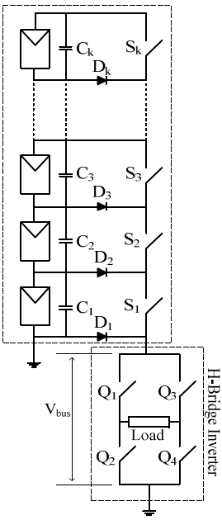
Fig.1 our proposed topology of multilevel inverter.
In the proposed topology, k power switches are required to generate k levels staircase waveform Vbus. Four additional switches of H-bridge inverter are used to get staircase ac waveform V_{ac} of 2k +1 levels. Effectively, to generate 2k +1 level staircase voltage ac waveform, only k + 4 power switches, k capacitors and k diodes are needed

which results in overall lesser device count than an existing multilevel topology, to the best of our knowledge.
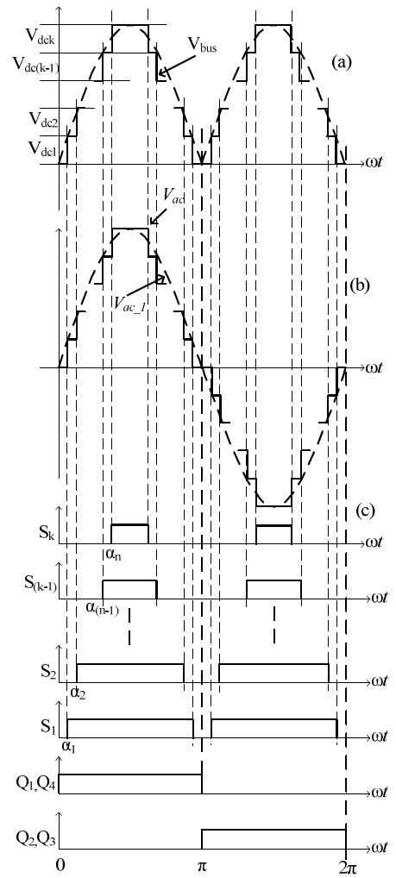
Fig.2 Output waveform and states of various switches.

III. INDUCTION MOTOR
An asynchronous motor type of an induction motor is an AC electric motor in which the electric current in the rotor needed to produce torque is obtained by electromagnetic induction from the magnetic field of the stator winding. An induction motor can therefore be made without electrical connections to the rotor as are found in universal, DC and synchronous motors. An asynchronous motor's rotor can be either wound type or squirrel-cage type.
Three-phase squirrel-cage asynchronous motors are widely used in industrial drives because they are rugged, reliable and economical. Single-phase induction motors are used extensively for smaller loads, such as household appliances like fans. Although traditionally used in fixed-speed service, induction motors are increasingly being used with variable-frequency drives (VFDs) in variable-speed service. VFDs offer especially important energy savings opportunities for existing and prospective induction motors in variable-torque centrifugal fan, pump and

compressor load applications. Squirrel cage induction motors are very widely used in both fixed-speed and variable-frequency drive (VFD) applications. Variable voltage and variable frequency drives are also used in variable-speed service.
In both induction and synchronous motors, the AC power supplied to the motor's stator creates a magnetic field that rotates in time with the AC oscillations. Whereas a synchronous motor's rotor turns at the same rate as the stator field, an induction motor's rotor rotates at a slower speed than the stator field. The induction motor stator's magnetic field is therefore changing or rotating relative to the rotor. This induces an opposing current in the induction motor's rotor, in effect the motor's secondary winding, when the latter is short-circuited or closed through external impedance. The rotating magnetic flux induces currents inthe windings of the rotor; in a manner similar to currents induced in a transformer's secondary winding(s). The currents in the rotor windings in turn create magnetic fields in the rotor that react against the stator field. Due to Lenz's Law, the direction of the magnetic field created will be such as to oppose the change in current through the rotor windings. The cause of induced current in the rotor windings is the rotating stator magnetic field, so to oppose the change in rotor-winding currents the rotor will start to rotate in the direction of the rotating stator magnetic field. The rotor accelerates until the magnitude of induced rotor current and torque balances the applied load. Since rotation at synchronous speed would result in no induced rotor current, an induction motor always operates slower than synchronous speed.The difference, or "slip," between actual and synchronous speed varies from about 0.5 to 5.0% for standard Design B torque curve induction motors. The induction machine's essential character is that it is created solely by induction instead of being separately excited as

in synchronous or DC machines or being self-magnetized as in permanent magnet motors.
For rotor currents to be induced the speed of the physical rotor must be lower than that of the stator's rotating magnetic field (n_{s}); otherwise the magnetic field would not be moving relative to the rotor conductors and no currents would be induced. As the speed of the rotor drops below synchronous speed, the rotation rate of the magnetic field in the rotor increases, inducing more current in the windings and creating more torque. The ratio between the rotation rate of the magnetic field induced in the rotor and the rotation rate of the stator's rotating field is called slip. Under load, the speed drops and the slip increases enough to create sufficient torque to turn the load. For this reason, induction motors are sometimes referred to as asynchronous motors. An induction motor can be used as an induction generator, or it can be unrolled to form a linear induction motor which can directly generate linear motion.
Synchronous Speed:
The rotational speed of the rotating magnetic field is called as synchronous speed.
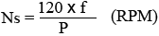 (1)
Where, f = frequency of the supply
P = number of poles
Slip:
Rotor tries to catch up the synchronous speed of the stator field, and hence it rotates. But in practice, rotor never succeeds in catching up. If rotor catches up the stator speed, there won’t be any relative speed between the stator flux and the rotor, hence no induced rotor current and no torque production to maintain the rotation. However, this won't stop the motor, the rotor will slow down due to lost of torque, and the torque will again be exerted due to relative speed. That is why the rotor rotates at speed which is always less the synchronous speed.

The difference between the synchronous speed (Ns) and actual speed (N) of the rotor is called as slip.
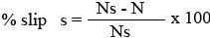 (2)

IV. MATLAB/SIMULINK RESULTS

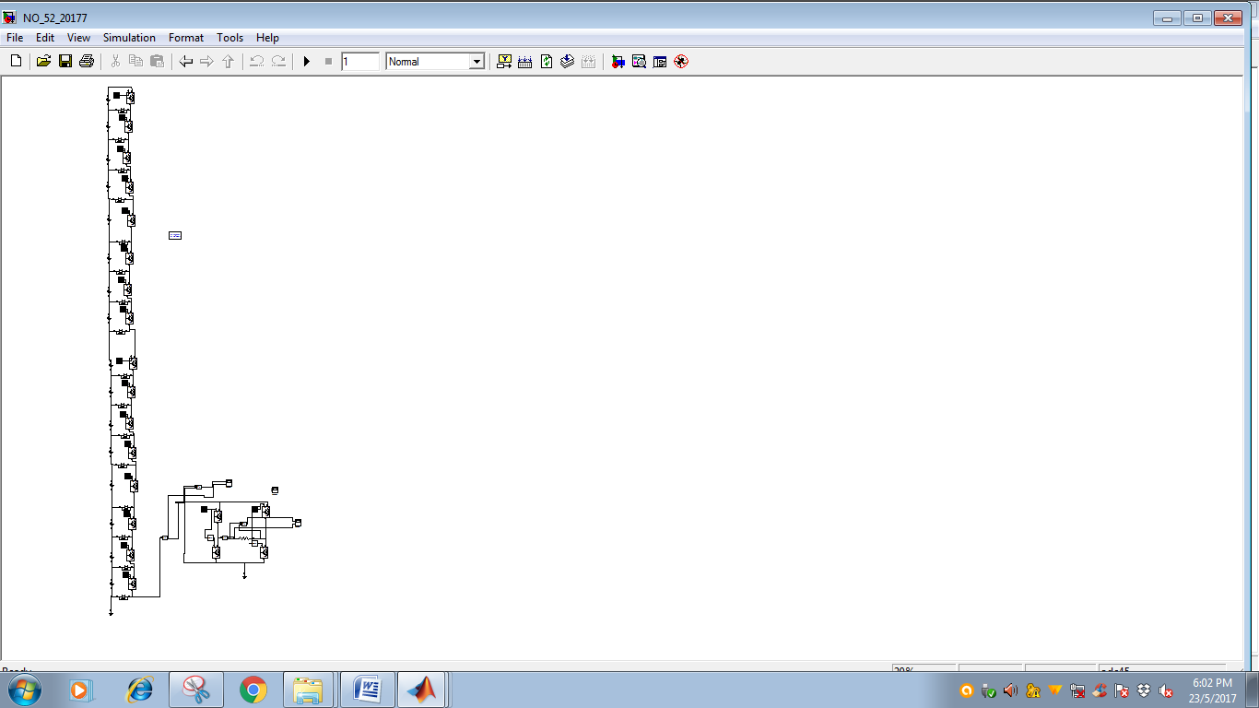
Fig.3 Simulink model diagram for 33 level multi level inverter
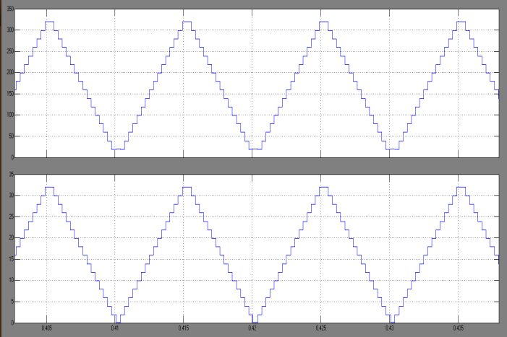

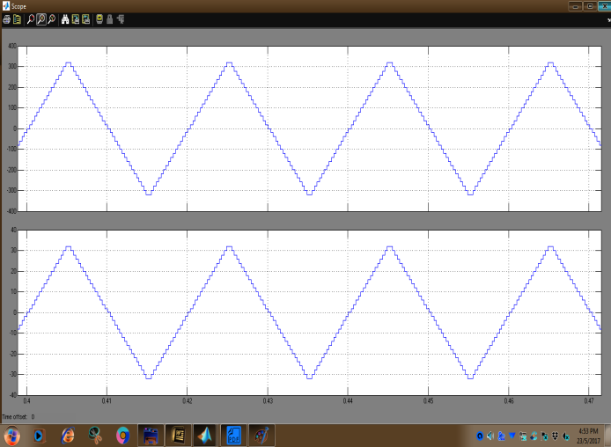
Fig.5 Simulated waveforms of AC output voltage and current of a 33 level multilevel inverter

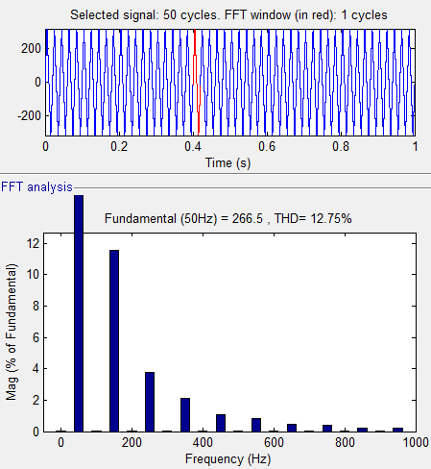

Fig.6 AC Inverter output Voltage THD.
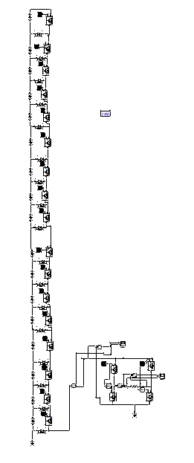
Fig.7 Simulink model diagram for 33 level multi level inverter

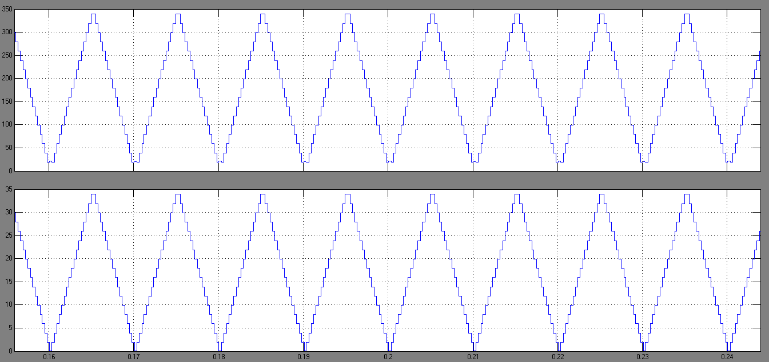
Fig.8 Simulated waveforms of DC bus voltage and current of a 35 level multilevel inverter

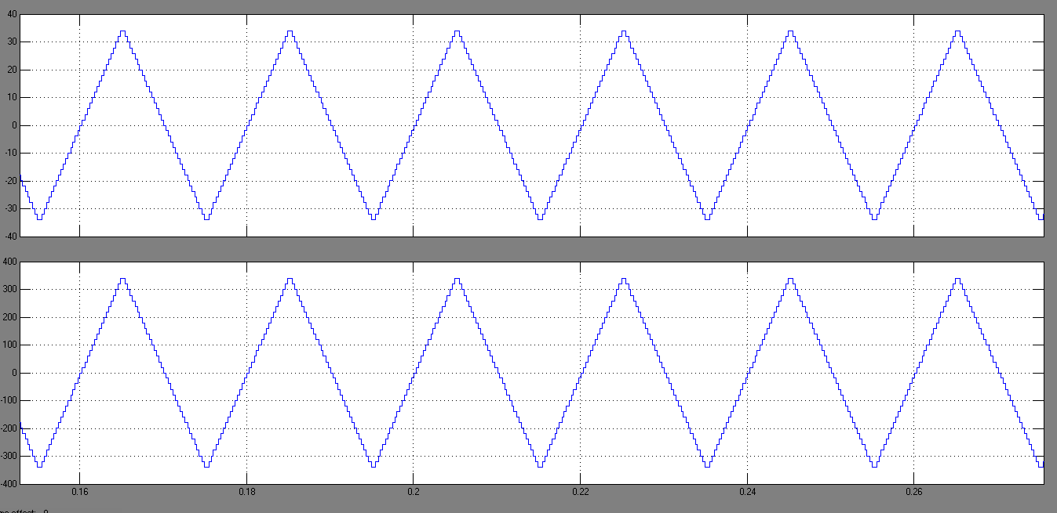
Fig.9 Simulated waveforms of AC output voltage and current of a 33 level multilevel inverter

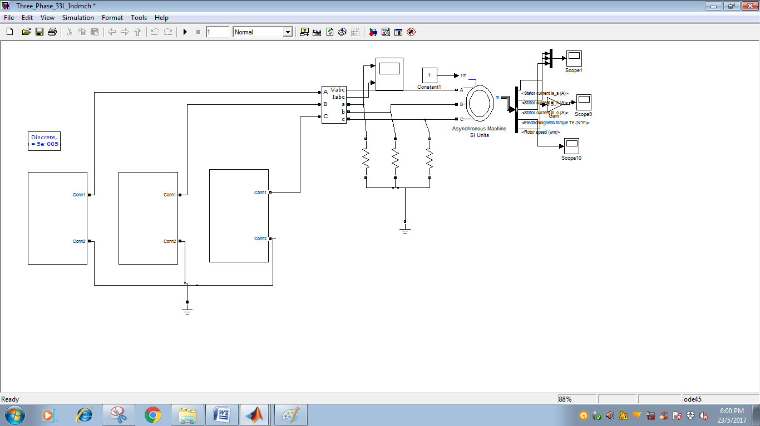
Fig.10 Simulink model connected with Induction motor drive

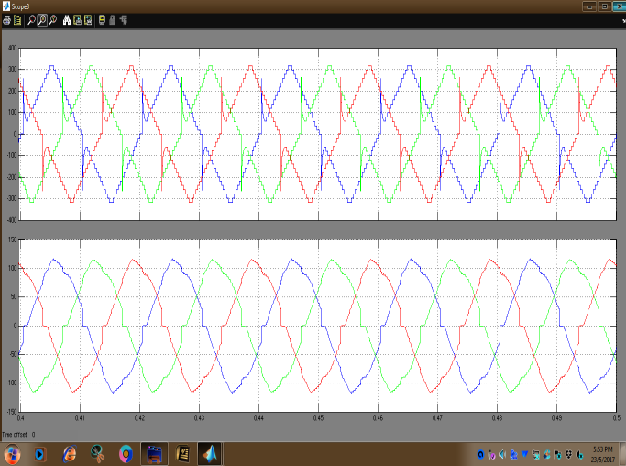

Fig.11 Three-phase supply voltage and current.

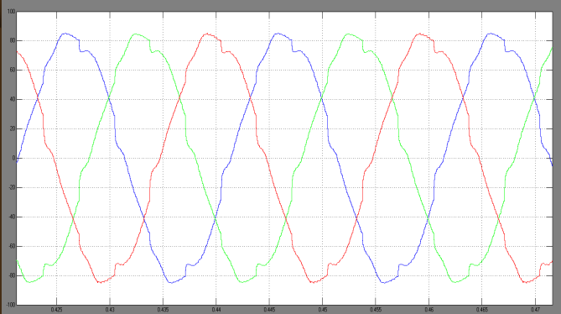

Fig.12 Stator current.

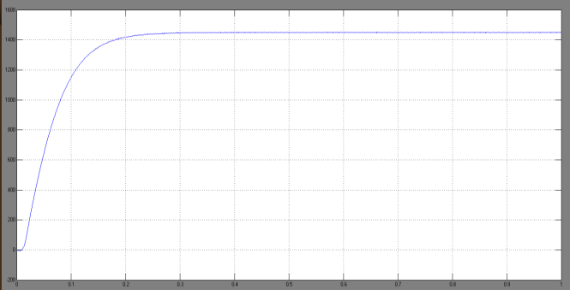

Fig.13 Speed of the induction motor.

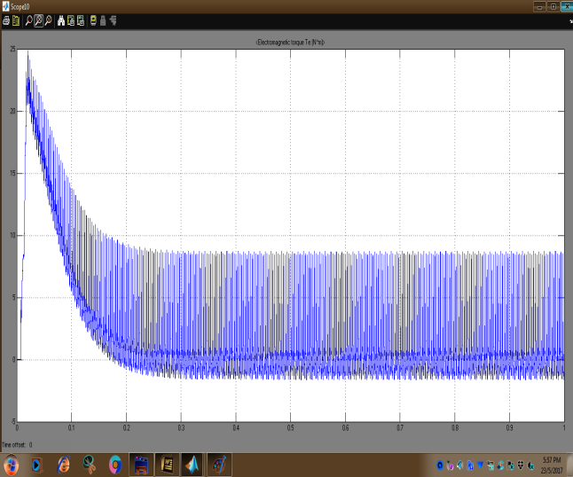
Fig.14 Torque characteristics of the induction motor.

V. CONCLUSION
A new topology of the three-phase multilevelinverter topology was introducedfor induction motor drive applications. The suggested configuration wasobtained from reduced number of power electroniccomponents. Therefore, the proposed topology results inreduction of installation area and cost.The proposed circuit is applied to InductionMotor Drive to check the performance of entiresystem. Simulation results are shown. THD alsoreduced with filter in the converter circuit.

REFERENCES
[1] A. B. Meinel and M. P. Meinel, Applied Solar Energy: An Introduction. Addison-Wesley, 1979.
[2] Ned Mohan, Power ELectrnoics A first Course. Wiley, 2012.
[3] S. Kouro and M. Malinowski, “Recent advances and industrial applications of multilevel converters,” Ind. Electron …, vol.57, no. 8,pp. 2553–2580, Aug. 2010.
[4] J. Rodríguez, J. S. Lai, and F. Z. Peng, “Multilevel inverters: A survey of topologies, controls, and applications,” IEEE Trans. Ind. Electron., vol. 49, no. 4, pp. 724–738, Aug. 2002.
[5] E. Najafi, A. Halim, M. Yatim, and S. Member, “Design and implementation of a new multilevel inverter topology,” IEEE Trans. Ind. Electron., vol. 59, no. 11, pp. 4148–4154, Nov. 2012.
[6] E. Villanueva, P. Correa, J. Rodriguez, and M. Pacas, “Control of a single-phase cascaded H-bridge multilevel inverter for grid-connected photovoltaic systems,” IEEE Trans. Ind. Electron., vol. 56, no. 11, pp.4399–4406, Nov. 2009.
[7] E. Babaei, S. Laali, and S. Alilu, “Cascaded multilevel inverter with series connection of novel H-bridge basic units,” Ind. Electron. IEEE Trans., vol. PP, no. 99, p. 1, Dec. 2014.

[8] M. Malinowski, K. Gopakumar, J. Rodriguez, and M. a. Perez, “A survey on cascaded multilevel inverters,” IEEE Trans. Ind. Electron., vol. 57, no. 7, pp. 2197–2206, Jul. 2010.
[9] A. Nabae, I. Takahashi, and H. Akagi, “A new neutral-point-clamped PWM inverter,” IEEE Trans. Ind. Appl., vol. IA-17, no. 5, pp. 518–523,Sep. 1981.
[10] T. A. Meynard and H. Foch, “Multi-level conversion: High voltage choppers and voltage-source inverters,” in Proc. Eur. Conf. Power Electron. Appl., 1992, vol. 2, pp. 45-50.
[11] M. Marchesoni, M. Mazzucchelli, and S. Tenconi, “A non-conventional power converter for plasma stabilization,” in Proc. Power Electron. Spec. Conf., 1988, pp. 122-129.
[12] R. González, E. Gubía, J. López, and L. Marroyo, “Transformerless single-phase multilevel-based photovoltaic inverter,” IEEE Trans. Ind. Electron., vol. 55, no. 7, pp. 2694–2702, Jul. 2008.
[13] E. Cipriano, S. Member, and C. Brand, “Nested multilevel topologies,” vol. 30, no. 8, pp. 4058–4068, Aug. 2015.
[14] S. Daher, J. Schmid, and F. L. M. Antunes, “Multilevel inverter topologies for stand-alone PV systems,” IEEE Trans. Ind. Electron., vol.55, no. 7, pp. 2703–2712, Jul. 2008.
[15] K. Gupta, A. Ranjan, P. Bhatnagar, L. K. Sahu, and S. Jain, “Multilevel inverter topologies with reduced device count: a review,” IEEE Trans. Power Electron..., to be published.

