A Grid-Connected Dual Voltage Source Inverter WithPower Quality Improvement Features
A. VENKATESH
PG Scholar, Department of Electrical and Electronics Engineering, Narsimha Reddy Engineering College, Hyderabad-500100
venkateshakula733@gmail.com

ABSTRACT
This paper presents a dual voltage source inverter (DVSI) scheme to enhance the power quality and reliability of the microgrid system. The proposed scheme is comprised of two inverters, which enables the microgrid to exchange power gen- erated by the distributed energy resources (DERs) and also to compensate the local unbalanced and nonlinear load. The con- trolalgorithmsaredevelopedbasedoninstantaneoussymmetrical component theory (ISCT) to operate DVSI in grid sharing and grid injecting modes. The proposed scheme has increased relia- bility, lower bandwidth requirement of the main inverter, lower cost due to reduction in filter size, and better utilization of micro- grid power while using reduced dc-link voltage rating for the main inverter. These features make the DVSI scheme a promising option for microgrid supplying sensitive loads. The topology and control algorithm are validated through extensive simulation and experimentalresults.

INTRODUCTION
TECHNOLOGICALprogressandenvironmentalconcernsdrivethepowersystemtoaparadigmshiftwithmorerenewable energy sources integrated to the networkbymeansof distributed generation (DG). These DG unitswithcoordi-natedcontroloflocalgenerationandstoragefacilitiesformamicrogrid [1]. In a microgrid, power fromdifferentrenewableenergysourcessuchasfuelcells,photovoltaic(PV)systems,andwindenergysystemsareinterfacedtogridandloadsusingpowerelectronicconverters.Agridinteractiveinverterplaysanimportant role in exchanging power from the microgridtothegridandtheconnectedload[2],[3].Thismicrogridinvertercan either work in a grid sharing mode while supplyingapartoflocalloadoringridinjectingmode,byinjectingpowertothe main grid.
Maintainingpowerqualityisanotherimportantaspectwhich hastobeaddressedwhilethemicrogridsystemisconnectedto the main grid. The proliferation of power electronics devices and electrical loads with unbalanced nonlinear currents has degraded the power quality in the power distribution net- work.Moreover,ifthereisaconsiderableamountoffeederimpedanceinthedistributionsystems,thepropagationofthese harmonic currents distorts the voltage at the point of common coupling (PCC). At the same instant, industry automation has reached to a very high level of sophistication, where plants like automobile manufacturing units, chemical factories, and semiconductor industries require clean power. For these appli- cations, it is essential to compensate nonlinear and unbalanced load currents[4].
Load compensation and power injection using grid interac- tiveinverters in microgrid have been presented in the literature [5], [6]. A single inverter system with power quality enhance- ment is discussed in [7]. The main focus of this work is to realizedualfunctionalitiesinaninverterthatwouldprovidethe activepowerinjectionfromasolarPVsystemandalsoworksas anactivepowerfilter,compensatingunbalances.

DUAL VOLTAGE SOURCE INVERTER
The proposed DVSI topology is shown in Fig. 1. It con- sists of a neutral point clamped (NPC) inverter to realize AVSI and a three-leg inverter for MVSI [18]. These are connected to grid at the PCC and supplying a nonlinear and unbalanced load. The function of the AVSI is to compensate the reactive, harmonics, and unbalance components in load currents. Here, load currents in three phases are represented by i_{la}, i_{lb}, andi_{lc},
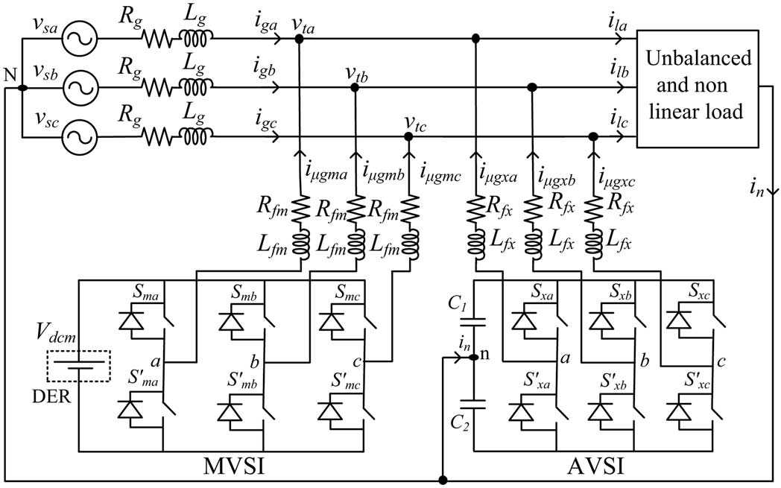

strategy for the reference current generation of two inverters in DVSI scheme.
B. Design of DVSI Parameters
AVSI: The important parameters of AVSI like dc-link voltage (Vdc), dc storage capacitors (C1 and C2), interfacing inductance (Lfx), and hysteresis band ( hx) are selected based on the design method of split capacitor DSTATCOM topol- ogy [16]. The dc-link voltage across each capacitor is taken as
1.6 times the peak of phase voltage. The total dc-link voltage reference (Vdcref ) is found to be 1040 V. Values of dc capacitors of AVSI are chosen based on the
change in dc-link voltage during transients. Let total load rat- ing is S kVA. In the worst case, the load power may vary from minimum to maximum, i.e., from 0 to S kVA. AVSI needs to exchange real power during transient to maintain the load power demand. This transfer of real power during the transient will result in deviation of capacitor voltage from its reference value. Assume that the voltage controller takes n cycles, i.e., nT seconds to act, where T is the system time period. Hence, maximum energy exchange by AVSI during transient will be nST . This energy will be equal to change in the capacitor strategy for the reference current generation of two inverters in DVSI scheme.
B. Design of DVSI Parameters
1) AVSI: The important parameters of AVSI like dc-link voltage (Vdc), dc storage capacitors (C1 and C2), interfacing inductance (Lfx), and hysteresis band ( hx) are selected based on the design method of split capacitor DSTATCOM topol- ogy [16]. The dc-link voltage across each capacitor is taken as
1.6 times the peak of phase voltage. The total dc-link voltage reference (Vdcref ) is found to be 1040 V.
Values of dc capacitors of AVSI are chosen based on the
change in dc-link voltage during transients. Let total load rat- ing is S kVA. In the worst case, the load power may vary from minimum to maximum, i.e., from 0 to S kVA. AVSI needs to exchange real power during transient to maintain the load power demand. This transfer of real power during the transient will result in deviation of capacitor voltage from its reference value. Assume that the voltage controller takes n cycles, i.e., nT seconds to act, where T is the system time period. Hence, maximum energy exchange by AVSI during transient will be nST . This energy will be equal to change in the capacitor

CONTROL STRATEGY FOR DVSISCHEME
The control algorithm for reference current generation using ISCT requires balanced sinusoidal PCC voltages. Because of the presence of feeder impedance, PCC voltages are distorted. Therefore, the fundamental positive sequence components of the PCC voltages are extracted for the reference current gen- eration. To convert the distorted PCC voltages to balanced
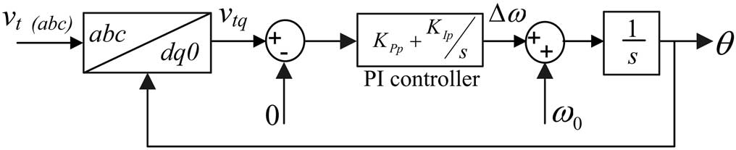

Fig. 2. Schematic diagram of PLL.

sinusoidalvoltages,dq0transformationisused.ThePCCvolt- ages in natural reference frame (v_{ta}, v_{tb}, and v_{tc}) are first transformed into dq0 reference frame as givenby phase locked loop (PLL) [23] is used. The schematic diagram of this PLL is shown in Fig. 2. It mainly consists of a pro- portional integral (PI) controller and an integrator. In this PLL, the SRF terminal voltage in q-axis (v_{tq}) is compared with 0 V andtheerrorvoltagethusobtainedisgiventothePIcontroller. The frequency deviation Δωis then added to the reference fre- quencyω₀and finally given to the integrator to get θ. It can be provedthat,when,θ=ω₀tandbyusingthePark’stransforma- tionmatrix(C),q-axisvoltageindq0framebecomeszeroand hence the PLL will be locked to the reference frequency (ω₀). AsPCCvoltagesaredistorted,thetransformedvoltagesindq0 frame(v_{td}andv_{tq})containaverageandoscillatingcomponents of voltages. These can be representedas

ISCTwasdevelopedprimarilyforunbalancedandnonlinear load compensations by active power filters. The system topol- ogy shown in Fig. 3 is used for realizing the reference current for the compensator [15]. The ISCT for load compensation is derived based on the following threeconditions

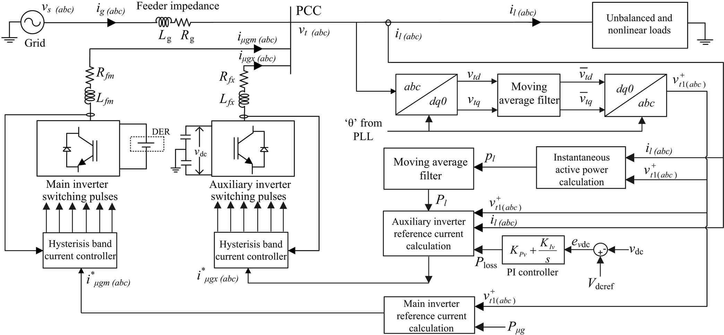

SIMULATIONSTUDIES
The simulation model of DVSI scheme shown in Fig. 1 is developed in PSCAD 4.2.1 to evaluate the performance. The simulation parameters of the system are given in Table I. Thesimulationstudydemonstratesthegridsharingandgrid
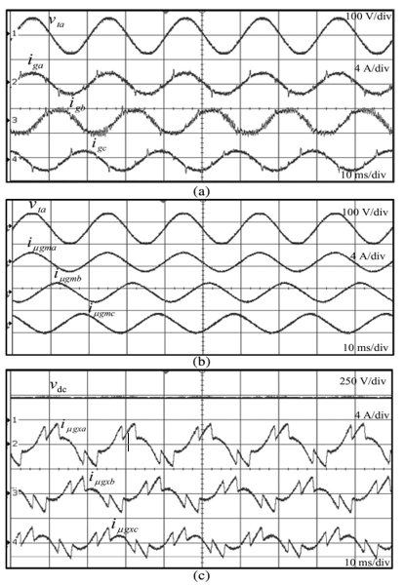
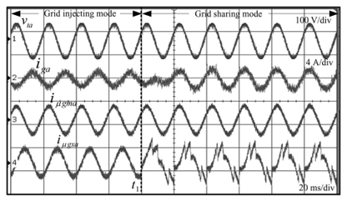
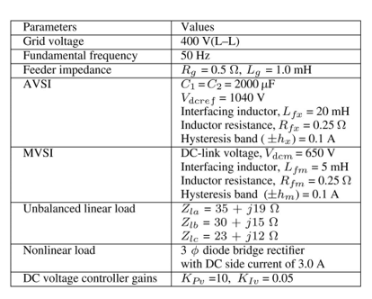
The distorted PCC voltages due to the feeder impedance without DVSI scheme are shown in Fig. 5(a). If these dis- torted voltages are used for the reference current generation ofAVSI, the current compensation will not be proper [14]. Therefore, the fundamental positive sequence of voltages is extracted from these distorted voltages using the algorithm explained in Section III-A. These extracted voltages are given in Fig. 5(b). These voltages are further used for the generation of inverter reference currents. Fig. 6(a)–(d) represents active power demanded by load (P_{l}), active power supplied by grid (P_{g}), active power supplied by MVSI (P_{μg}), and active power supplied by AVSI (P_{x}), respectively. It can be observed that, from t = 0.1 to 0.4 s, MVSI is generating 4 kW power and the load demand is 6 kW. Therefore, the remaining load active power(2kW)isdrawnfromthegrid.
EXPERIMENTALRESULTS
performance of the proposed DVSI is verified with experimental studies. A digital signal processor (DSP)-based prototype of DVSI as shown in Fig. 11 has been developed in the laboratory. The experimental system parameters are given in Table II. The setup consists of two 10 kVA SEMIKRON build two-level inverter for realizing AVSI and MVSI. A DSP TMS320F28335isusedtoprocessthedataindigitaldomainwith a sampling time of 19.5 µs. The signal and logic level circuitconsistofHalleffectvoltageandcurrenttransducers,signal conditioning, and protection circuits along with isolated dcpowersupplies.Arealtimealgorithmhasbeenimplemented incodecomposerstudio(CCS)onthehostcomputer.TheDSP acquires the signals and processes them to generate reference currents for AVSI and MVSI. The switching commands gener- ated by the DSP are then issued to inverters through its general purpose input and outputports.

CONCLUSION
A DVSI scheme is proposed for microgrid systems with enhanced power quality. Control algorithms are developed to generatereferencecurrentsforDVSIusingISCT.Theproposed scheme has the capability to exchange power from distributed generators (DGs) and also to compensate the local unbalanced and nonlinear load. The performance of the proposed scheme has been validated through simulation and experimental stud- ies. As compared to a single inverter with multifunctional capabilities, a DVSI has many advantages such as, increased reliability, lower cost due to the reduction in filter size, and more utilization of inverter capacity to inject real power from DGs to microgrid. Moreover, the use of three-phase, three- wire topology for the main inverter reduces the dc-link voltage requirement. Thus, a DVSI scheme is a suitable interfacing option for microgrid supplying sensitive loads.

