Three Port Dc-Dc Converter For Standalone Photovoltaic
J.VEERESH
PG Scholar, Department of Electrical and Electronics Engineering, Narsimha Reddy Engineering College, Hyderabad-500100

veereshjogu@gmail.com
Abstract
Themostcommonlyusedrenewableenergyisthesolarenergy.TheEfficiencyandcostofthePVsystemisanimportantcriterion.In this paper, a three - port DC-DC converter for Photo-Voltaic system is designed with improved forward-flyback topology. This converter is designed to achieve high step-up capability and its system efficiency improvement using multiple operation modes of a converter. In this paper, the coupled inductor which acts as the transformer providesflexible voltage conversion ratio and galvanic isolation. Switching pulses to the converter are generated by PWM and Phase shift control technique thereby giving almost constant output voltage regulation. The design of proposed converter is done with MATLAB Simulink software. The converter with three operating modes is designed and results analyzed with experimental work. The proposed converter results compared with Two port converter.

Introduction
PV based power generation is of prime importance nowadays, because the cost of photovoltaic panels is reducing continuously.Stand-alonesystemsareusedinapplicationslike satellites,unmannedaerialvehicles,anddomesticapplications. These systems need storage elements to accommodate the intermittent solar power generation. Conventionally, the two porttopologyutilizesthedualactivebridges,fullbridgeorhalf bridge which can support the multiport structure to some extent. By those methods, it is not easy to achieve multiple inputs and multiple outputs for power electronic applications. The traditional method implementing a multi port system is done with the help of a transformer with multiple secondary windings. But it will have a drawback that they are non- bidirectionalinpower.Anotherconventionalconverteristriple half bridge bidirectional converter, which needs two high frequency three

winding transformers and six MOSFET switches, which leads to circuit complexity. It also makes the system expensive. this converter is also not able to maintain soft switching in case of wide operating voltages at the ports. The two port DC-DC converter uses the flyback topology. It uses a high frequency transformer. It has two modes of operation.Theefficiencyofthissystemisquitepoor.Three port converters are capable of providing a single unit solution which interfaces multiple energy sources and also common loads. These converters can perform better than the conventional two port converters due to their small size and their lower part count. It becomes more attractive due to their multiple energy source connection, low cost, compact size. In this converter, the coupled inductor which acts as the transformer is used to provide galvanic isolation and flexible.

BLOCK DIAGRAM FOR 3 PORT DC -DC CONVERTER
The DC input from the panel is given to the converter and the PIC microcontroller is shown in Figure 1. The controller operates the MOSFET driver circuit and sends pulses for any pair of MOSFET switches depending upon the mode of operation.Thecoupledinductorstorestheenergyintheformof magnetic field and delivers the current during the OFF period oftheswitches.Throughmutualinductance,ittransfersenergy to theload.

PROPOSED CONVERTER CIRCUIT DIAGRAM
The circuit of proposed converter is shown in Figure 2.Ithas combination of forward and flyback topologies. During the conduction time of switch, the inductor stores energy in the magnetic field in the inductor air gap during flyback topology. Whenever the switch turns off, the stored magnetic field collapses. The energy gets transferred to the output of the flyback converter, which is in the form of electric current. It can be shown as two inductors sharing a common core with windings of opposite polarities. In the forward topology, the coupled inductor works like a transformer with same polarity windings. It will pass the energy to the output during the conduction time of converter switch.
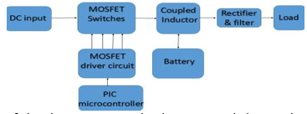

Figure 1 Block Diagram for 3 Port DC-DC Converter

In this converter, three modes of operation are possible. The three modes of operation are as follows:
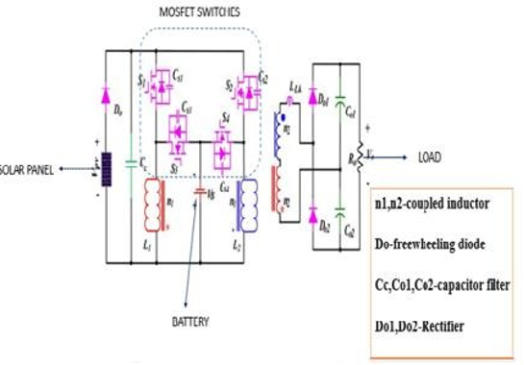
Figure 2 Circuit diagram of three port DC-DC converter

MODE 1: In the first mode, the power from the panel is given to the battery and also to the load.

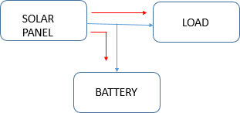
Figure 3 Mode-1
In State 1: S1, S2 will be ON. The current path will be from panel-D0-S1-n1-paneland panel-D0-S2-n1-panel. By mutual inductance,currentreachestheload.State2:S1,S4willbeON. Thecurrentpathwillbefrompanel-D0-S1-n1-panelandS4-n1- battery-S4.State 3:S1, S2 will be ON. The current path will be from panel-D0-S1-n1-paneland panel-D0-S2-n1-panel. By mutualinductance,currentreachestheload.State4:S2,S3will beON.Thecurrentpathwillbefrompanel-D0-S2-n1-paneland S3-n1-battery-S3

MODE 2: The second mode is that whenever the panel power is very low, the power from the battery is given to the load.
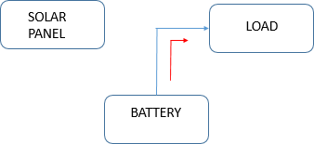
Figure 4 Mode-2
Duringthismode,S3andS4arethemainswitches.Thecurrent path will be from battery to the coupled inductors. By mutual inductance, the power reaches the load. Thus, the circuitworks as flyback forwardconverter.
MODE 3: In this mode, the load is disconnected and the power from the panel is given to the battery

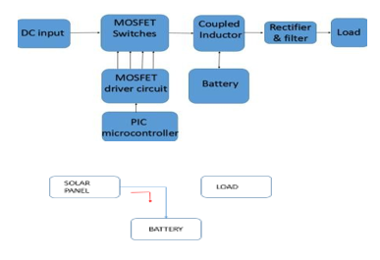
Figure 5 Mode-3
State1:S1,S2willbeON.Thecurrentpathwillbefrompanel- D0-S1-n1-paneland panel-D0-S2-n1-panel. State 2:S1, S4 will beON.Thecurrentpathwillbefrompanel-D0-S1-n1-paneland S4-n1-battery-S4.State 3:S1, S2 will be ON. The current path will be from panel-D0-S1-n1-paneland panel-D0-S2-n1- panel.State 4:S2, S3 will be ON. The current path will be from panel-D0-S2-n1-panelandS3-n1-battery-S3

PULSE WIDTH MODULATION
Pulse-width modulation (PWM) of a signal modulates the duty cycle and which in turn modifies its width of pulses given to switches.Itisgenerallyusedtoeithersendtheinformationover a communication channel or control the amount of power sent to a load. The average power delivered to the load is proportional to the modulation in duty cycle. By having a high modulation rate, passive electronic filters can be used to smooth the pulse train. High frequency PWM power control systems are easily made to happen with semiconductor switches. The discrete ON/OFF states of the modulation process are used to control the state of the switches which eventuallycontrolthevoltageacrosstheloadorcurrentthrough theload.Themajoradvantageofthissystemistheswitchesare either OFF (not conducting any current), or ON and have (ideally) no voltage drop across the switch. Hence the power loss in MOSFET switches is verylow.

Phase shift control
Phase shift can be defined as the amount by which a wave has beenshiftedbyhorizontalmeansfromtheoriginalwave.Since the horizontal axis refers time, a phase shift denotes a shift in time from the original wave. Phase shift is normallymeasuredindegrees.Acompletecycleisrepresentedas360degrees.The output voltage of converter can be controlled by using phase shift control. By phase shift control, the switches attain zero voltage switching, which reduces the switching losses of the converter. In this proposed system, the output voltage waveforms of the converter are controlled by both PWM as well as phase shift control strategies. Thus, it makes the converter moreefficient.

SIMULATION RESULTS AND DISCUSSION
Simulink Model
The MATLAB is a productive software platform for technical and mathematical computing, which is used for solving engineeringandscientificproblems.MATLABprogrammingis easy-to-use environment where problems and solutions are expressed in familiar mathematical notation. The simulation circuitforthreeportDC-DCconverterisshowninFigure6.

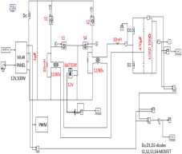
Figure 6 Simulation circuit of three port DC-DC converter.

The Simulink model for three port DC-DC converter for PV systemissimulatedusingMATLABR2010a.Theconventional two port DC-DC converter is also simulated and both the simulation results are compared andanalyzed.

Table 1 Simulation results for three port dc-dc converter
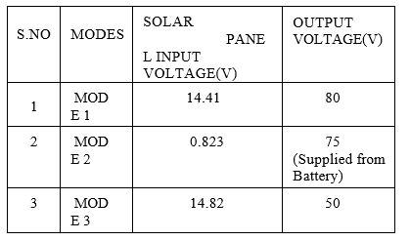

Mode 1 (Output Voltage)
The input temperature is 308F and input irradiance is 175.For an input voltage of 14.41V, the output voltage obtained is 80V

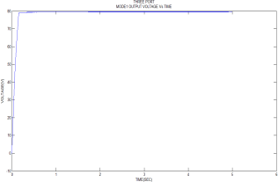
Figure 7 output voltage waveform of mode 1 of three port converter

Mode 2 (Output Voltage)
Theinputtemperatureis280Fandinputirradianceis10.Foran input voltage of 0.823V, and battery voltage of 80v, the output voltage obtained is 75V.

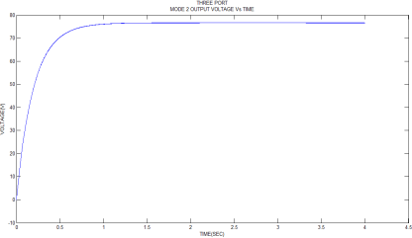
Figure 8 output voltage waveform of mode 2 of three port converter

Mode 3 (Output Voltage)
The input temperature is 308F and input irradiance is 180.For an input voltage of 14.82V, the output voltage obtained is 50V.

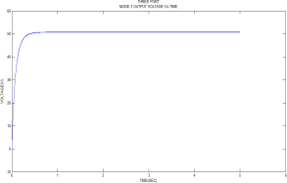
Figure 9 output voltage waveform of mode 3of three port converter

COMPARISION WITH CONVENTIONAL CONVERTER
The simulation circuit of conventional two port DC- DC converter is shown in Figure 10. The simulation results are compared with proposed converter results is shown in TABLE 2.

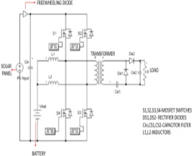
Figure 10 Circuit diagram for two port DC-DC converter

Table 2 Comparison of Simulation results

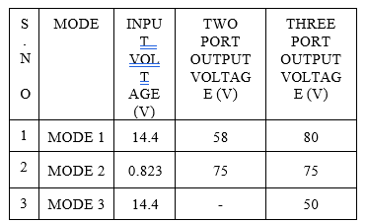

CONCLUSION:

Thusthreeportdc-dcconverterwiththreeoperatingmodesand high step up capability has designed. The results prove that three port converter was better with conventional two port converter. The future scope of this system can be extended to four-port or multi-port converters. In four port converter, in additiontothesolarinputport,batteryportandoutputport,one wind energy port can be added. Multiport converter has plenty of interacting control loops due to integrated power trains. The integrated system will have a lower overall mass and more compact packaging. And also has lower cost, improved reliability and enhanced dynamic performance due to power stage integration and centralizedcontrol.

