Thermal Analysis of Engine Cylinder Fins by Changing Material and Fin Geometry
MR. KHAWAR SHAFAQUE¹, MR.G.SATISHKUMAR²
¹PG Scholar, Dept of Thermal Engineering, Narsimha Reddy Engineering College, Hyderabad
²Associate Professor & HOD, Narsimha Reddy Engineering College, Hyderabad-500100
khawarshafaque@gmail.com, satishkumarnrec@gmail.com
ABSTRACT:The cylinder of engine is a major component of automobile, which is undergone high variation of temperature and thermal stresses. Fins are mounted on the cylinder of engineto cool the cylinder by increasing theheattransfer rate. It will be helpful to know heat dissipation around the cylinder by carrying out thermal analysis on the engine cylinder fins. We know that, by increasing the surface area we can increase the heat dissipation rate, so designing such a large complex engine is very difficult. In this work two types of fluid are used to increase the heat dissipation rate. The main objective of this work is to evaluate the thermal behavior by varying cooling fluid, material and fin geometries of cylinder fins. Cooling fluids used in this theory is air and oil. The 3D modeling software used is Solid Works. Thermal analysis is performed on the cylinder fins to analyze the change in temperature distribution. Thermal analysis is carried out by using ANSYS. The variation of temperature distribution over time is of interest in many applications such as in cooling. The accurate thermal simulation could permit critical design parameters to be identified for improved life. Presently Material used for manufacturing cylinder fin body is Aluminum Alloy 6061 which has thermal conductivity of 151-202 w/mk. Present analysis is carried out for cylinder fins using this material and also using Aluminum alloy which have higher thermalconductivities and Cast Iron.
Key words:Fins, Solid Works, ANSYS.

INTROUCTION:
We know that in case of Internal Combustion engines, combustion of air and fuel takes place inside the engine cylinder and hot gases are generated. The temperature of gases will be around 2300-2500°C. This is a very high temperature and may result into burning of oil film between the moving parts and may result it seizing or welding of same. So, this temperature must be reduced to about 150-200°C at which the engine will work most efficiently. Too much cooling is also not desirable since it reduces the thermal efficiency. So, the object of cooling system is to keep the engine running at its most efficient operating temperature. It is to benoted that the engine is quite inefficient when it is cold and hence the cooling system is designed in such a way that it prevents cooling when the engine is warming up and till it attains to maximum efficient operating temperature, then it startscooling.
Toavoidoverheating,andtheconsequentilleffects,theheattransferredtoanenginecomponent(aftera certain level) must be removed as quickly as possible and be conveyed to the atmosphere. It will be proper to say the cooling system as a temperature regulation system. It should be remembered that abstraction of heat from the workingmediumbywayofcoolingtheenginecomponentsisa directthermodynamicloss.

NATURAL AIR COOLING
In normal cause, larger parts of an engine remain exposed to the atmospheric air. When the vehicles run, the air at certain relative velocity impinges upon the engine, and sweeps away its heat. The heat carried-away by the air is due to natural convection, therefore this method is known as natural air-cooling. Engines mounted on 2-wheelers are mostly cooled by natural air. As the heat dissipation is a function of frontal cross-sectional area of the engine, therefore there exists a need to enlarge this area. An engine with enlarge area will becomes bulky and in turn will also reduce the power by weight ratio. Hence, as an alternative arrangement, fins are constructed to enhance the frontal cross-sectional area of theengine.
Fins (or ribs) are sharp projections provided on the surfaces of cylinder block and cylinder head. They increase the outer contact area between a cylinder and the air. Fins are, generally, casted integrally with thecylinder.Theymayalsobemountedonthecylinder.
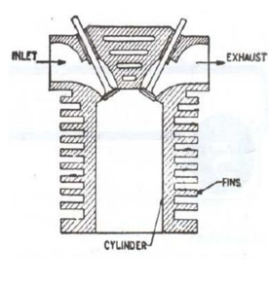
Fig1. Natural air cooling

FINS:
A fin is a surface that extends from an object to increase the rate of heat transfer to or from the existingenvironment by increasing convection. The amount of conduction, convection, radiation of an object determines the amount of heat it transfers. Increasing the temperature difference between the object and the environment, increasing the convection heat transfer coefficient, or increasing the surface area of the object increases the heat transfer. Sometimes it is not economical or it is not feasible to change the first two options. Adding a fin to the object, however, increases the surface area and can sometimes be economical solution to heat transfer problems. Circumferential fins around the cylinder of a motor cycle engine and fins attached to condenser tubes of a refrigerator are a few familiarexamples.
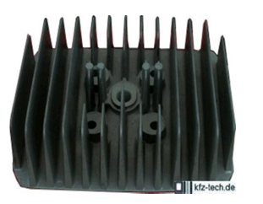
Fig2. Automobile Fin
FernandoIllansimulatedtheheattransferfromcylindertoair ofatwo-strokeinternalcombustionfinnedengine. The cylinder body, cylinder head (both provided with fins), and piston have been numerically analyzed and optimized in order to minimize engine dimensions. The maximum temperature admissible at the hottest point of the engine has been adopted as the limiting condition. Starting from a zero-dimensional combustion model developed in previous works, the cooling system geometry of a two-stroke air cooled internal combustion engine has been optimized in this paper by reducing the total volume occupied by the engine. A total reduction of 20.15% has been achieved by reducing the total engine diameter D from 90.62 mm to 75.22 mm and by increasing the total height H from 125.72 mm to 146.47 mm aspect ratio varies from 1.39 to 1.95. In parallel withthetotalvolumereduction,aslightincreaseinengineefficiencyhas beenachieved.
G. Babu and M. Lavakumar analyzed the thermal properties by varying geometry, material and thickness of cylinder fins. The models were created by varying the geometry, rectangular, circular and curved shaped fins and also by varying thickness of the fins. Material used for manufacturing cylinder fin body was Cast Iron whichhas high thermalconductivityandalsousingAluminumalloy6061 which has thermal conductivity of 151-202 w/mkandAluminumalloy which have higher thermal conductivities. They concluded that by reducing the thickness and also by changing the shape of the fin to curve shaped, the weight of the fin body reduces thereby increasing the efficiency. The weight of the fin body is reduced when Magnesium alloy is used and using circular fin, material Aluminum alloy 6061 and thickness of 2.5mm is better since heat transfer rate is more and using circular fins the heat lost is more, efficiency and effectiveness is alsomore.
J. Ajay Paul et.al. carried out Numerical Simulations to determine heat transfer characteristics of different fin parameters namely, number of fins, fin thickness at varying air velocities. A cylinder with a single fin mountedon it was tested experimentally. The numerical simulation of the same setup was done using CFD. Cylinders with fins of 4 mm and 6 mm thickness were simulated for 1, 3, 4 & 6 fin configurations. They concluded that 1. When fin thickness was increased, the reduced gap between the fins resulted in swirls being created which helped in increasing the heattransfer.
2. Large number of fins with less thickness can be preferred in high speed vehicles than thick fins with less numbers as it helps inducing greater turbulence and hence higher heat transfer.
N. Phani Raja Rao et.al. analyzed the thermal properties by varying geometry, material and thickness of cylinder fins. Different material used for cylinder fin were Aluminum Alloy A204, Aluminum alloy 6061 and Magnesiumalloywhichhavehigherthermalconductivitiesandshownthatbyreducingthe thicknessandalsoby changing the shape of the fin to circular shaped, the weight of the fin body reduces thereby increasing the heat transfer rate and efficiency of the fin. The results shows, by using circular fin with material Aluminum Alloy 6061 is better since heat transfer rate, Efficiency and Effectiveness of the fin ismore.
Young Researchers, Central Tehran Branch, Islamic Azad University, Tehran, Iran has stated that heat transfer in a straight fin with a step change in thickness and variable thermal conductivity which is losing heat by convection to its surroundings is developed via differential transformation method (DTM) and variational iteration method (VIM). In this study, we compare DTM and VIM results, with those of homotopy perturbaion method (HPM) and an accurate numerical solution to verify the accuracy of the proposed methods. As an important result, it is depicted that the DTM results are more accurate in comparison with those obtained by VIM and HPM. After these verifications the effects of parameters such as thickness ration, α, dimensionless fin semi thickness, δ, length ratio, λ, thermal conductivity parameter, β, Biot number, Bi, on the temperature distribution are illustrated andexplained.

PROBLEMDEFINITION:
In the present paper investigation on thermal issues on automobile fins were carried out. Investigation yields the temperature behavior and heat flux of the fins due to high temperature in the combustion chamber. ANSYS work bench is utilized for analysis. The analysis is done for different models of fins that are commercially available now a days and a comparison is thus established between them. Also the material is changed so that better heat transfer rate can beobtained.

MODELING OF CYLINDER FIN:
Cylinder along with fin was modeled in Pro-E. The dimensions of the cylinder along with fin were taken from commercially available bike data sheet. Fins with different geometries (circular, rectangular and arc type) were modeled usingPro-E.
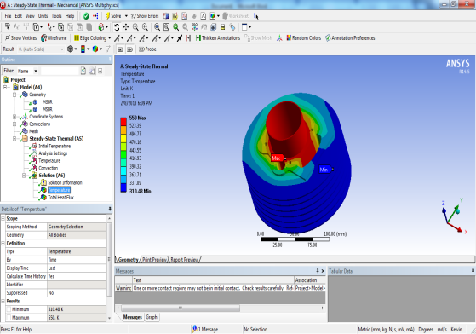
Fig. Circular Cylinder fin
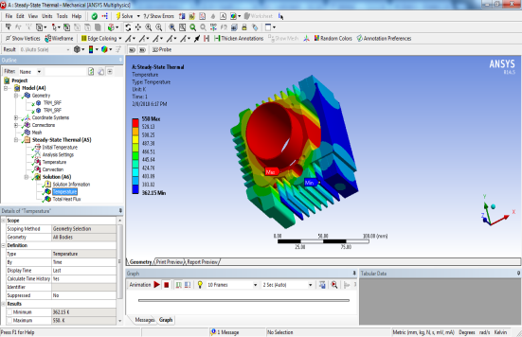
Fig. Rectangular cylinder fin
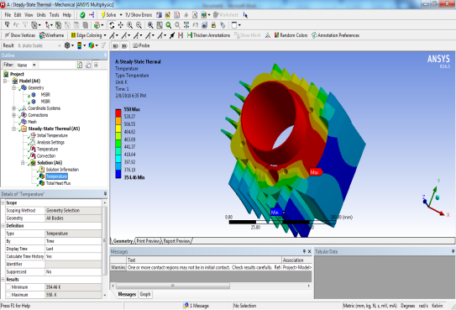
Fig. Arc Type Fin

ANALYSIS IN ANSYS WORKBENCH:
Analysis of the cylinder fin for different geometries was carried out in ANSYS workbench. The basic model was generated using Pro-E and that model is imported to ANSYS work bench. Meshing is done in ANSYS work bench.
Transient thermal analysis was carried out. Transient thermal analyses determine temperatures and other thermal quantities that vary over time. The variation of temperature distribution over time is of interest in many applications such as with cooling of electronic packages or a quenching analysis for heat treatment. Also of interest are the temperature distribution results in thermal stresses that can cause failure. In such cases the temperatures from a transient thermal analysis are used as inputs to a static structural analysis for thermal stress evaluations. In the present study as the fins undergo temperature variation along time so transient thermal analysis was carried out. Boundary conditions were given in terms of temperature asfollows,
Materials that are s for present analysis are Aluminum alloy 6061, Aluminum alloy, and Cast Iron. Cooling fluids used in this are air and oil.
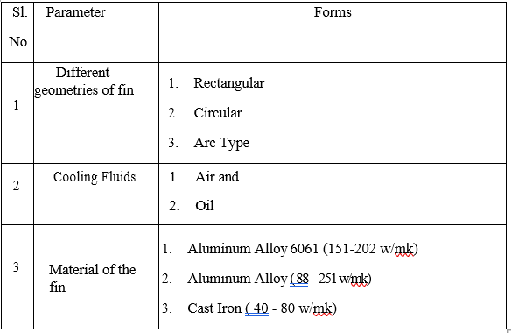

RESULTS AND DISCUSSION:
A different metals block with fins mounted on it is used for analysis in the present paper. This is imported into ANSYS workbench environment and boundary conditions were applied. Analysis is carried out for different geometry of fins (circular, rectangular and arc type) with various materials and with different cooling fluids that is for air and oil. The results are shownbelow:
FLUID- AIR
1) RECTANGULAR FIN
Material: Aluminum Alloy 6061 Temperature
Heat Flux
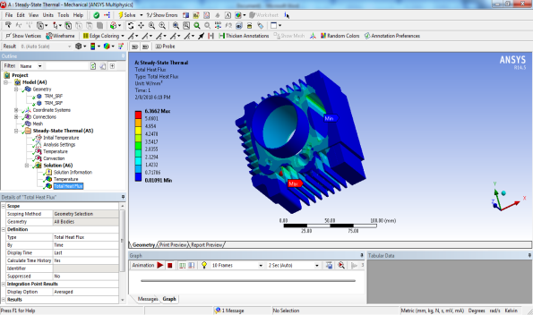
Material: Aluminum Alloy Temperature
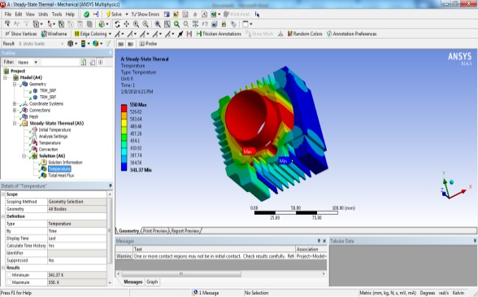
Heat Flux
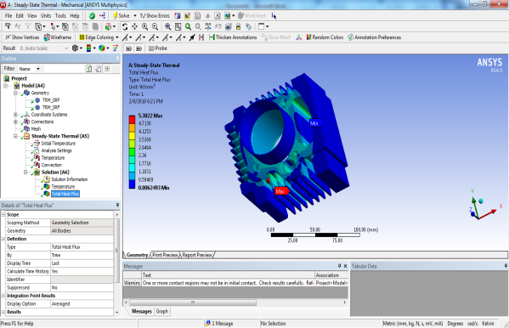
Material: Cast Iron
2) CIRCULAR FIN
Material: Aluminum Alloy 6061
Temperature
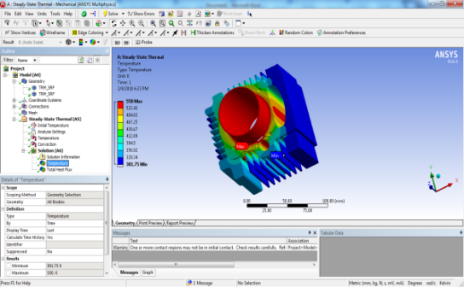
Heat Flux
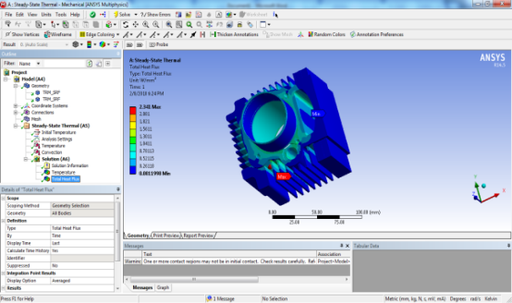 Temperature
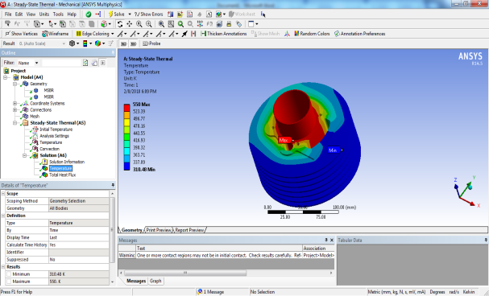
Heat Flux
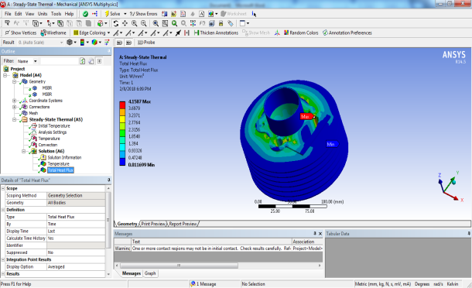

3) ARC TYPE FIN
Material: Aluminum Alloy 6061 Temperature
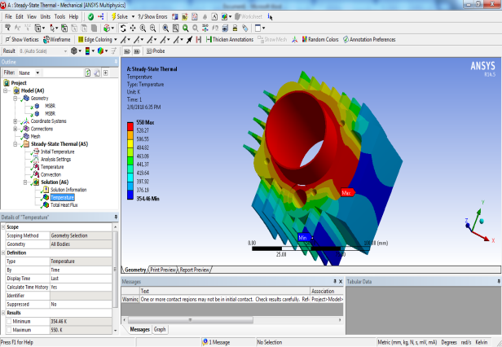
Heat Flux 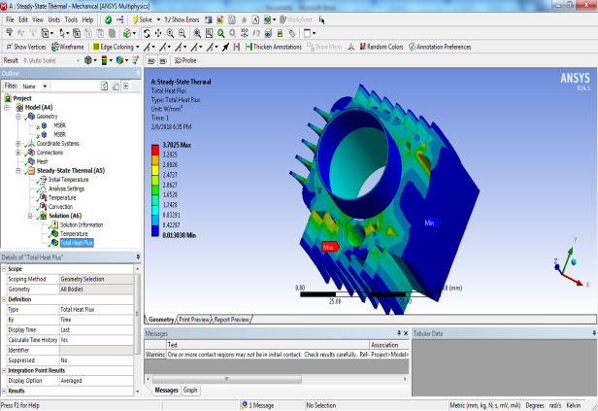
Material: Aluminum Alloy Temperature

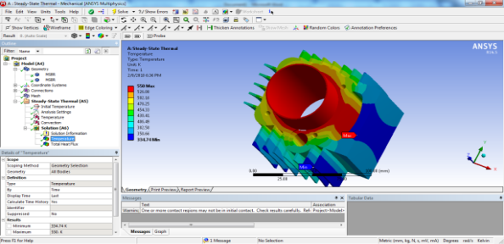
Heat Flux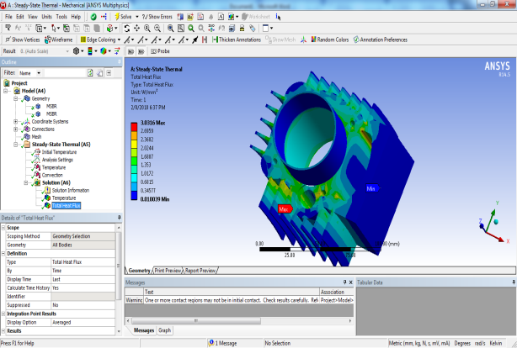
Material: Cast Iron Temperature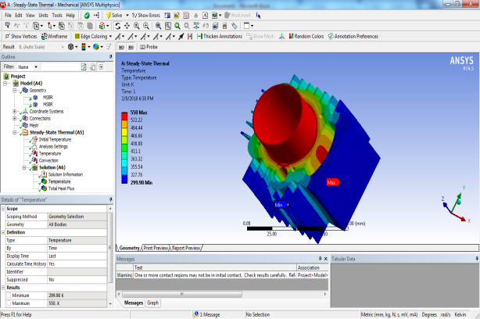
Heat Flux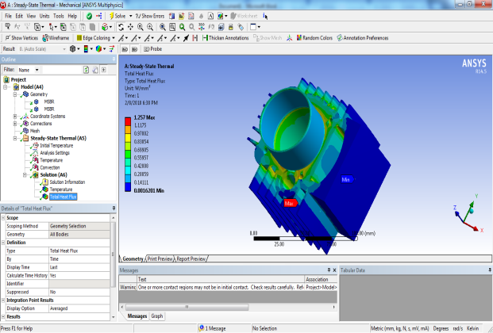

RESULT TABLE
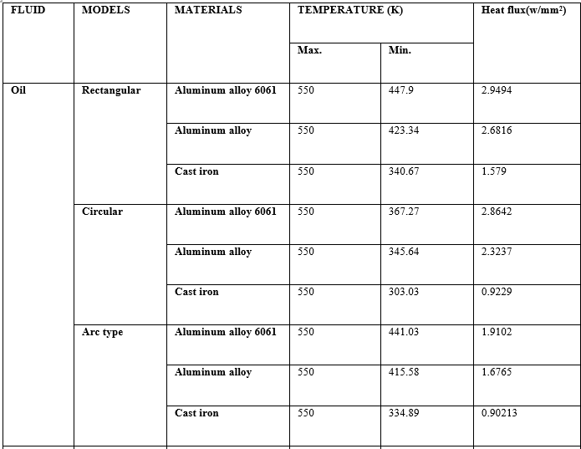
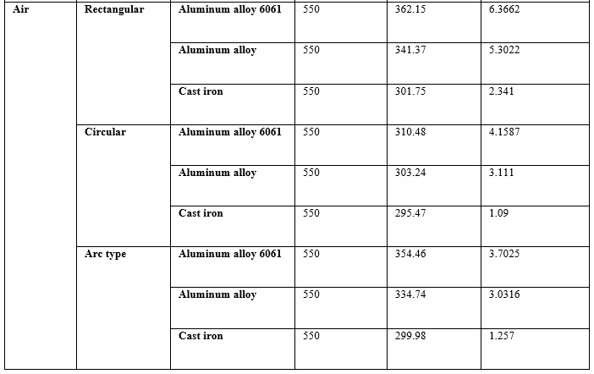
HEAT FLUX PLOT FORAIR

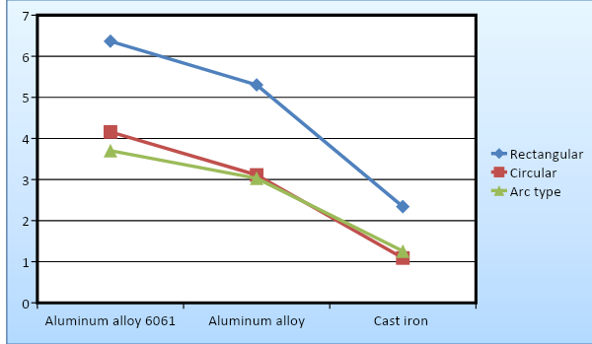

FOR OIL
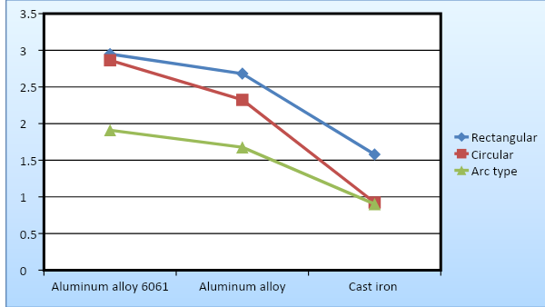
Above twographs showsthetemperaturevariationsintherectangular, circular and arc typefins for different cooling fluids that is for air and oil.Butintherectangular cross section fins from the graph it is clear that heat flux is high for aluminum alloy 6061 than other materials and heat transfer is also more for air as a fluid. So that in circular cross sectioned fins the temperature is not distributed over the entire area of the engine cylinder fin. But in case of rectangular cross sectioned fins with different sizes of engine cylinder fins the temperature is distributed over the entire area of the fins. So that a better heat transfer rate is achieved in case of rectangular fins. This can be seen clearly in the results. The temperatures are distributed throughout the area of the rectangular fin.

CONCLUSION:
In present work, a cylinder fin body is modeled and transient thermal analysis is done by using Pro/Engineer and ANSYS. These fins are used for air cooling systems for two wheelers. Fins are mounted on the cylinder of engine to cool the cylinder by increasing heat dissipation rate. In this work, two types of fluid are used such as air and oil to enhance the rate of heat dissipation. The motive of this work is to find out thermal properties by changing cooling fluid, material and fin geometry. So in this project, two materials have been taken which have more thermal conductivities than aluminum alloy. The materials are Aluminum Alloy 6061 and Aluminum Alloy and Cast iron and thermal analysis is done for all the three materials.
It is observed that heat flux is high for Aluminum Alloy 6061 than other materials and heat transfer is also more. So Aluminum Alloy 6061 and rectangular fin and air as a fluid is best preferred

REFERENCES:
- Thermal Engineering by I. Shvets, M. Kondak
- Thermal Engineering by Rudramoorthy
- Thermal Engineering by R.K. Rajput
- Thermal Engineering by Sarkar
- Gibson, A.H., The Cooling of air of Petrol Engines, Proceedings of the Institute of Automobile Engineers, Vol.XIV (1920), pp.243–275.
- Biermann, A.E. and Pinkel, B., Heat Transfer from Finned Metal Cylinders in an Air Stream, NACA Report No.488 (1935).
- Thornhill, D. and May, A., An Experimental Research into the Cooling of Finned Metal Cylinders.
- Free Air Stream, SAE Paper 1999-01-3307, (1999). ( 4 ) Thornhill, D., Graham, A., Cunnigham, G., Troxier, P. and Meyer, R.,
- Experimental Research into the Free Air-Cooling of Air-Cooled Cylinders, SAE Paper 2003-32-0034, (2003). ( 5 ) Pai, B.U., Samaga, B.S. and Mahadevan, K., Some
- Experimental Researches of Heat Transfer from Finned Cylinders of Air-Cooled I.C. Engines, 4th National Heat Mass Transfer Conference, (1977), pp.137–144.
11. International Journal of Engineering Research & Technology (IJERT) Vol. 2 Issue 8, August 2013 IJERT.

