AN EFFECTIVE DUAL FEED INDUCTION GENERATOR WITH OPEN OPERATING PENETRATE CAPABILITIES BY EMPLOYING FUZZY LOGICCONTROLLER
KIRAN,KAVYA,MOUNIKA,SOUMYA

¹PG Scholar, Department EEE (POWER ELECTRONICS), SVS Institute of technology, Warangal, Telangana, India.
²Assistant professor, Department EEE, SVS Institute of technology, Warangal, Telangana, India.
³Assistant Professor, Department EEE, SVS Institute of technology, Warangal, Telangana, India.
⁴Associate Professor, Department EEE, SVS Institute of technology, Warangal, Telangana, India.

ABSTRACT
This project deals with the exercise of a dual-feed Induction generator (DFG) with open operating penetrate capabilities employing the GSK. The main grant about work strike the rule of the Global Service Center for the afford of the composition to the sliding management delivery. The rotor side transformer (RSK) is acclimated widen the pedigree of strength and to cater the recommended strength prescribed to dfig. The WEC technique performs a passive compensator to cater unity even when wind diesel inclines. The administer data of GSK and RSK are produced conscientiously. The Wix-based DFIG is sham adopting Mat lab / Simulink. The reproduction results are documented with the test results of state-of-the-art DFG for original treat surroundings, in the manner that fickle wind further and unhinged loads/mono phase.
Key words: Dual feed induction generator, Rotor side transformer, nonlinear load, Power quality, Wind energyconversion system (WECS).

I.INTRODUCTION
With population density and mechanization, potential stipulate has enlarged far. However, historic potential origins equally coal, oil, and gas are poor in variety. Now, continuous electricity causes come to for outlook electricity require. The separate preeminent advantages on this subject inexhaustible expert are environmentally peaceful and unrestricted in description. Due to vocational advances, the cost of geothermal power staged reaches the cost of ordinary management plants. Therefore, geothermal power is gorgeous culled of all viable potential authorities. In the beforehand days, wind generator was used as eternal fly wind cylinder with nine-to-five induction dynamo and condenser banks. Most wind types of diesel prevail fly by means of their directness and reasonable. By watching the characteristics of wind cylinder, one can cal promptly control that to squeeze the height potential, the design must be negotiated at volatile rotor hurry at original wind flees.
Using modern strength thermionic generator, the machinery may set upon a pliable further. Therefore, the above-mentioned wind-boost wind cylinder allows enhancing wind electricity manufacturing. Of all fickle-hurry wind diesel, dual-impulse dynamos (DFGs) are approved by reason they're economical. Other advantages in this regard DVG are high law harvest, low alteration rate, and excel use of dynamosThese devices also arrange good dampen opera for weak structure. Independent rule of alive and interacting violence is achieved with a recurring aim method granted. This bearing administer organization is regularly achieved in synchronized rotation of the coordinate system oriented one of two at the electricity axis or veil axis. In this work, the rotor side transformation governs (RSK) transport out in an intensity-oriented standpoint. The organization edge requirements for structure connectedness and wind farm exercise are discussed. Wind Power Conversion System (WYX) to net disorder correlated to WEX definitive fly in [13]. As the wind penetrates into the grid substantially, use the Wix yo-yo hurry for reciprocal functions equally prestige load and forced in chorus moderation as well sovereignty breed. This integrity is achieved by made up of superb seductive dynamism depot organizations as implied in [14]. Other companion services, equally the requirement for the bilateral facility and ephemeral balance, are achieved about the admittance of the limited compensator (STATSOM). Statcom uses distributions again a wheel-drive strength stockpile arrangement at the wind farm to force musicals and recurrence disturbances. However, the authors have used two increased cylinders for this purpose. A sensational conducting electricity stockpile process is recommended in a DSC link of a specification vane for the excellence of sovereignty (OPEC) to correct the excellence and real talent of electricity. In all reproduction methods, the authors used insulate evangelist to satisfy symphonic and also to govern the reciprocal ingenuity. However, in again stages, some researchers restricted the manage conclusion for real DVEGs to assuage potential excellence problems and rebuild the bilateral potential. Compensation consonants and command of return talent are achieved by virtue of current RSK. Therefore, the symphonies of the RSK are injected into rotor coils. This plans losses and crashes in the design. These strange symphonies in the rotating part may also build stereotyped imbalances. Furthermore, the joint law coverage and in chorus benefit are obtained quite the above-mentioned methods accepting the RSC govern. These methods develop the RSC valuation.TABLE 1
CURRENT DISTORTION LIMITS FOR GENERAL DISTRIBUTIONS YSTEMS IN TERMS OF INDIVIDUAL HARMONICS ORDER (ODD HARMONICS)
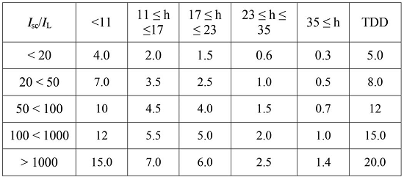
II. Proposed system configuration
Fig.shows a representational blueprint of the expected DFIG occupying WECS with mixed keen dribble capabilities. In DFIG, the stator is honestly linked to the grid as exposed in Fig Two attached associated intensity expert evangelist (VSCs) stretch in the seam the rotor and the grid. Nonlinear loads dovetail at PCC as established in Fig. The expected DFIG entirety as a dynamic pass through bonus to the operating strength crop akin to natural DFIG. Harmonics generated all nonlinear load linked at the PCC deceive the PCC heat. These nonlinear loads symphonic currents are mitigated by GSC administer, in order that the stator and grid currents are consonant-free. RSC is administered for achieving top sovereignty tend to track (MPPT) and also for producing integrity strength part at the stator side applying intensity-oriented reference system. Synchronous framework (SRF) administer approach is used for extracting the principal factor of load currents for the GSC manage.
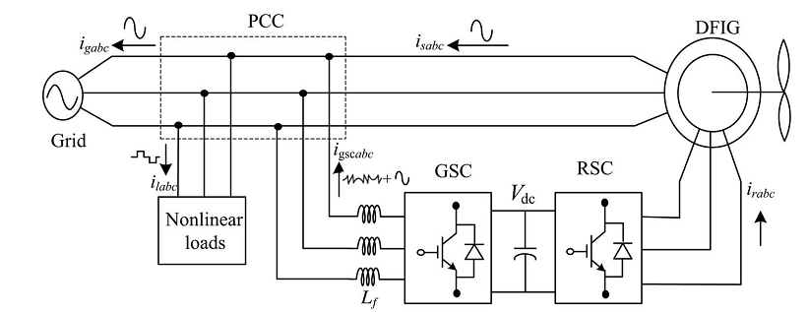
Fig.1: Proposed system configuration

III. DESIGN OF DFIG-BASED WECS
Selection of ratings of VSCs and dc-link electricity is greatly serious for the lucrative action of WECS. The ratings of DFIG and dc gadget used included empirical process required in Appendix. In this branch, an exact form of VSCs and dc-link intensity is discussed for the developmental technique used hustling A. Selection of DC-Link Voltage Normally, the dc-link potential of VSC must be beyond double the peak of top development potential. The pick of dc link potential look to both rotor heat and PCC intensity. While forasmuch as from the rotor side, the rotor potential is slip times the stator heat. DFIG used in view of this paradigm has stator to rotor turns correlation as 2:1. Normally, the DFIG working slip is ±0.3. So, the rotor potential is constantly lower than the PCC intensity. So, the compose criteria for the option of dc-link heat perhaps achieved by in consideration of only PCC intensity. While in consideration of from the GSC side, the PCC line intensity (v a b) is 230 V, as the gadget goes in estuary mode. Therefore, the dc-link electricity is guessed at as [31]
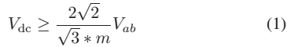
Where, Vab is the line voltage at the PCC. Maximum modulation index is selected as 1 for linear range. The value of dc-link voltage (Vdc) by (1) is estimated at 375 V. Hence, it is selected as 375 V.

IV.CONTROL STRATEGY
A. CONTROL OF RSC
The main purpose of RSC is to extract maximum power with independent control of active and reactive powers. Here, the RSC is controlled in voltage-oriented reference frame. Therefore, the active and reactive powers are controlled by controlling direct and quadrature axis rotor currents (idr and iqr), respectively. Direct axis reference rotor current is selected such that maximum power is extracted for a particular wind speed. This can be achieved by running the DFIG at a rotor speed for a particular wind speed. Therefore, the outer loop is selected as a speed controller for achieving direct axis reference rotor current (i∗dr) as
Where, the speed error (ωer) is obtained by subtracting sensed speed (ωr) from the reference speed (ωr∗). kpd and kid are the proportional and integral constants of the speed controller. ωer(k) and ωer(k − 1) are the speed errors at kth and (k−1)th instants. i* dr(k) and i*dr(k − 1) are the direct axis rotor reference current at kth and (k−1)th instants. Reference rotor speed (ωr∗) is estimated by optimal tip speed ratio control for a particular wind speed.
The tuning of PI controllers used in both RSC and GSC are achieved using Ziegler Nichols method. Initially, kid value is set to zero and the value of k pd was increased until the response stars oscillating with a period of Ti. Now, the value of kpd is taken as 0.45 k pd and kid is taken as 1.2 kpd/Ti. Normally, the quadrature axis reference rotor current (i∗qr) is selected such that the stator reactive power (Q s) is made zero. In this DFIG, quadrature axis reference rotor current (i∗qr) is selected for injecting the required reactive power. Inner current control loops are taken for control of actual direct and quadrature axis rotor currents (idr and iqr) close to the direct and quadrature axis reference rotor currents (i∗dr and i∗ qr). The rotor currents idr and iqr are calculated from the sensed rotor currents (ira, irb, and irc) as [32]
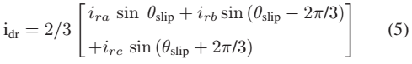
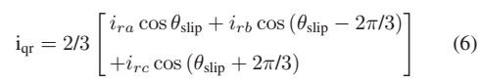
Where, slip angle (slip) is calculated as
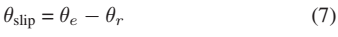
Where, θ e is calculated from PLL for aligning rotor currents into voltage axis. The rotor position (θr) is achieved with an encoder. Direct and quadrature axis rotor voltages (vdr and vqr ) are obtained from direct and quadrature axis rotor current errors (ider and iqer) as
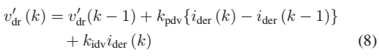
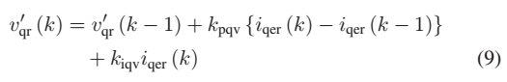
Where
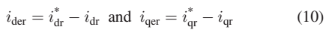

Where, Kpdv and Kidv are the proportional and integral gains of direct axis current controller. Kpqv and Kiqv are the proportional and integral gains of quadrature axis current controller. Direct and quadrature components are decoupled by adding some compensating terms as [26]
These reference direct and quadrature voltages (vdr∗, vqr∗) are converted into three phase reference rotor voltages (vra∗, vrb∗, vrc∗) as [32]
These three phase rotor reference voltages (vra∗, vrb∗, vrc∗) are compared with triangular carrier wave of fixed switching frequency for generating pulse-width modulation (PWM) signals for the RSC.
B. Control of GSC
The novelty of this work lies in the control of this GSC for mitigating the harmonics produced by the nonlinear loads. The control block diagram of GSC is shown in Fig. Here, an indirect current control is applied on the grid currents for making them sinusoidal and balanced. Therefore, this GSC supplies the harmonics for making grid currents sinusoidal and balanced. These grid currents are calculated by subtracting the load currents from the summation of stator currents and GSC currents. Active power component of GSC current is obtained by processing the dc-link voltage error (vdce) between reference and estimated dc-link voltage (Vdc∗ and Vdc) through PI controller as
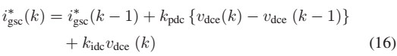
Where kpdc and kidc are proportional and integral gains of dc-link voltage controller. Vdce(k) and Vdce(k − 1) are dclink voltage errors at kth and (k−1)Th instants.

V.SIMULATION RESULTS
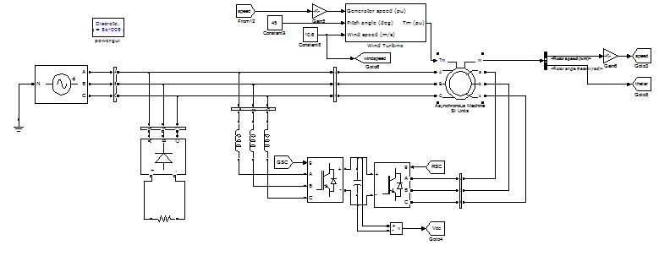
Fig 2. main circuit
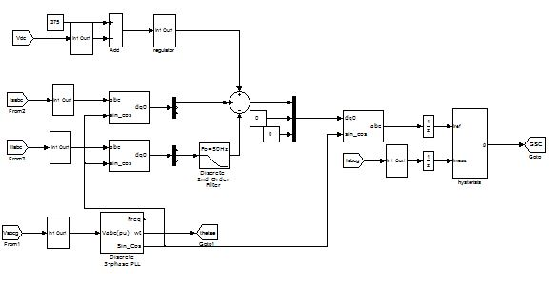
Fig 3.sub circuit-1

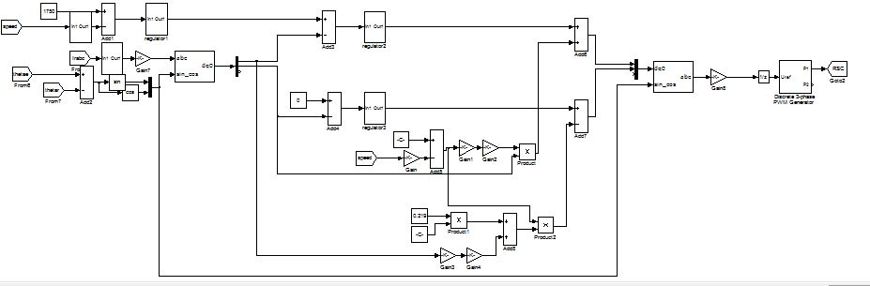
Fig 4. sub circuit-2
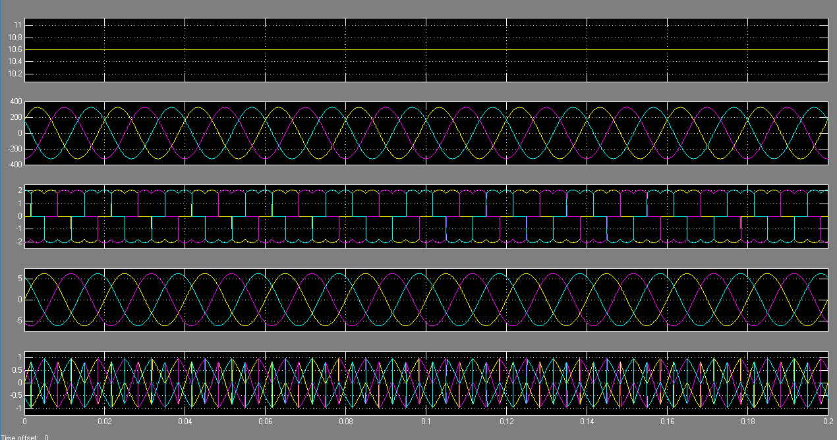
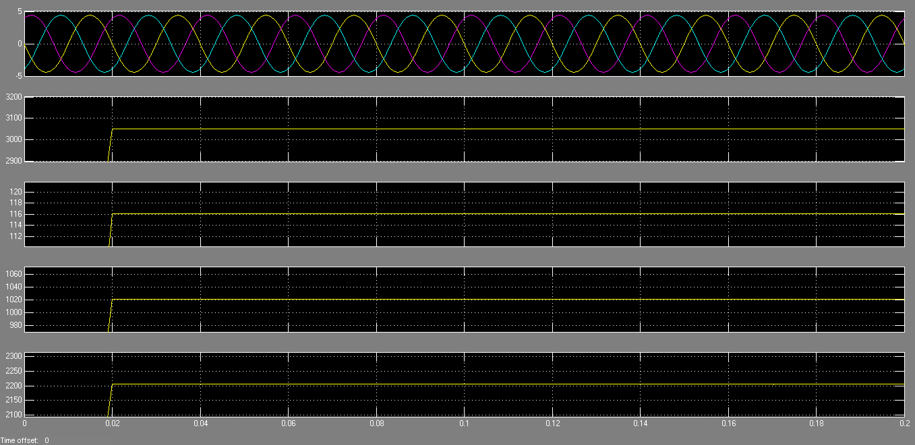
Fig.5:Simulated performance of the proposed DFIG-based WECS at fixed wind speed of 10.6 m/s (rotor speed of 1750rpm).
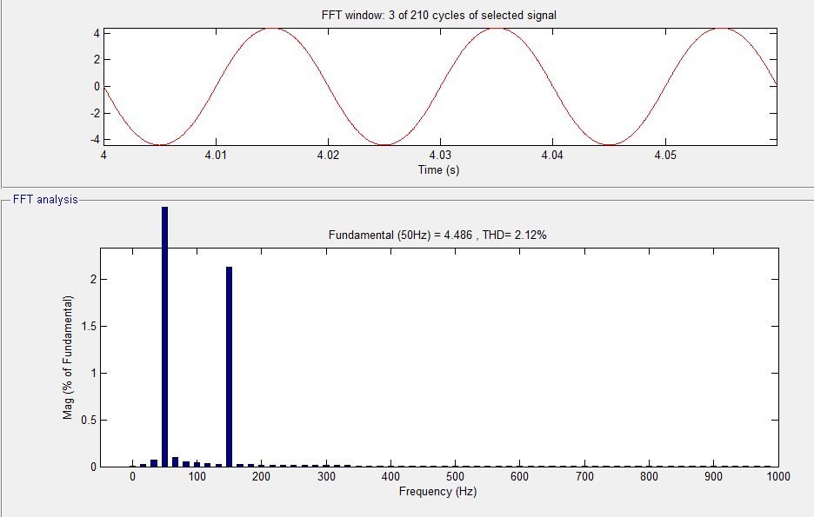
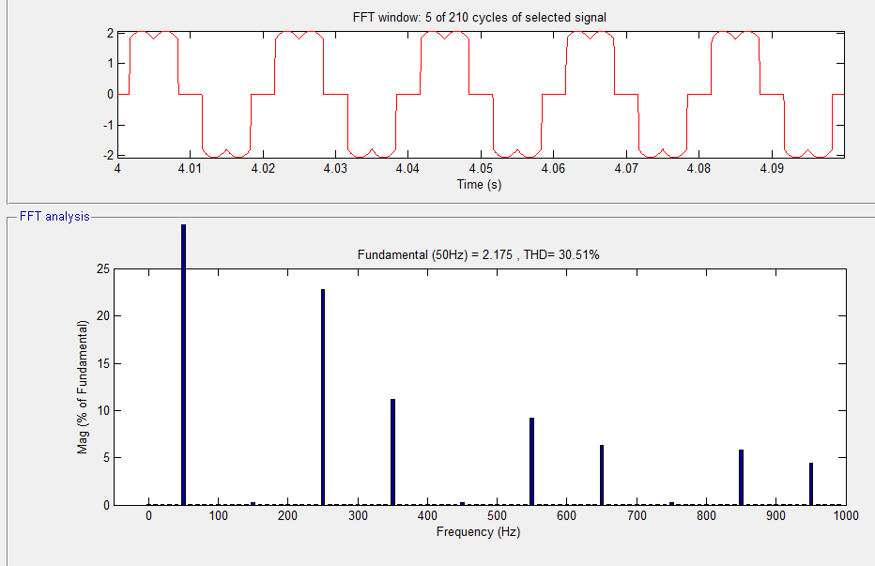
Fig.6. Simulated waveform and harmonic spectra of (a) grid current (iga), (b) load current (ila), at fixed wind speed of 10.6 m/s (rotor speed of 1750 rpm).
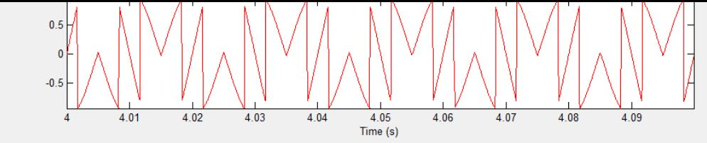
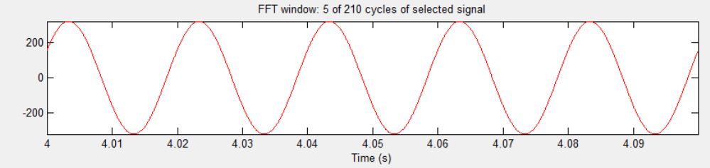
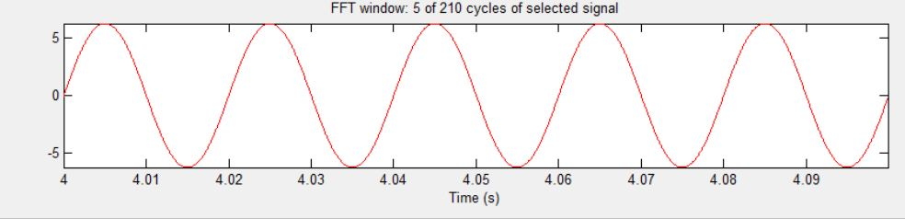
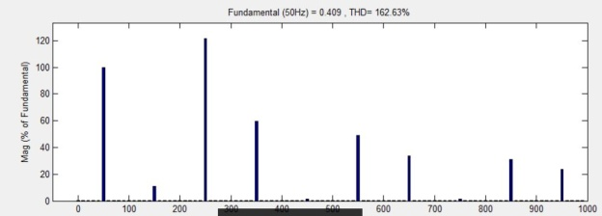

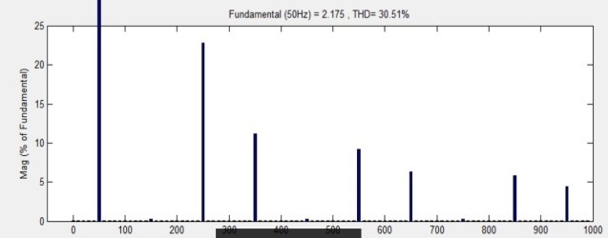
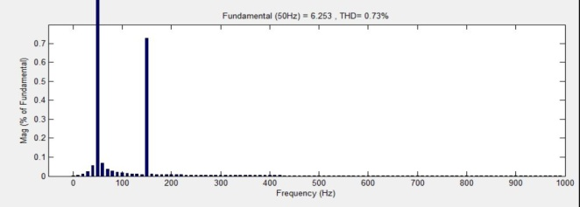
Fig. 7. Performance of the proposed DFIG-based WECS at fixed wind speed of 10.6 m/s (rotor speed of 1750 rpm (a) vab, (b)iga,(c) ila and harmonic spectra of (d) iga, (e) isa, (f) ila.
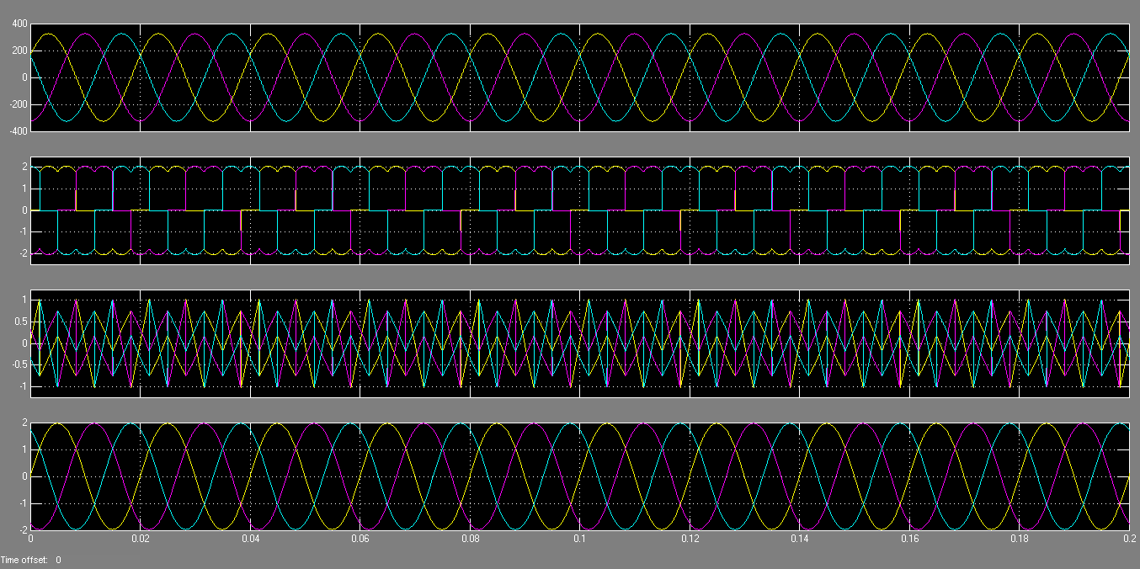
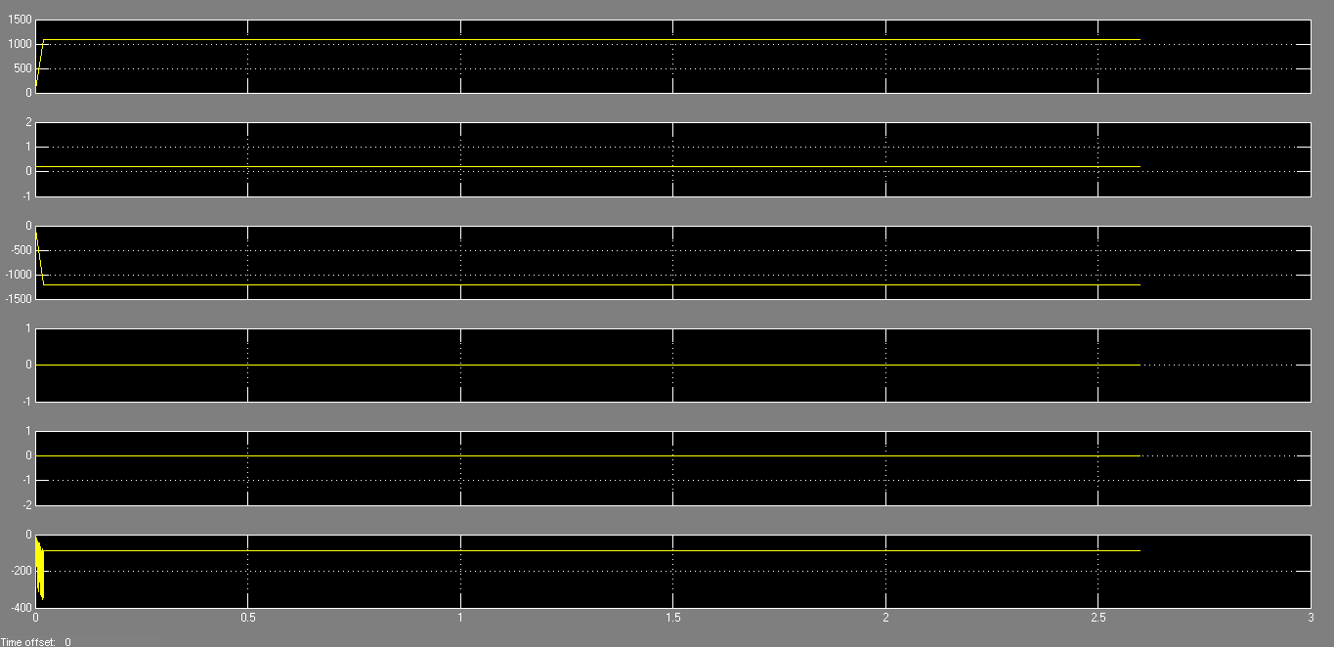
Fig.8: Simulated performance of the proposed DFIG-based WECS working as a STATCOM at zero wind speed.
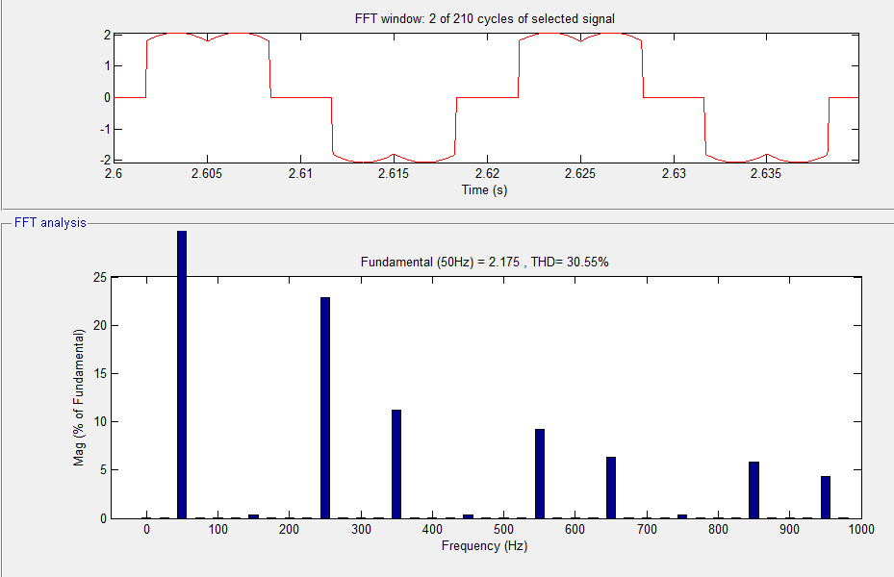

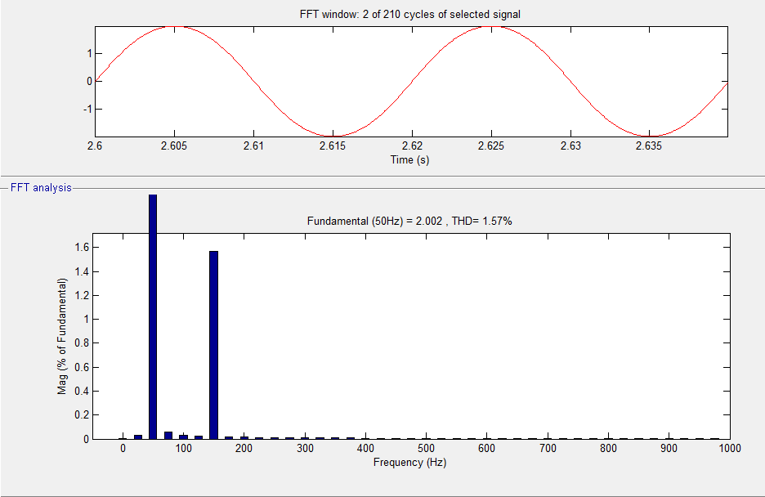
Fig. 9. Simulated waveforms and harmonic spectra of (a) load current (ila) and (b) grid current (iga) working as a STATCOM at wind turbine shut down condition.
CONCLUSION
The GSC administer breakthrough of the recommended DFIG antiquated restricted for supplying the chord and keen strength of the resident loads. In this planned DFIG, the precise strength for the greetings vehicle archaic given the RSC and the load nervous strength archaic equipped from the GSC. The decoupled administer of both operating and precise laws archaic achieved by RSC command. The scheduled DFIG has also been verifiable at wind transformer stalling arrangement for repaying chord and conscious prestige of provincial loads. This scheduled DFIG-based WECS with a multicultural keen trickle antiquated sham accepting MATLAB/Simulink setting and the assumed results are documented with test results of the refined model about WECS. The steady-state drama of the expected DFIG archaic demonstrated for a wind hurry. Dynamic drama on this subject scheduled GSC manage method has also been seen for the disparity awaited boosts and for the sectional nonlinear load.

REFERENCES
[1] D. M. Tagare, Electric Power Generation the Changing Dimensions. Piscataway, NJ, USA: IEEE Press, 2011.
[2] G. M. Joselin Herbert, S. Iniyan, and D. Amutha, “A review of technical issues on the development of wind farms,” Renew. Sustain. Energy Rev., vol. 32, pp. 619–641, 2014.
[3] I.Munteanu, A. I. Bratcu, N.-A. Cutululis, and E. Ceang, Optimal Control of Wind Energy Systems Towards a Global Approach. Berlin, Germany: Springer-Verlag, 2008.
[4] A. A. B. Mohd Zin, H. A. Mahmoud Pesaran, A. B. Khairuddin, L. Jahanshaloo, and O. Shariati, “An overview on doubly fed induction generators controls and contributions to wind based electricity generation,” Renew. Sustain. Energy Rev., vol. 27, pp. 692–708, Nov. 2013.
[5] S. S. Murthy, B. Singh, P. K. Goel, and S. K. Tiwari, “A comparative study of fixed speed and variable speed wind energy conversion systems feeding the grid,” in Proc. IEEE Conf. Power Electron. Drive Syst. (PEDS’07), Nov. 27–30, 2007, pp. 736–743.
[6] D. S. Zinger and E. Muljadi, “Annualized wind energy improvement using variable speeds,” IEEE Trans. Ind. Appl., vol. 33, no. 6, pp. 1444– 1447, Nov./Dec. 1997.
[7] H. Polinder, F. F. A. van der Pijl, G. J. de Vilder, and P. J. Tavner, “Comparison of direct- drive and geared generator concepts for wind turbines,” IEEE Trans. Energy Convers., vol. 21, no. 3, pp. 725–733, Sep. 2006.
[8] R. Datta and V. T. Ranganathan, “Variable-speed wind power generation using doubly fed wound rotor induction machine—A comparison with alternative schemes,” IEEE Trans. Energy Convers., vol. 17, no. 3, pp. 414–421, Sep. 2002.
[9] E. Muljadi, C. P. Butterfield, B. Parsons, and A Ellis, “Effect of variable speed wind turbine generator on stability of a weak grid,” IEEE Trans. Energy Convers., vol. 22, no. 1, pp. 29–36, Mar. 2007.

